Cycle detection with the undirected graph:

1. BFS;

Use the visitd with array

Push the ndoe wiht the node and the dparent as the input the the queue.

The use the above to check with the adjacency and non adjacemcy . Make teh olution out of it.

1. DFS:

Here as the paramter take everything wiht you. What is the parent if at a time the parent is not seen and you have found out the visited then you need to say that you have got the cycle.



It is more like the BFS witb the distance 0 will puhs the distance with the distance 1, hence this keeps hapennign.

Iniatla set uso is we need that coordiante and how muhc iit is differening in distance.

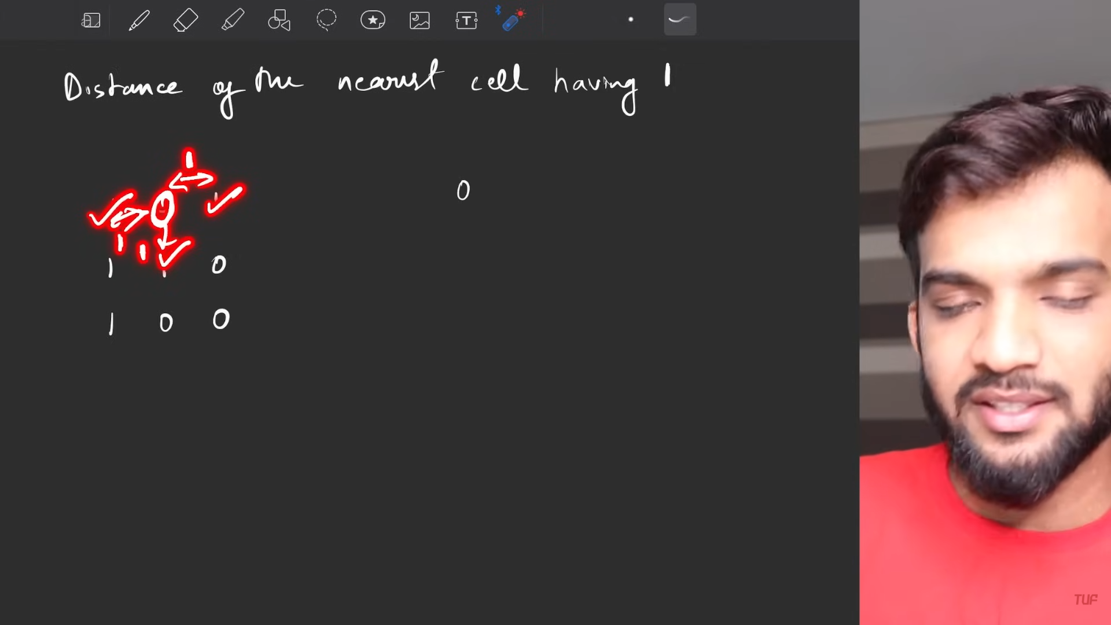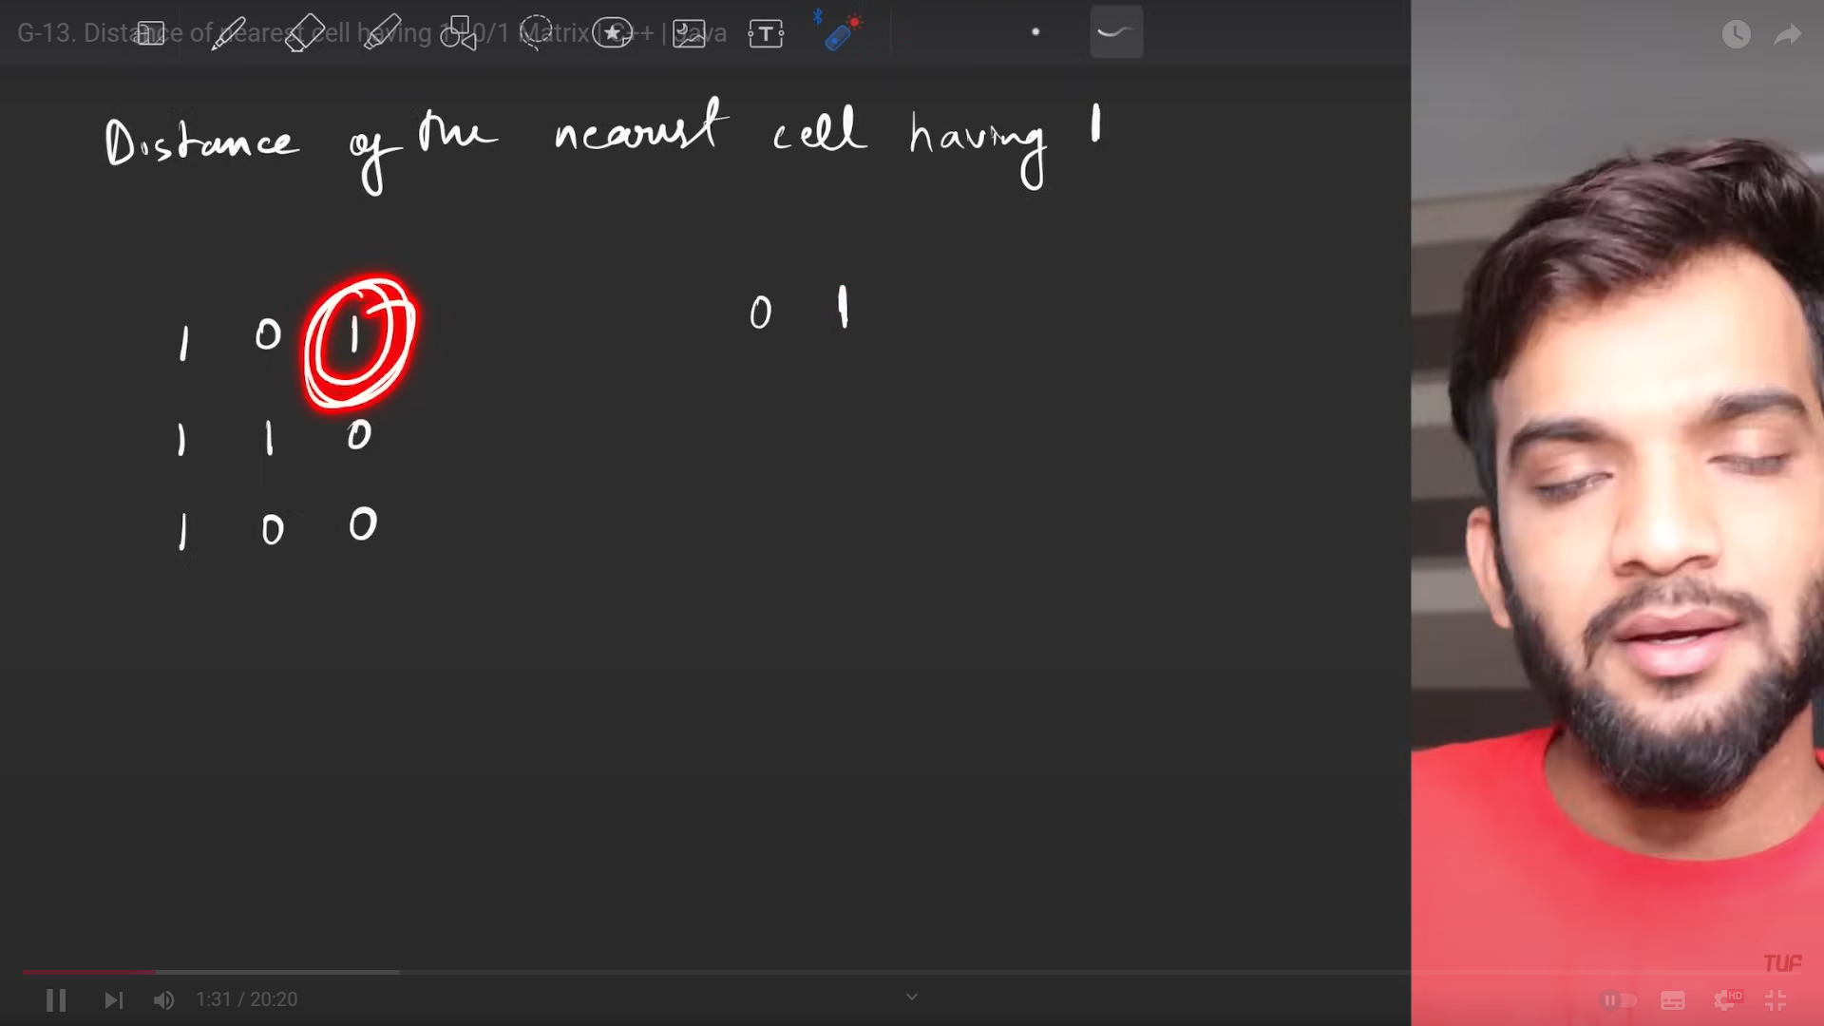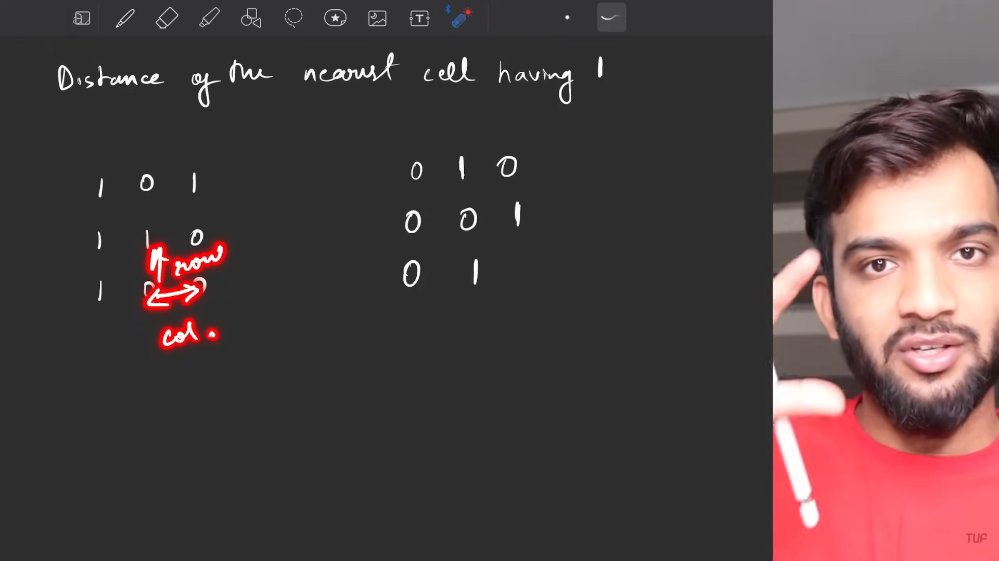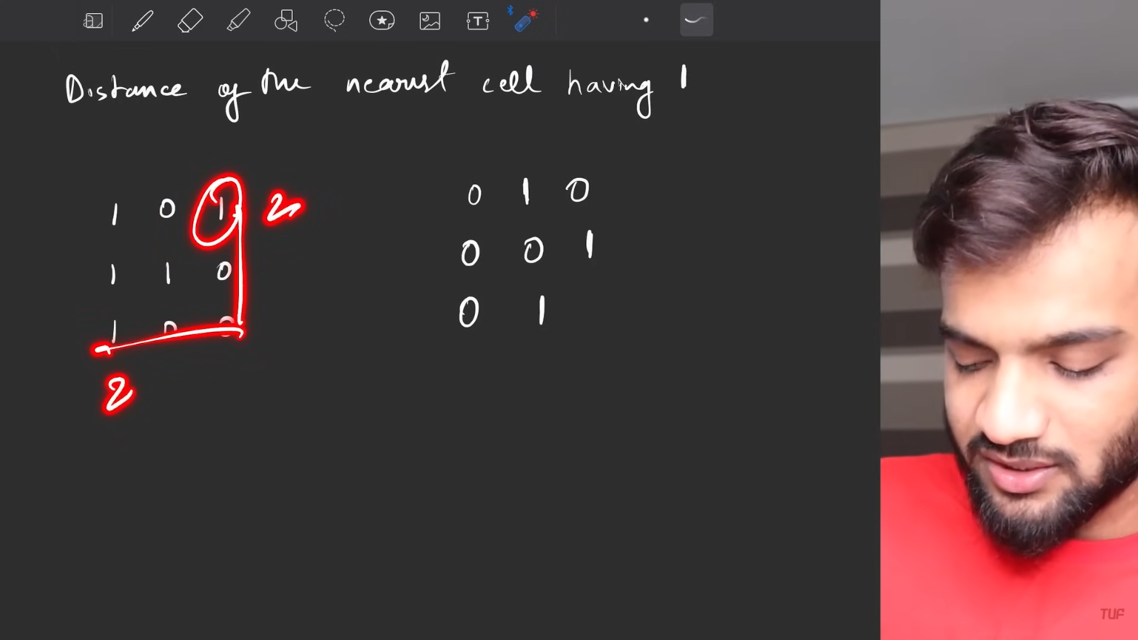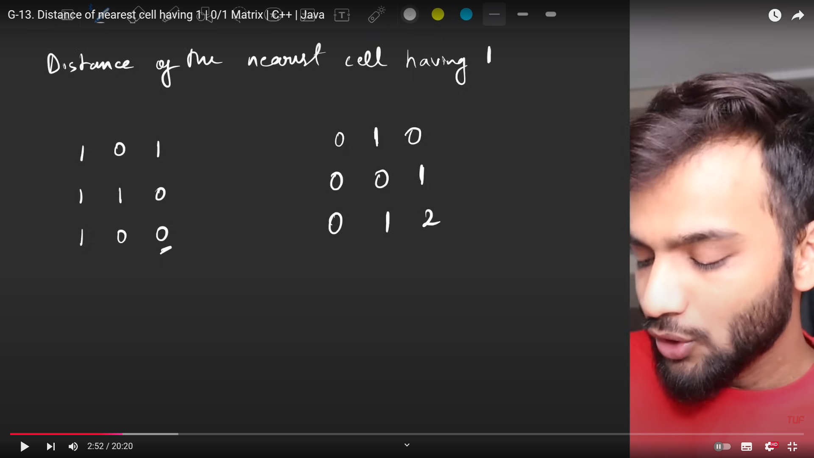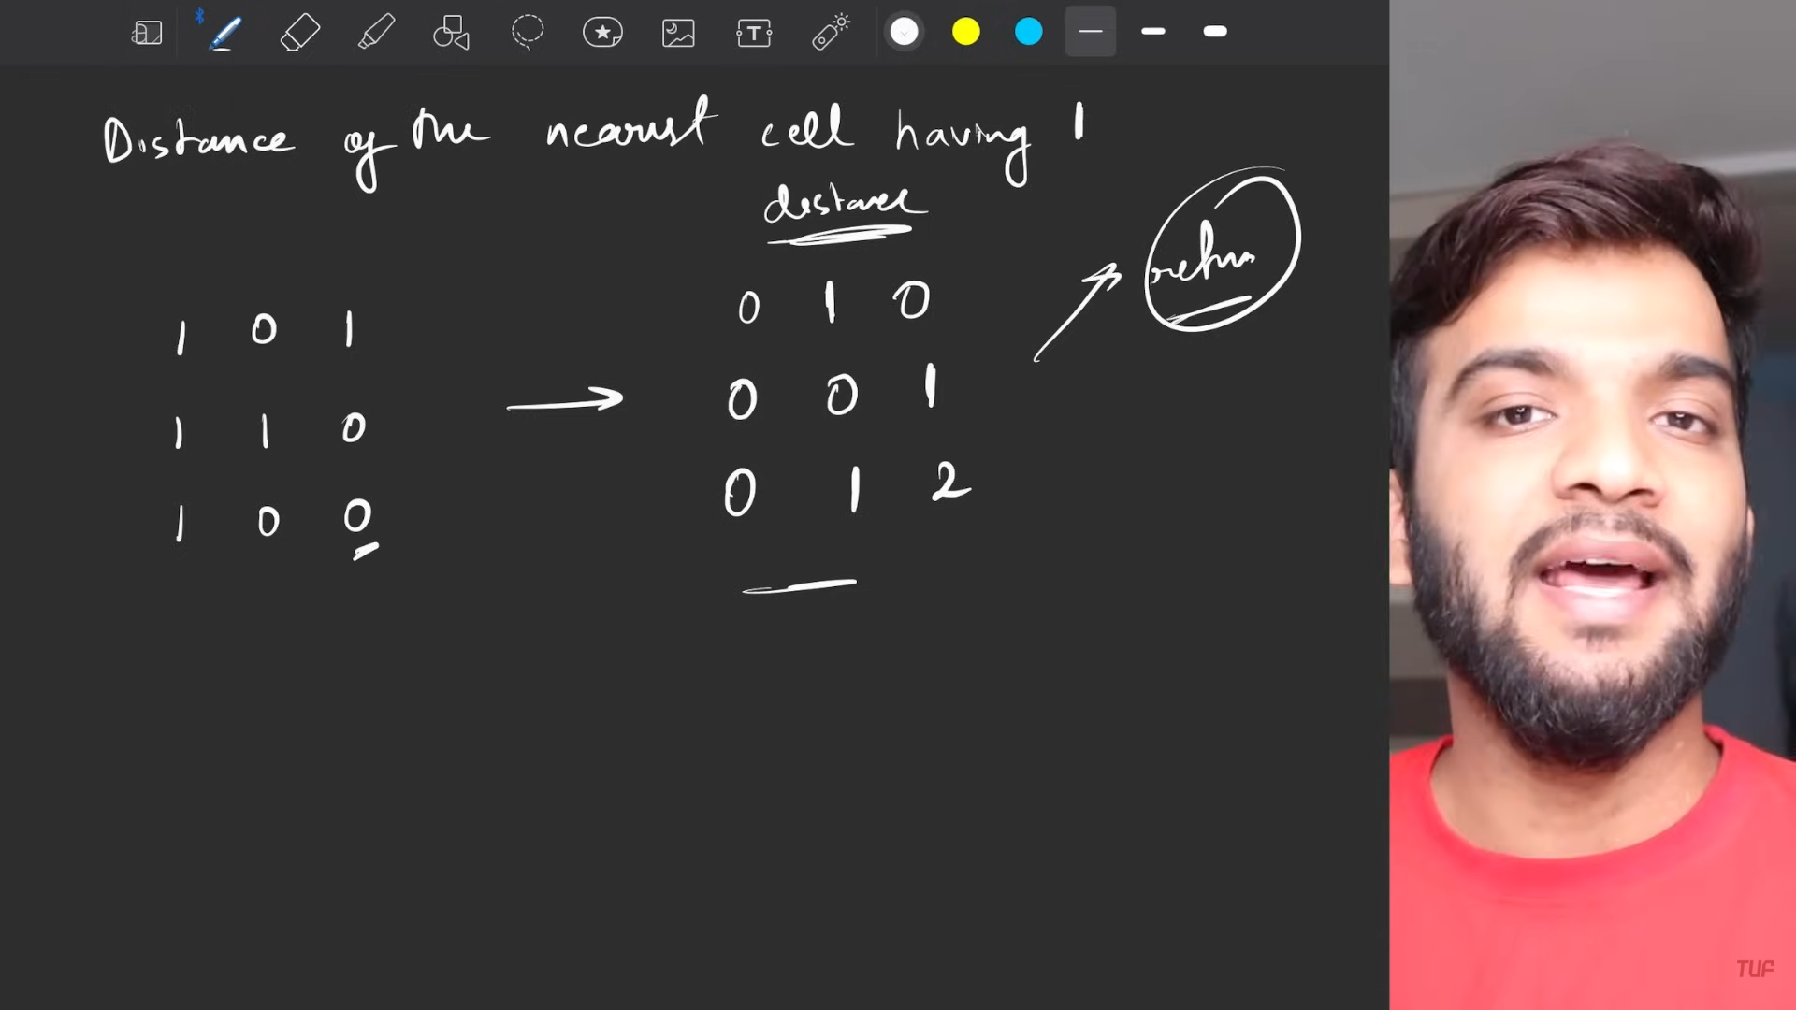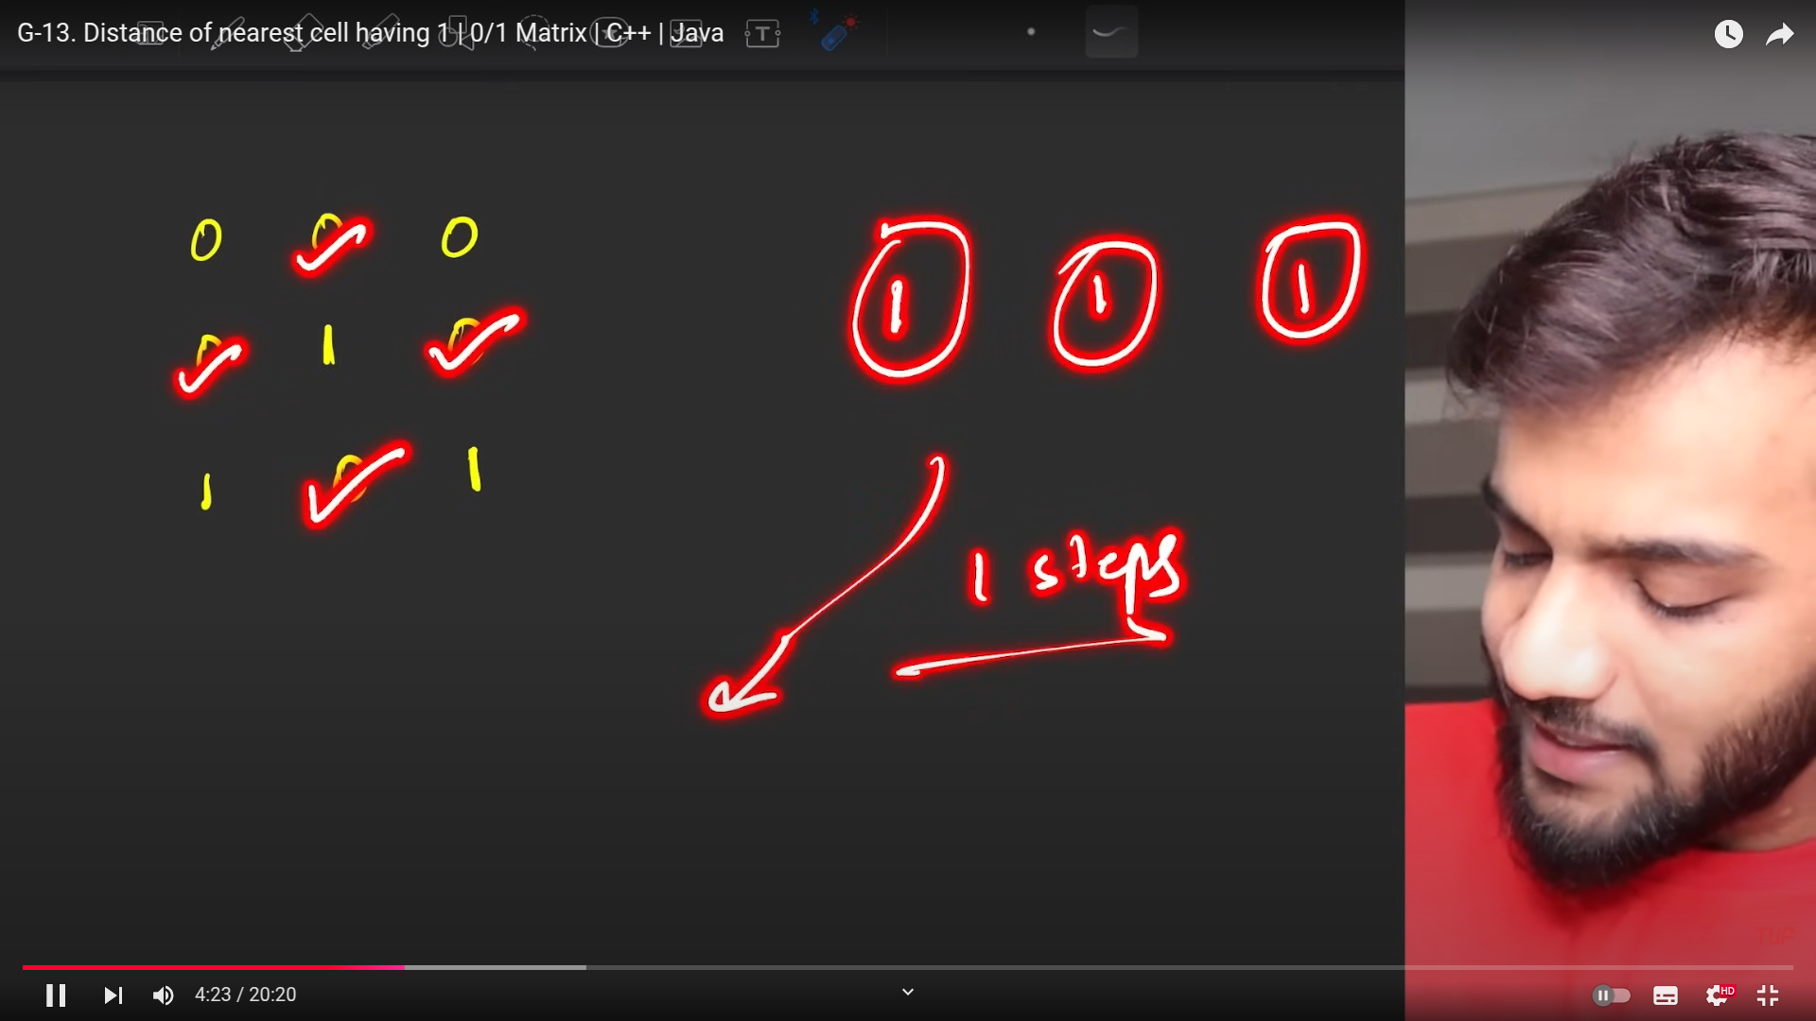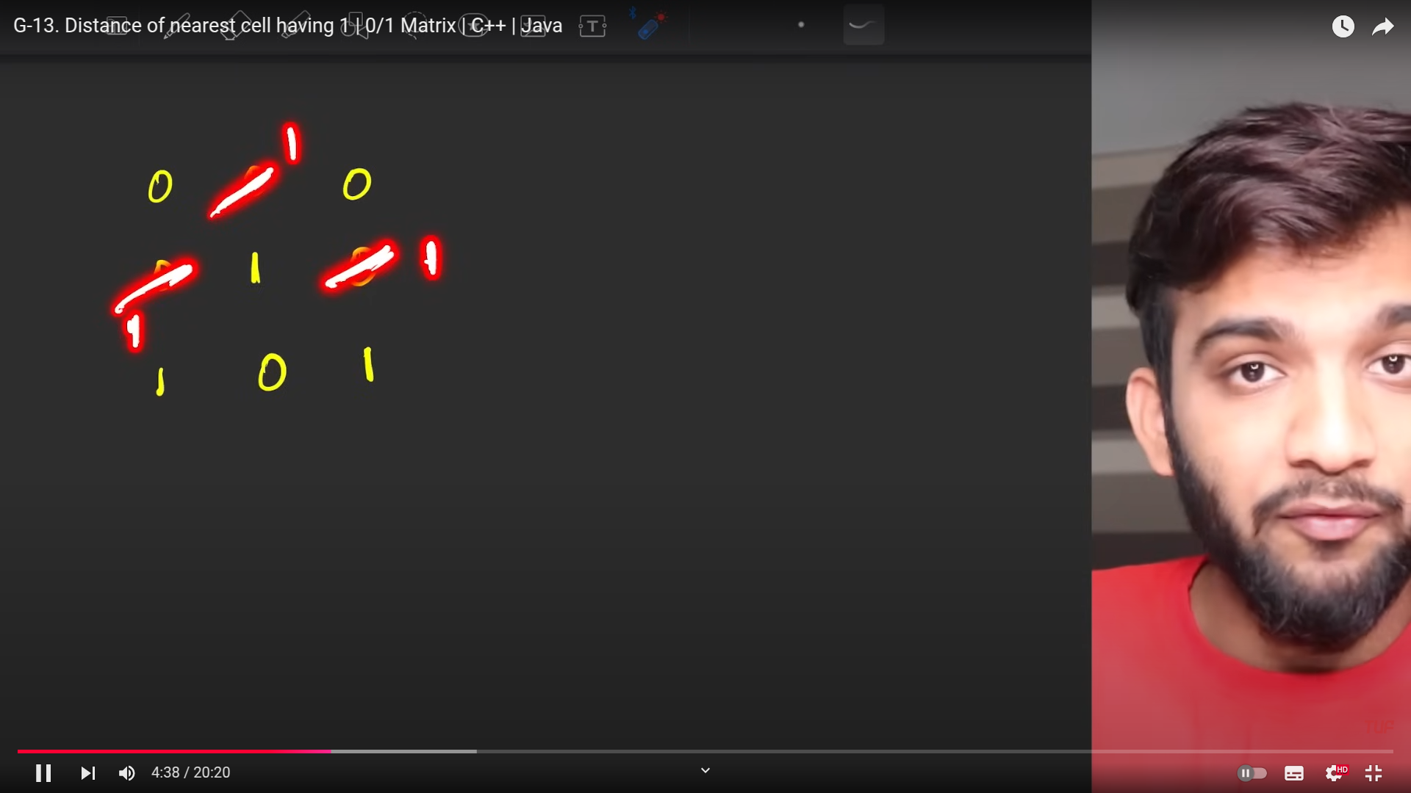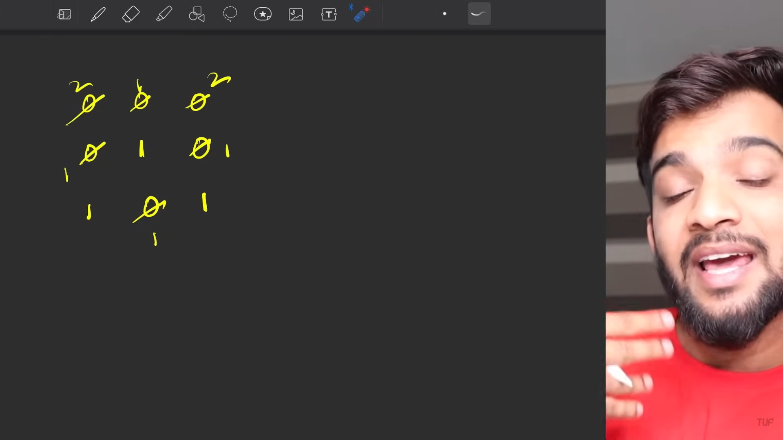

**BFS always moves step by step.** Hence this suits me well. **If DFS is used then we will have to use many steps instead.**  Which will not return the optimal answers.

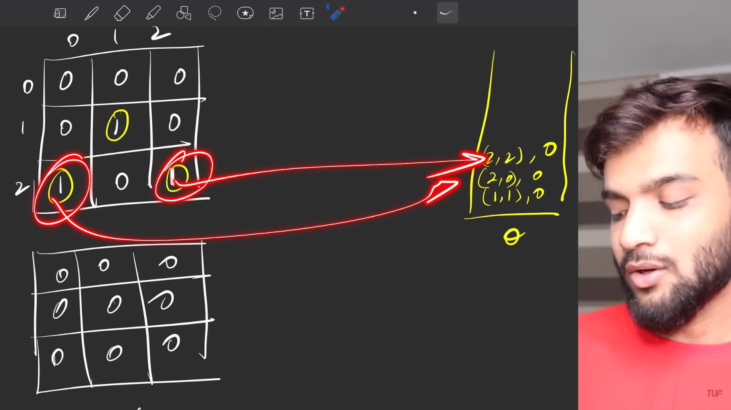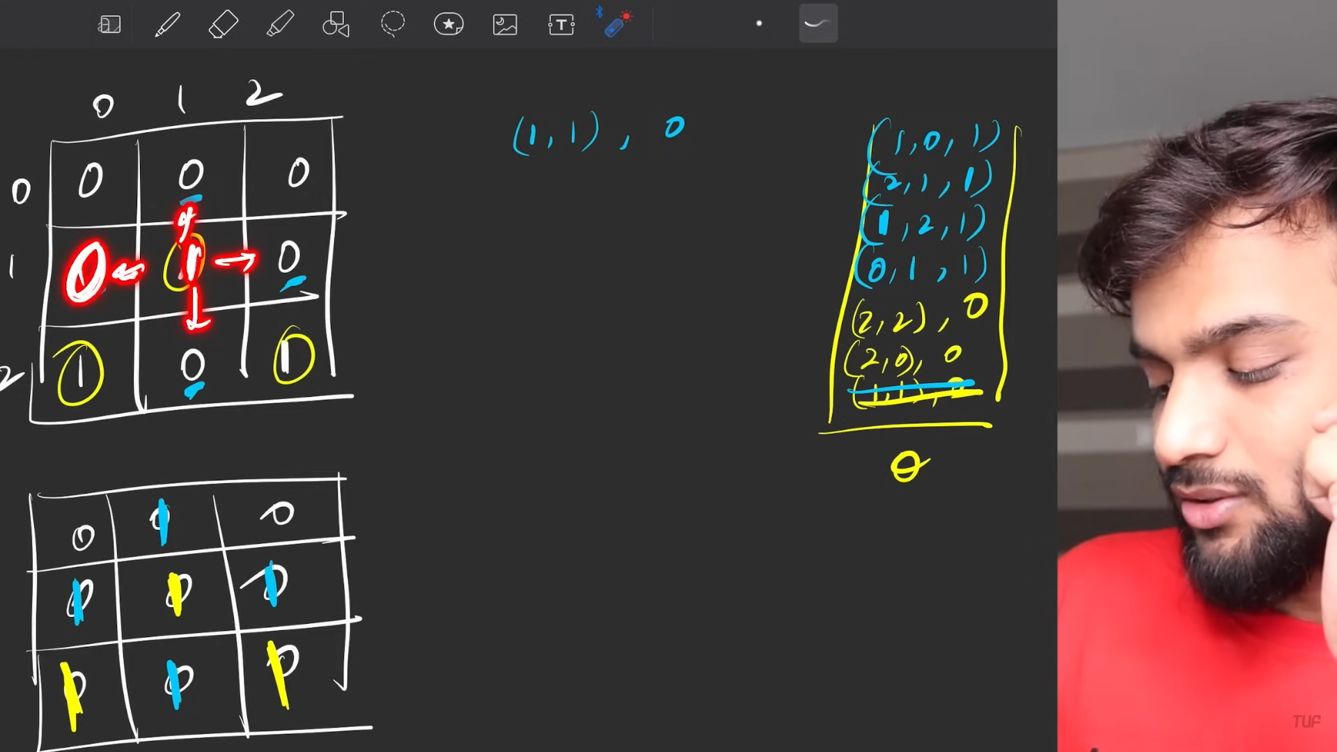

Move in 4 ward direction so that you can easily reach everything properly. In soem distance .

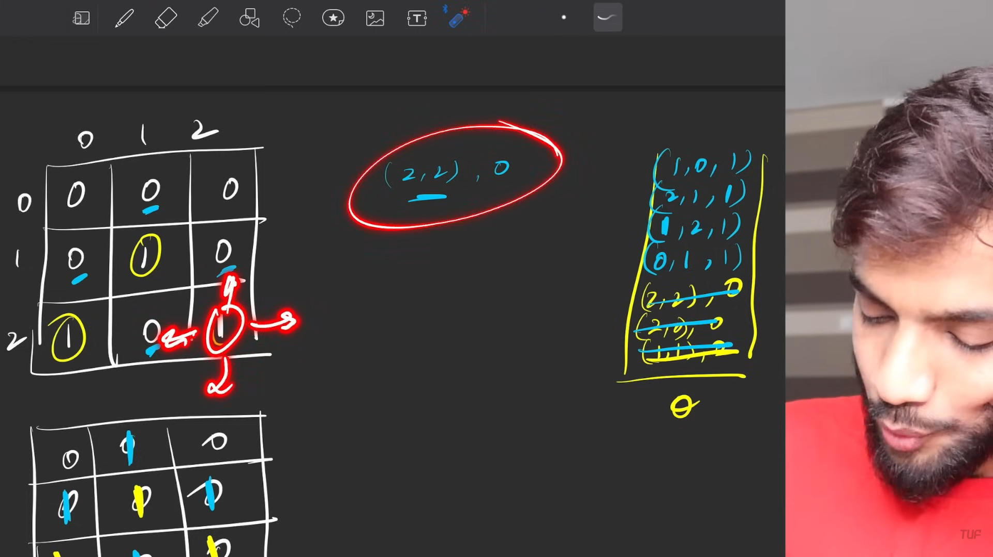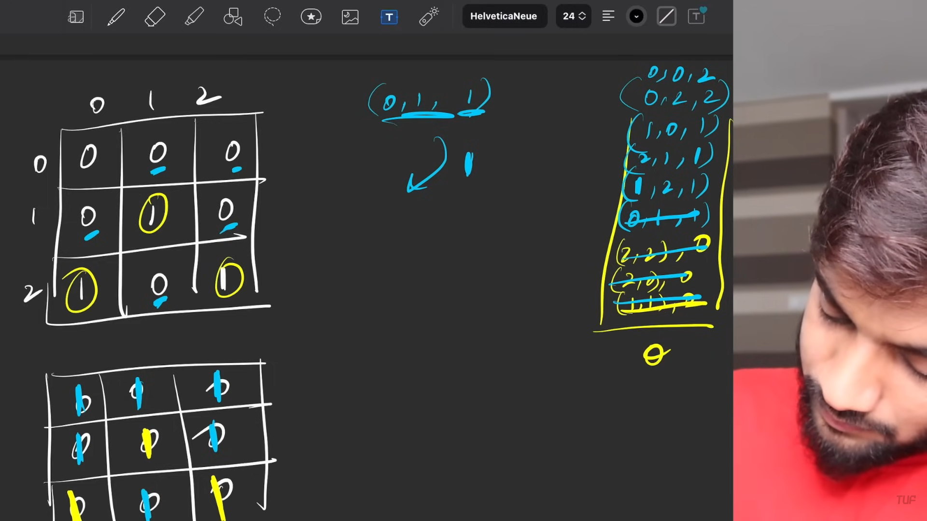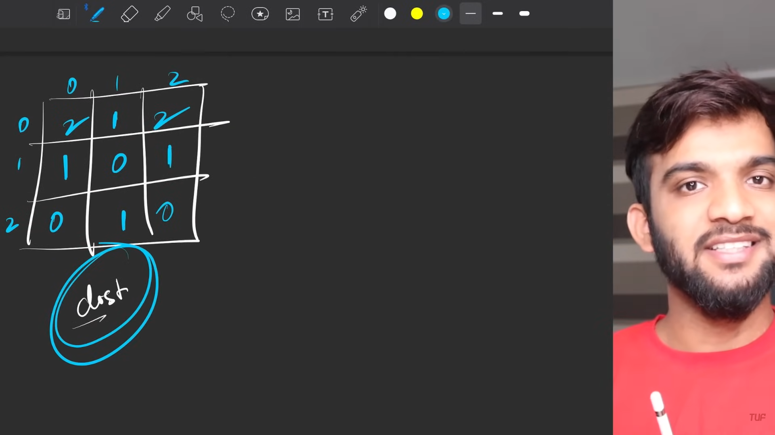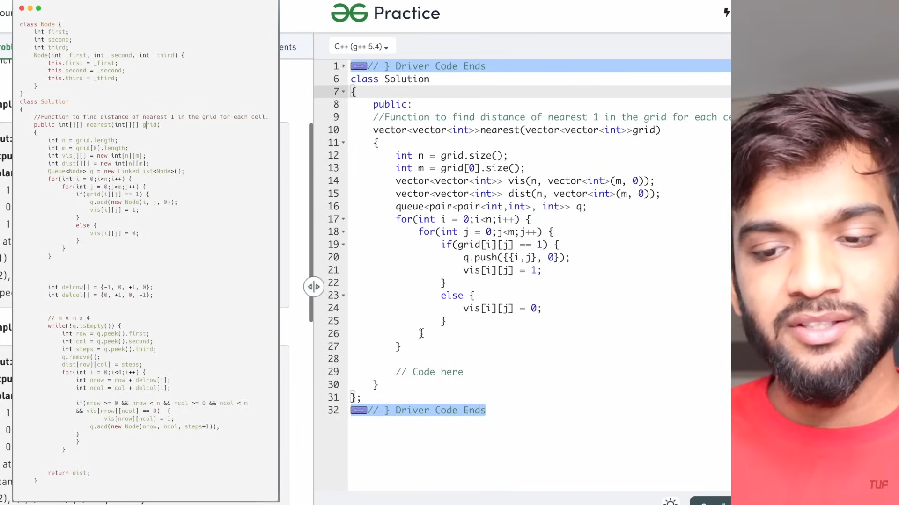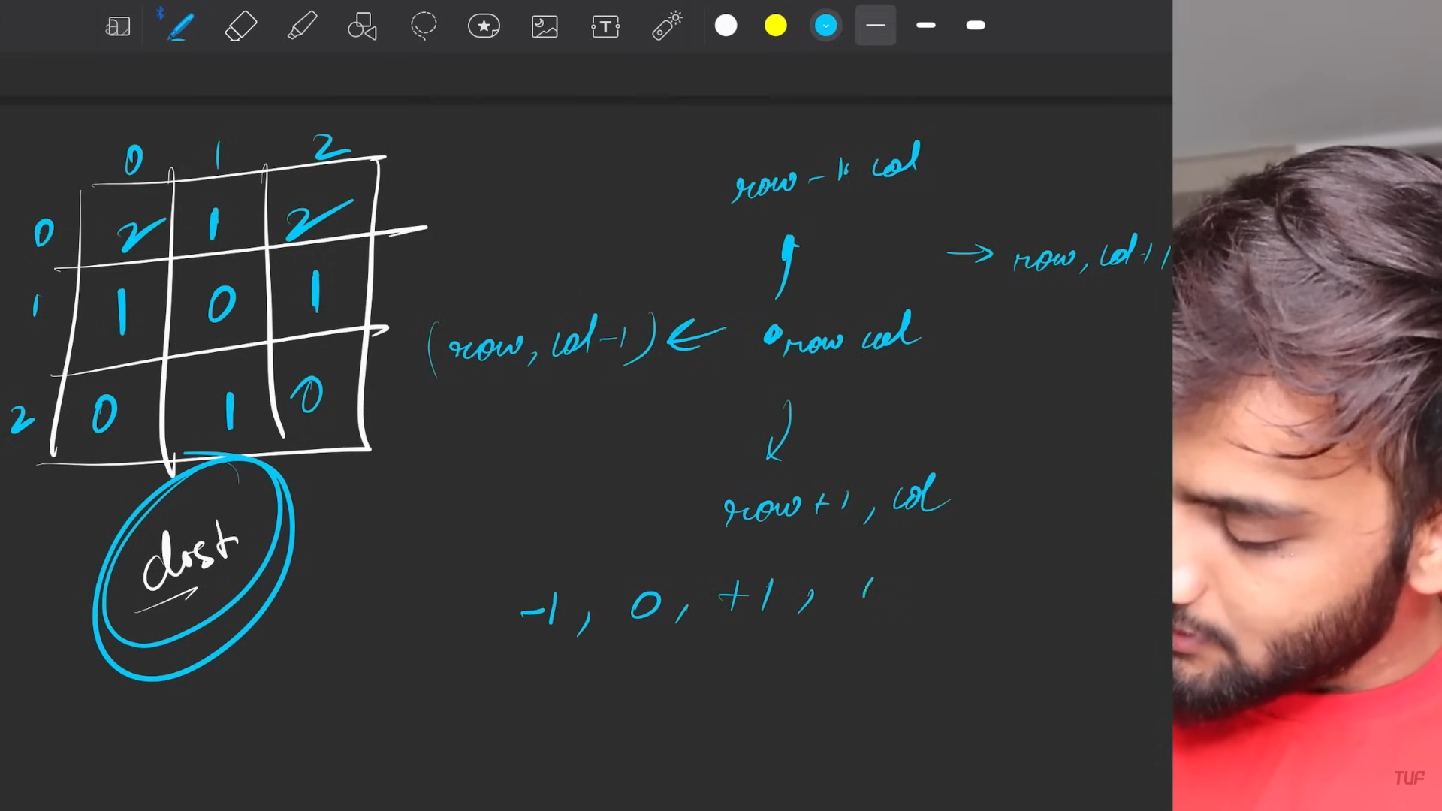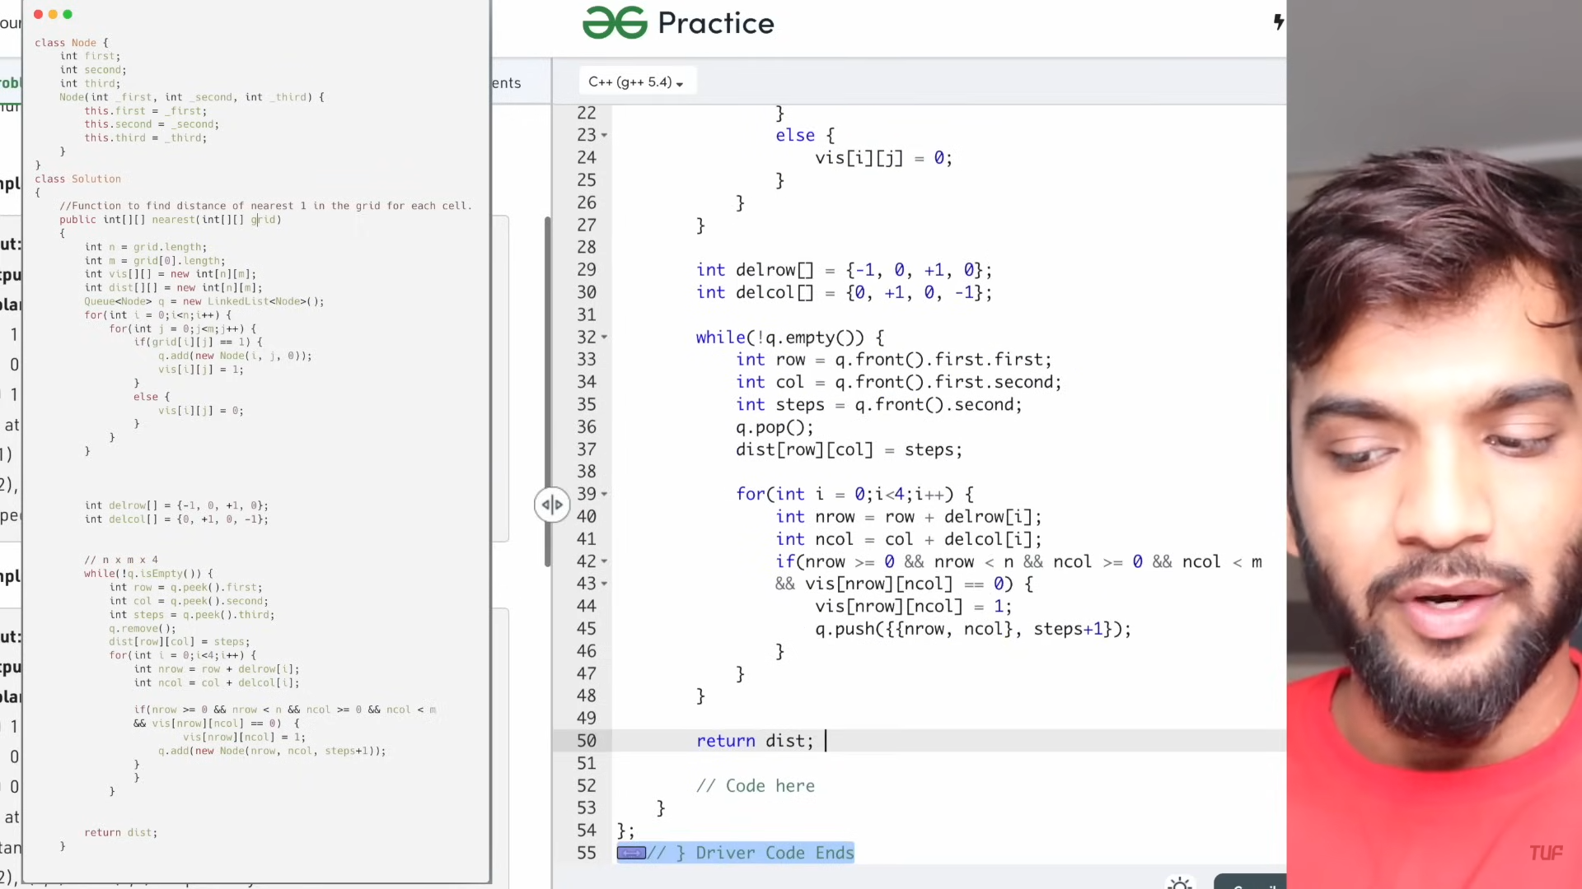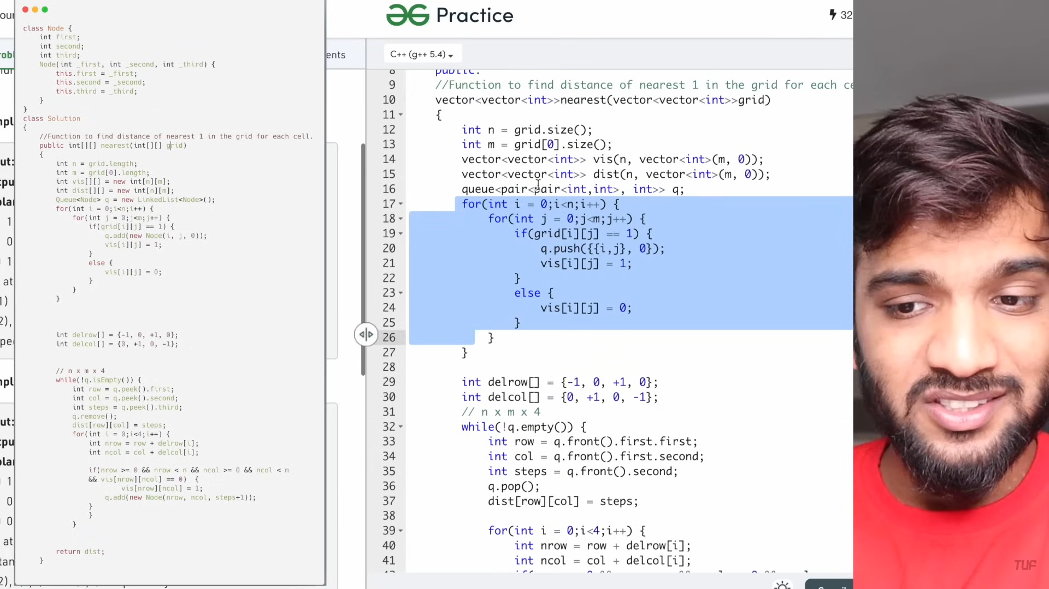

**Replace os wiht xs**

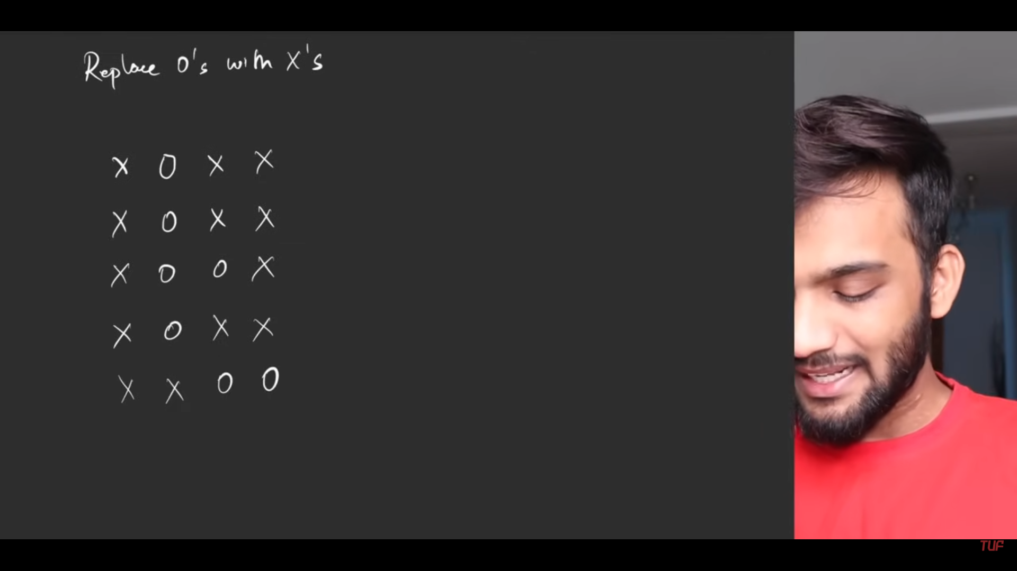

These are sourrounded by x on all the sides except at the top.



Now see, these are all souurrounded by all x at all direction , hnec we oncert all the os to xs.

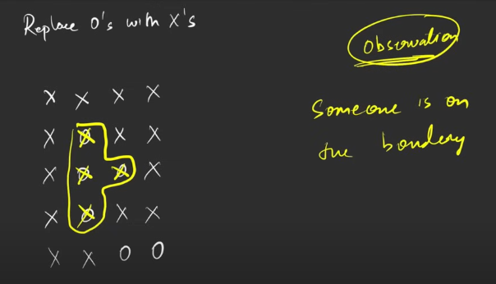

These all things are not connected to teh boundaries.

1. If some one connected to the boundary then thise things cannot be sourrounded.

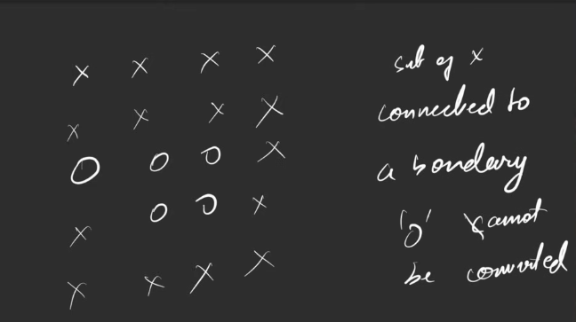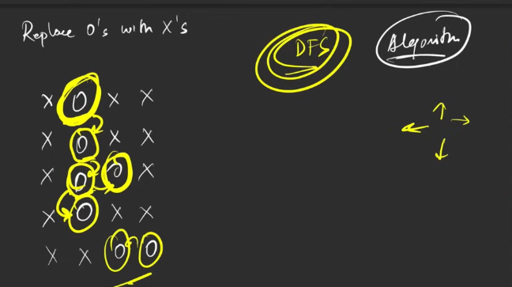

1. These things cannot be converted.

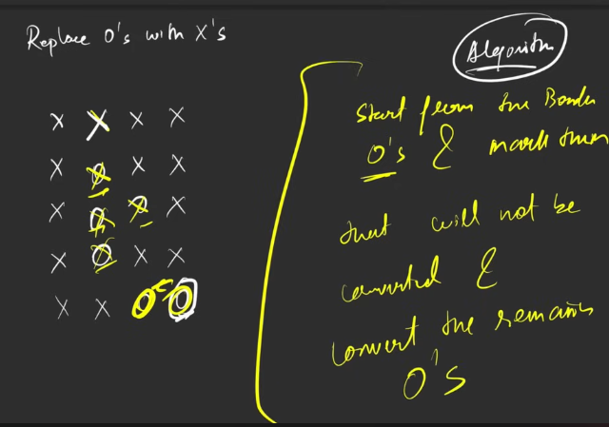

1. Check is there is anybody on the edges, if anybooyd is seen on the end as 0 start straversing and mark all teh connected to be as the the no converteible.

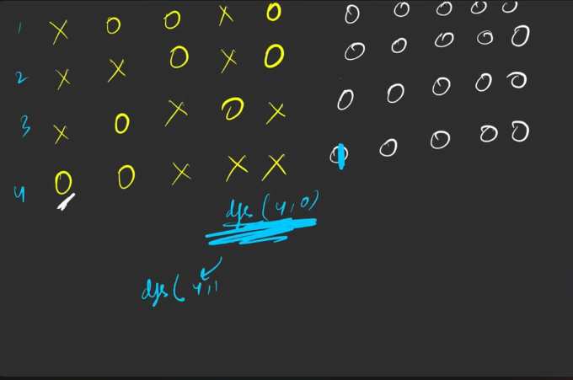

1. s

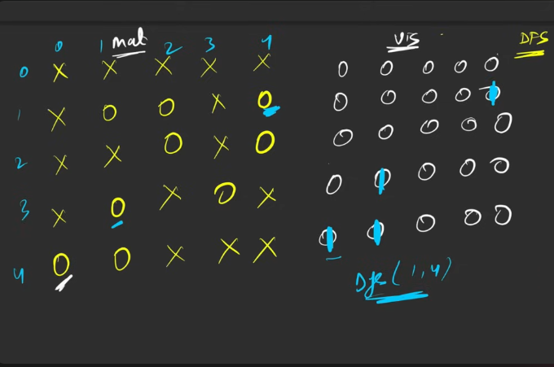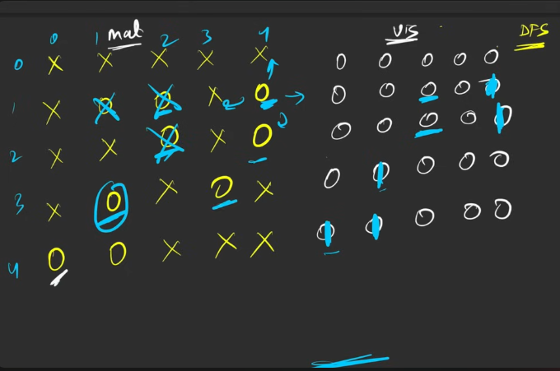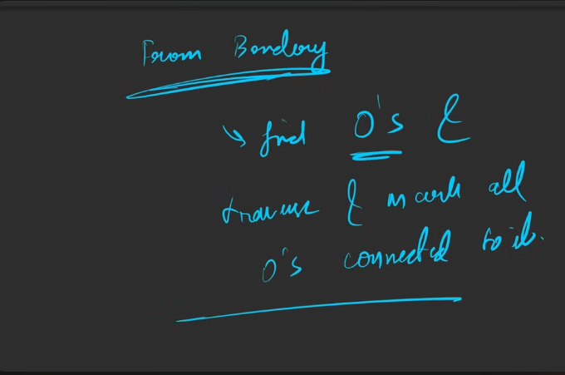

1. Code is there on the sit , you can check and make it as soon as possible.

**NUMBER OF ENCLAVES**

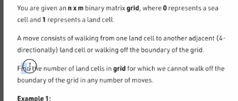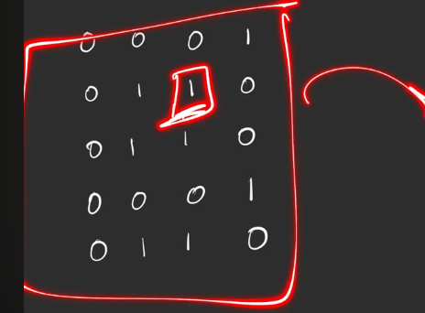

From the one which is there n th emiddle, from there we cann0t make any move outside.

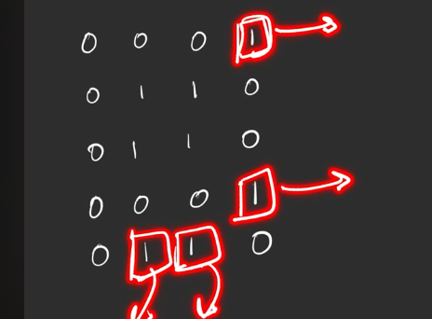

The which is there on the end ones, from there we can move outside.

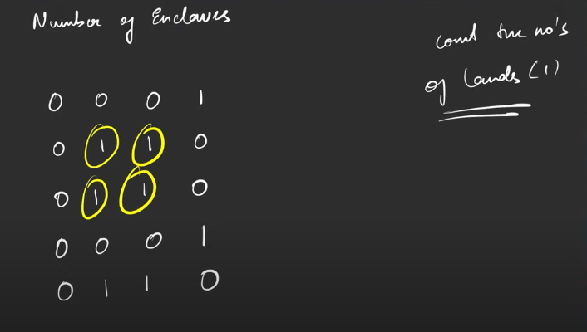

4 lands from wehre we cannot go out of the boundary.

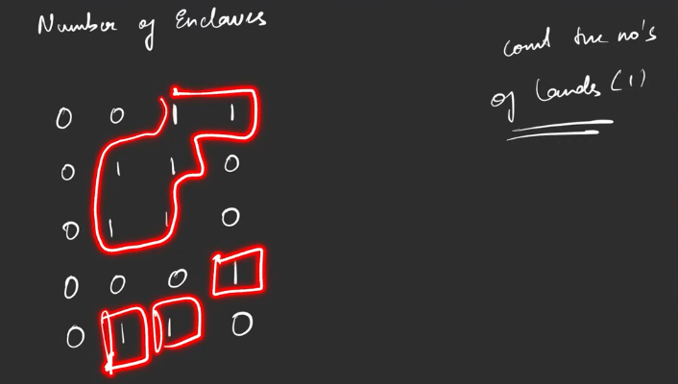

0 lands from where ww can go out of the boudary.

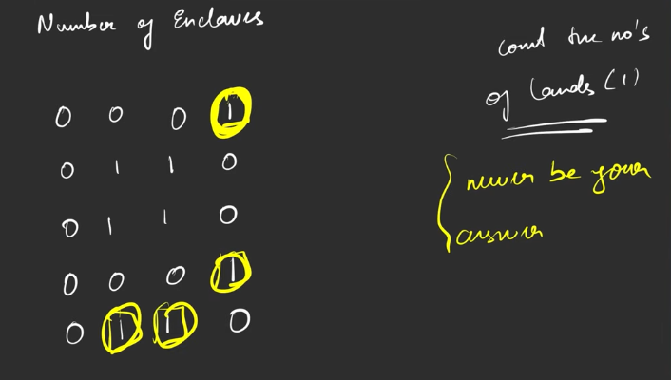

Anything which are connected to the boundary cannot be the part of my answer. Some number of lands which re not the part of the boundary is th epart of the answer.

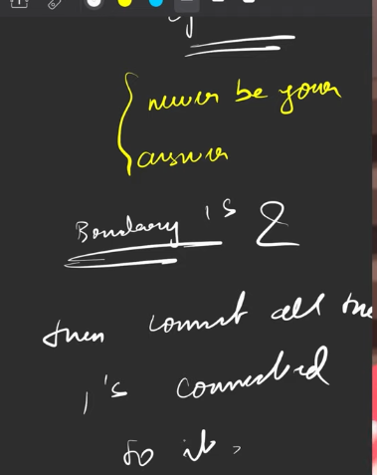

BOTH the BFS and DFS works here.

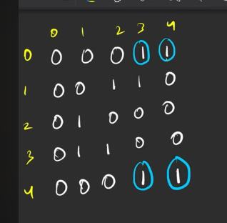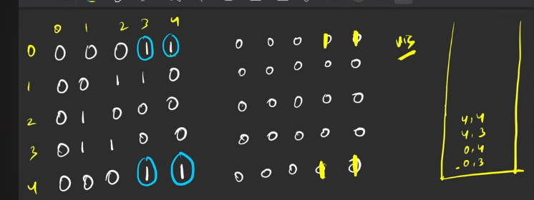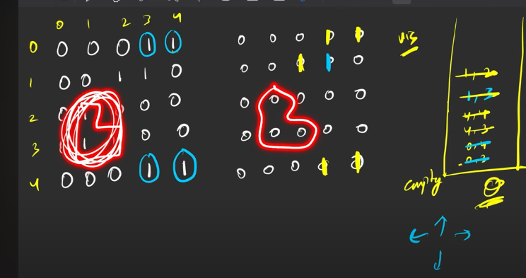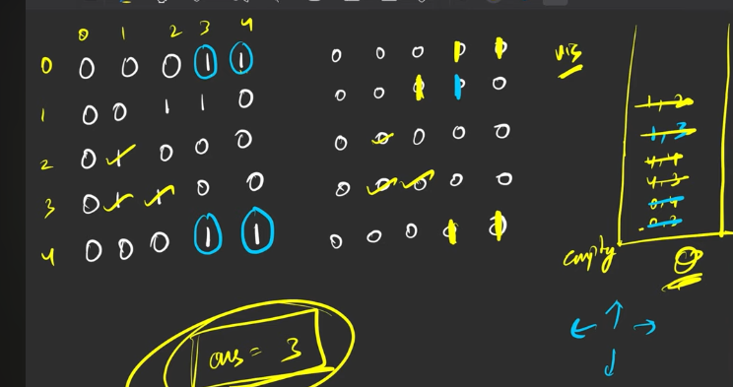

This I can do it.

**NUMBER OF DISTINCT ISLANDS**

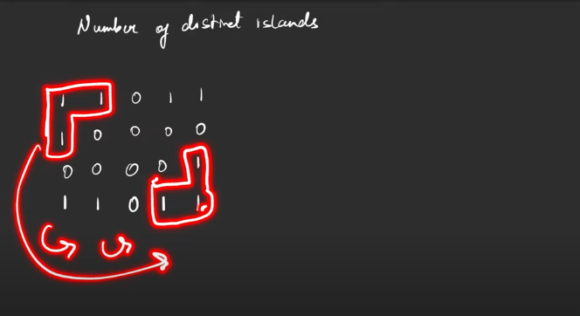

Below are the islands that are connected.

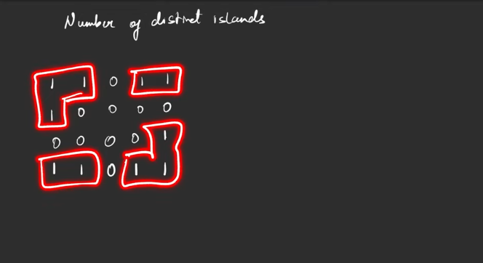

The marked ones are identical and the did=e ntical ones are counted once.

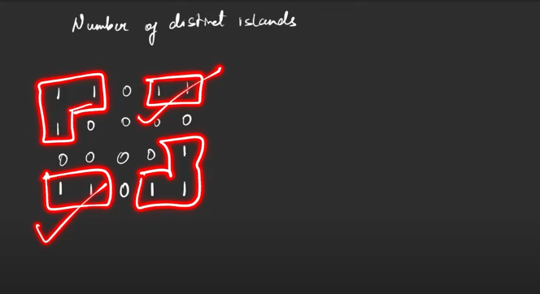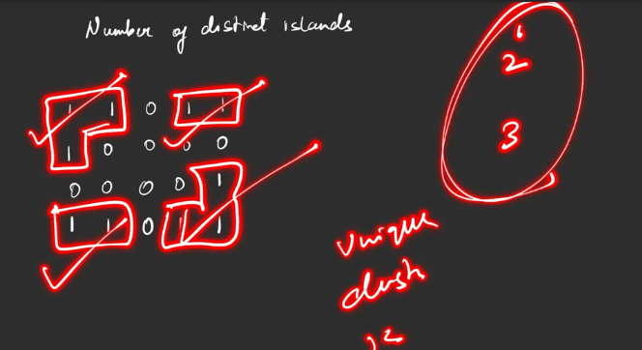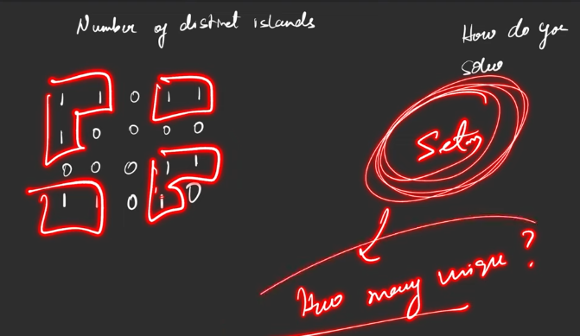

Stroing the vector / list in set.

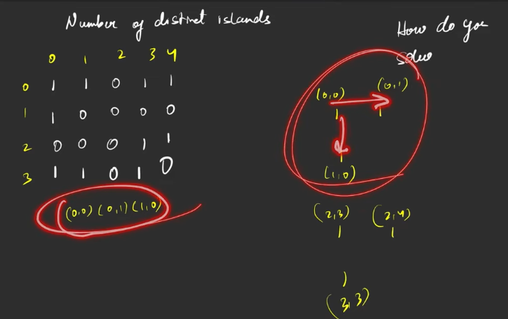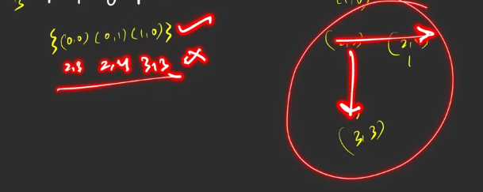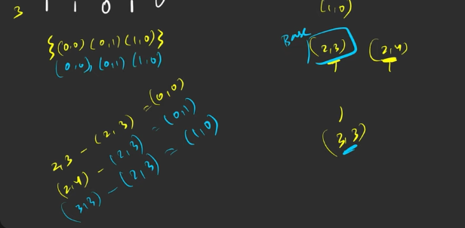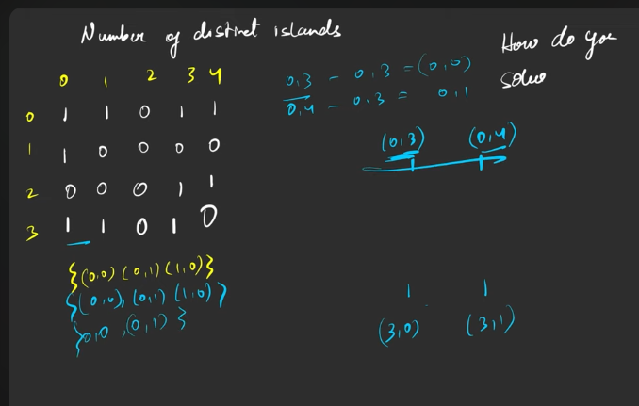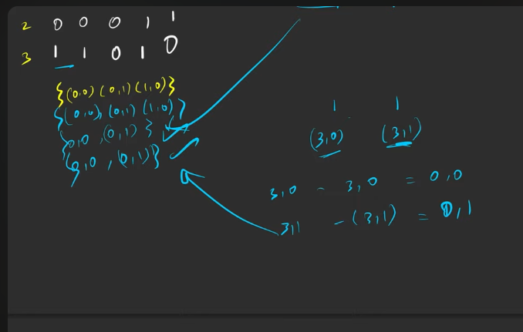

**Trap**: If you do not follow the same pattern then it will not help.

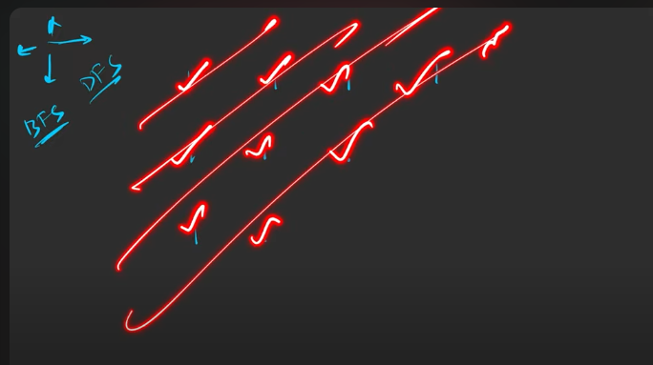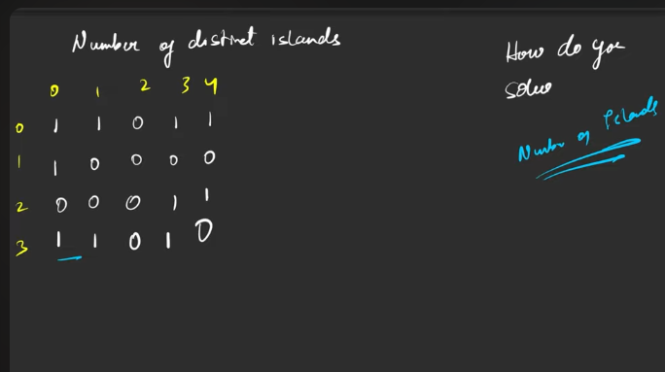

This is the exapnsion of the umber of islands.

Code you can do it.

**Cycle detection in directed Graph using DFS**

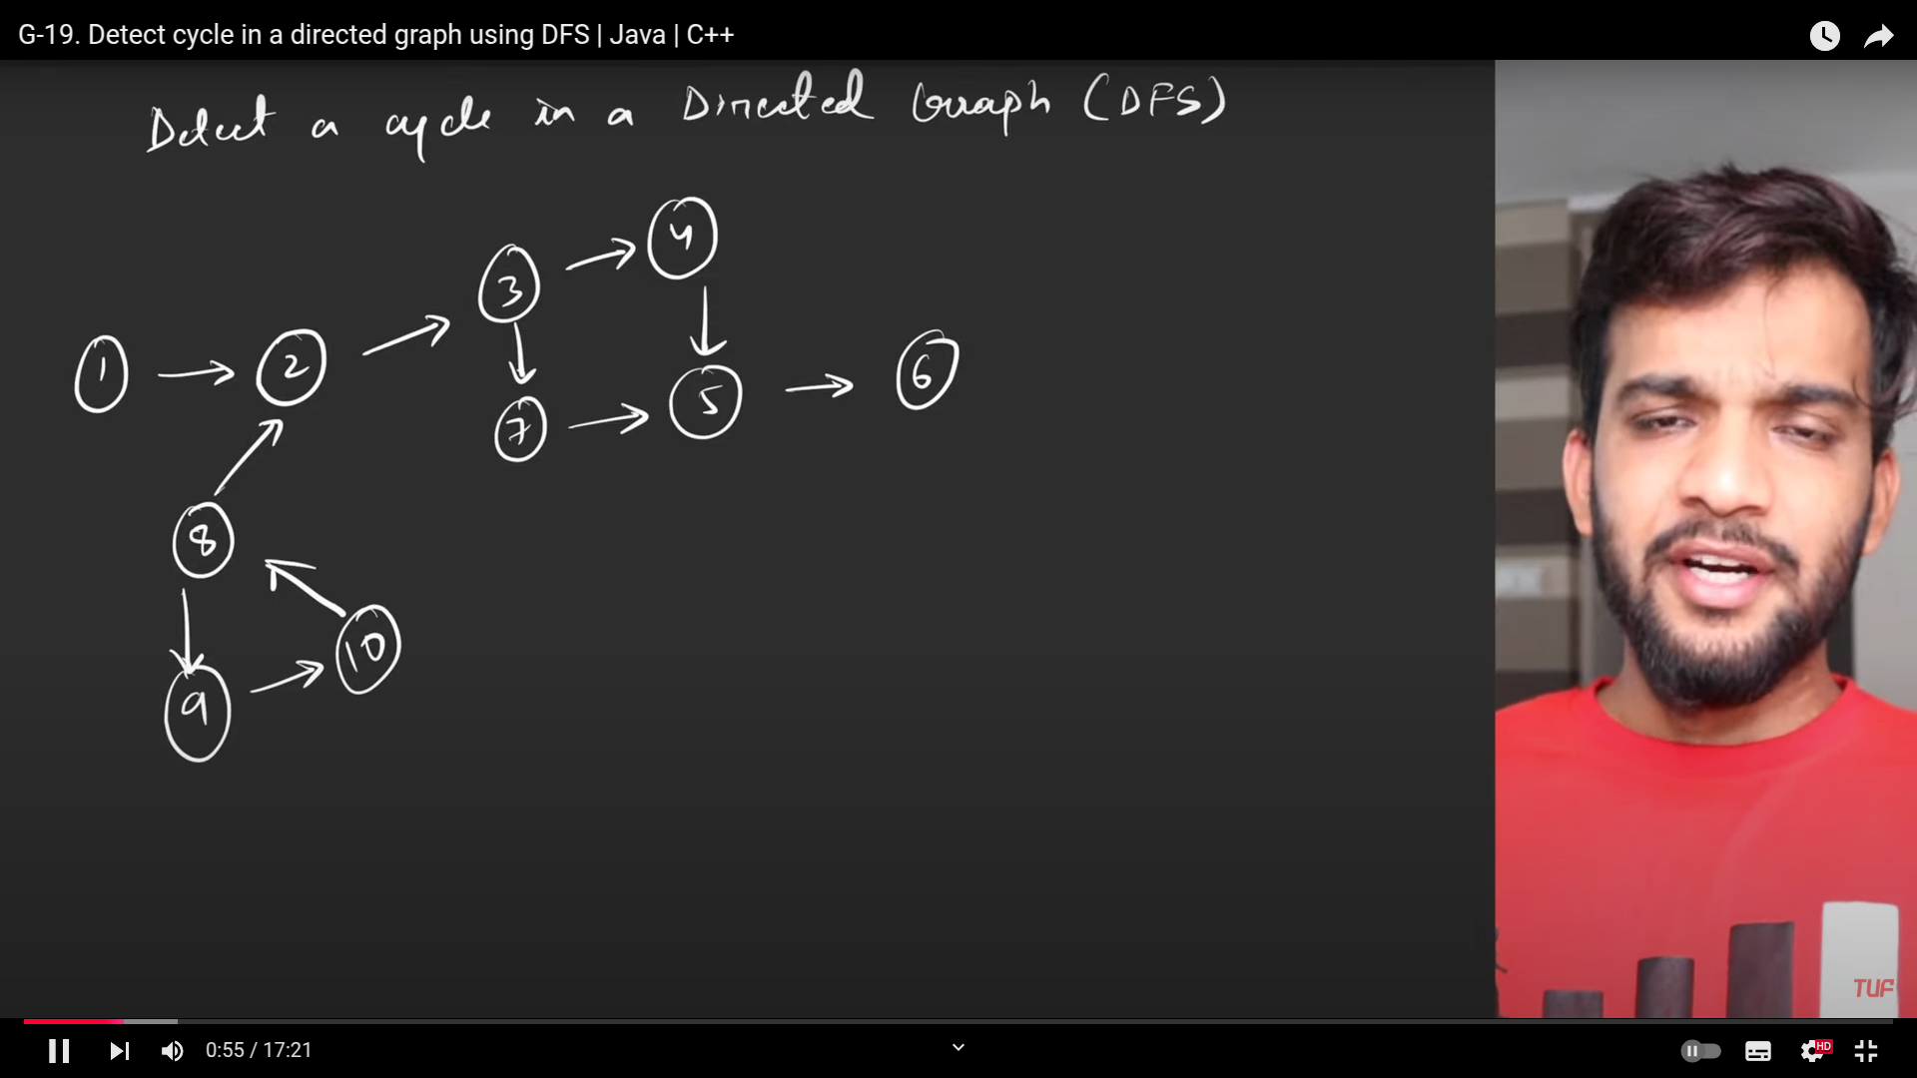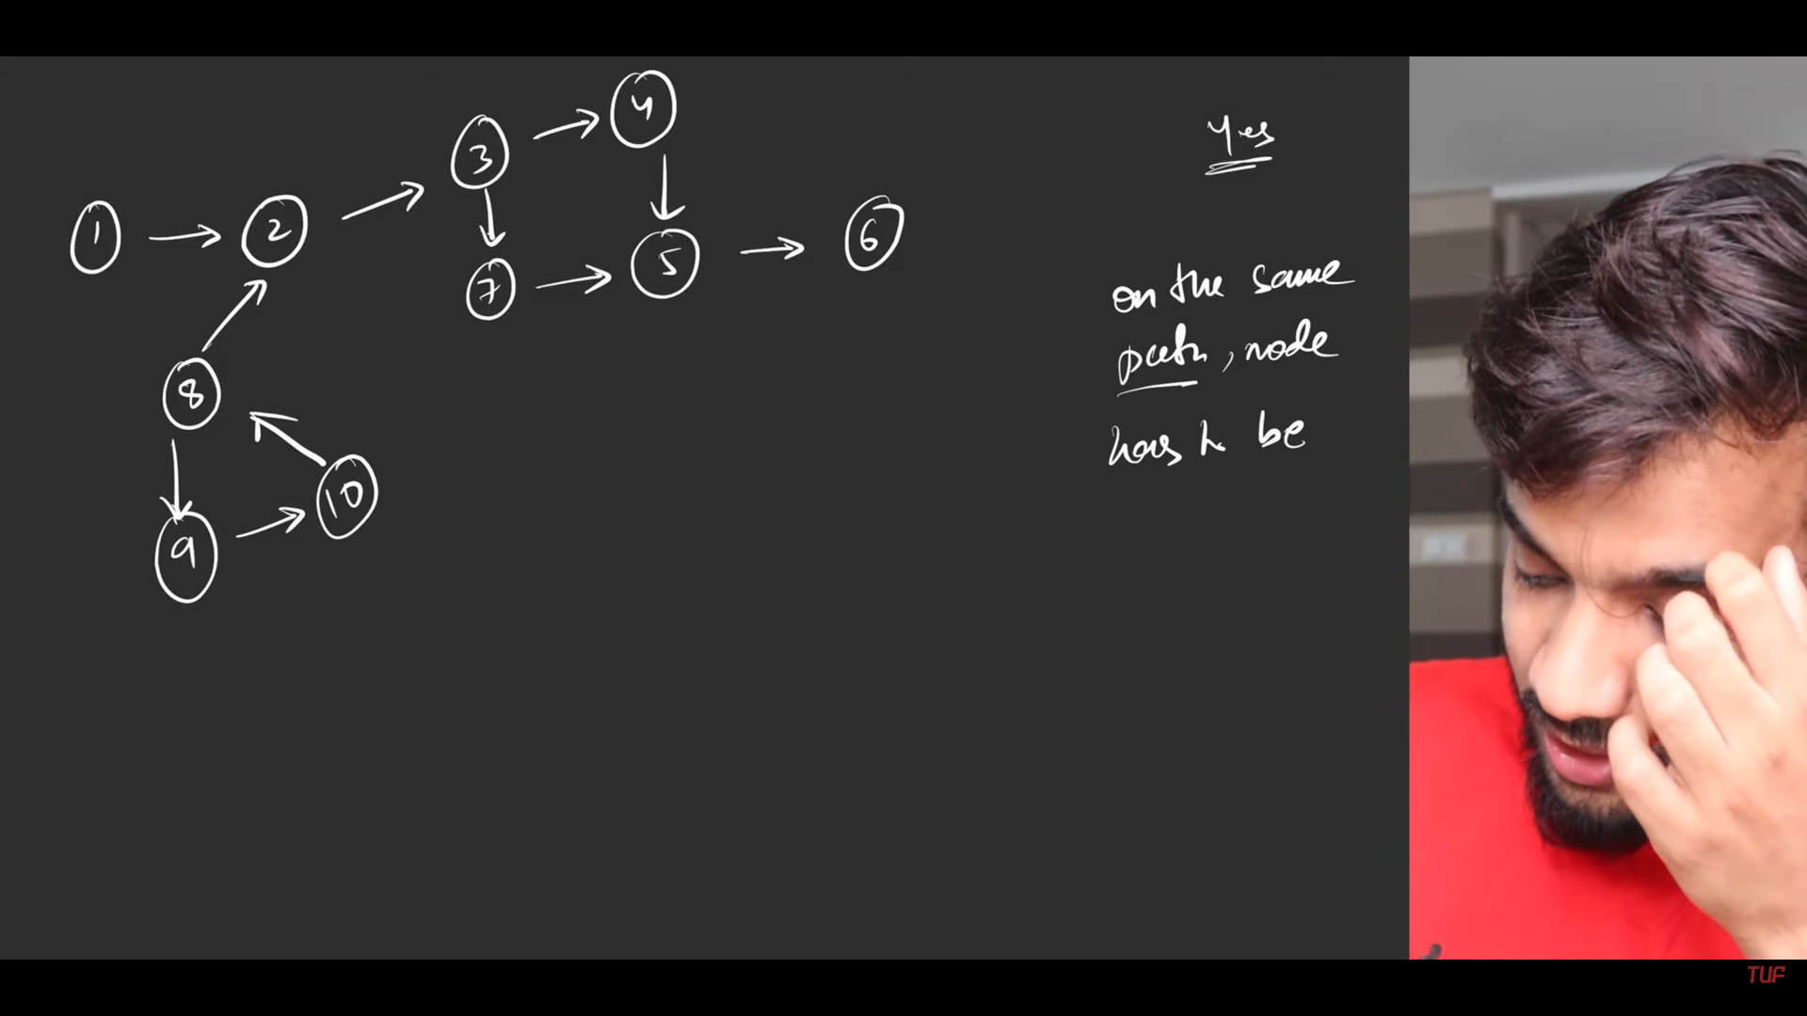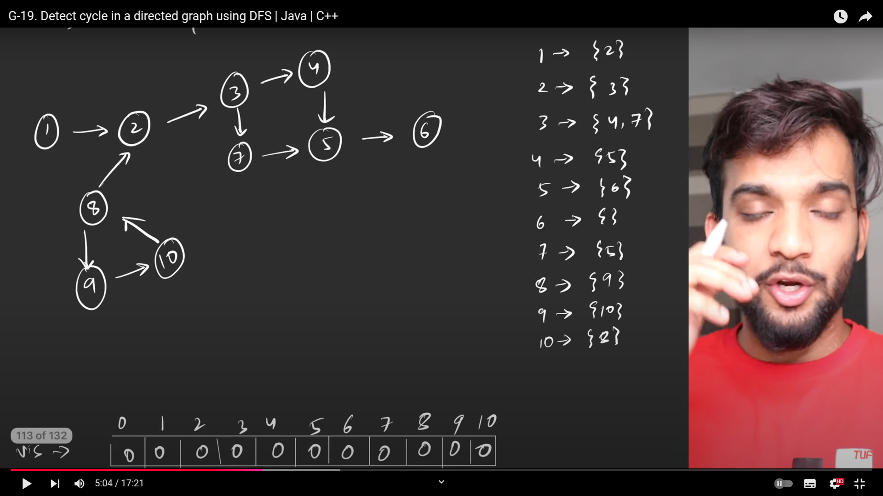

1. So the cycle is found , when visted along the same path(8-9-10), if the path is different, already visited then it is not considered as the then it is not considered as cycle(3-4-5-7).
2. When you are going back, from dfs, need to mark path as 0 for the node since it is going out of the path.

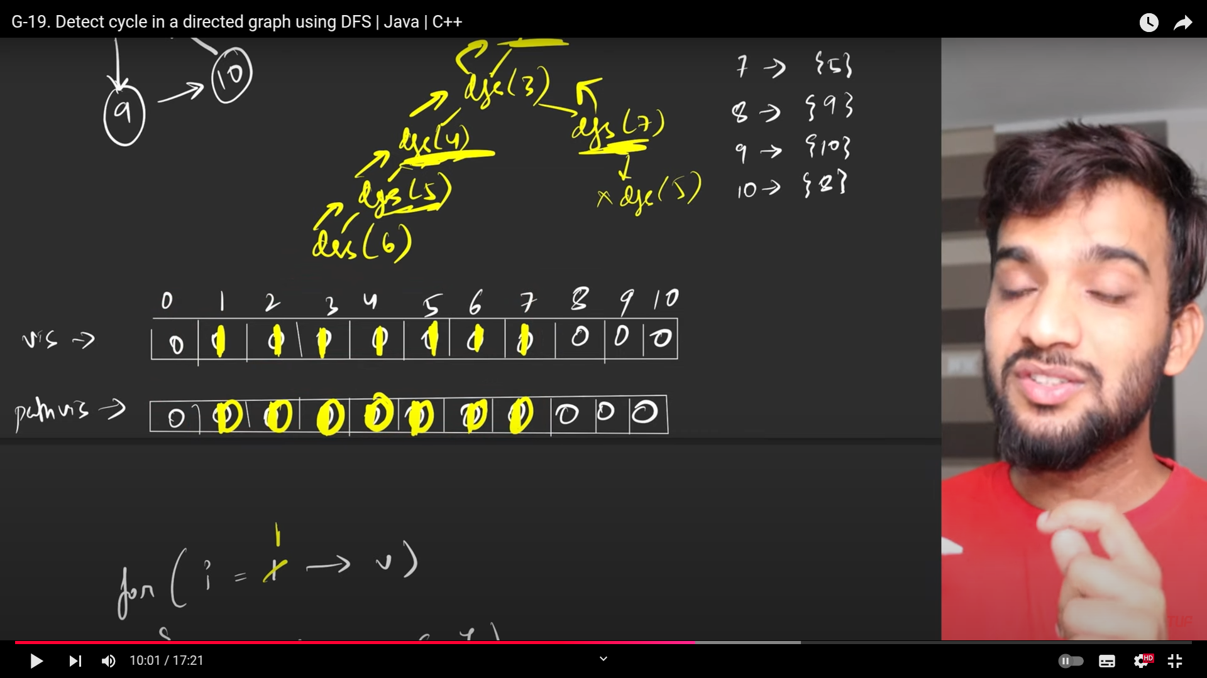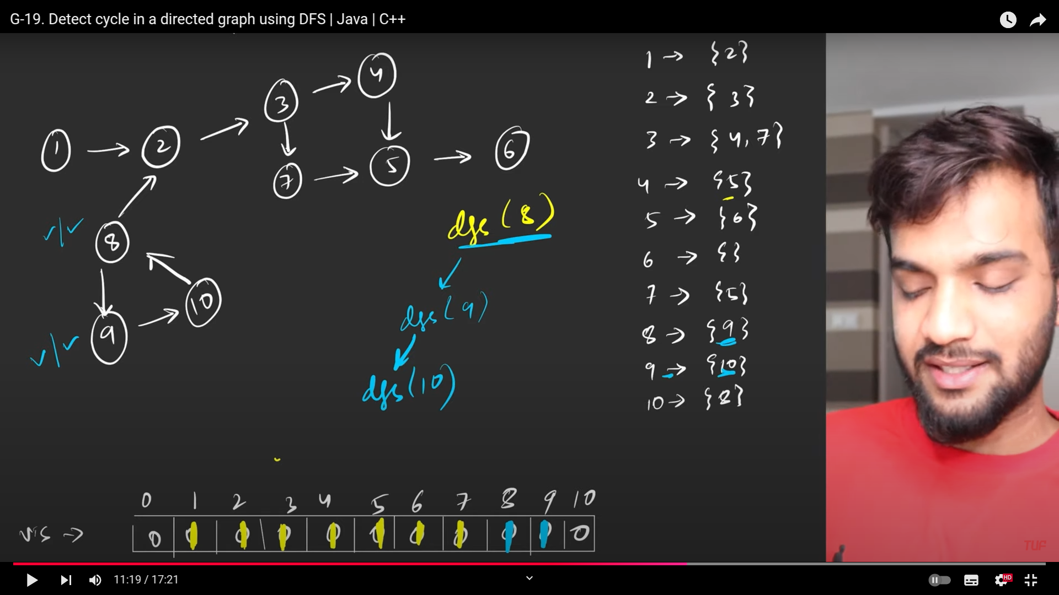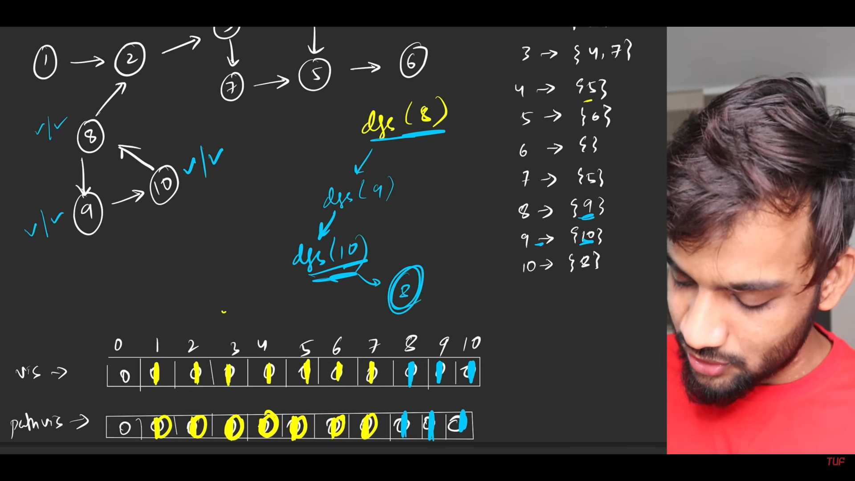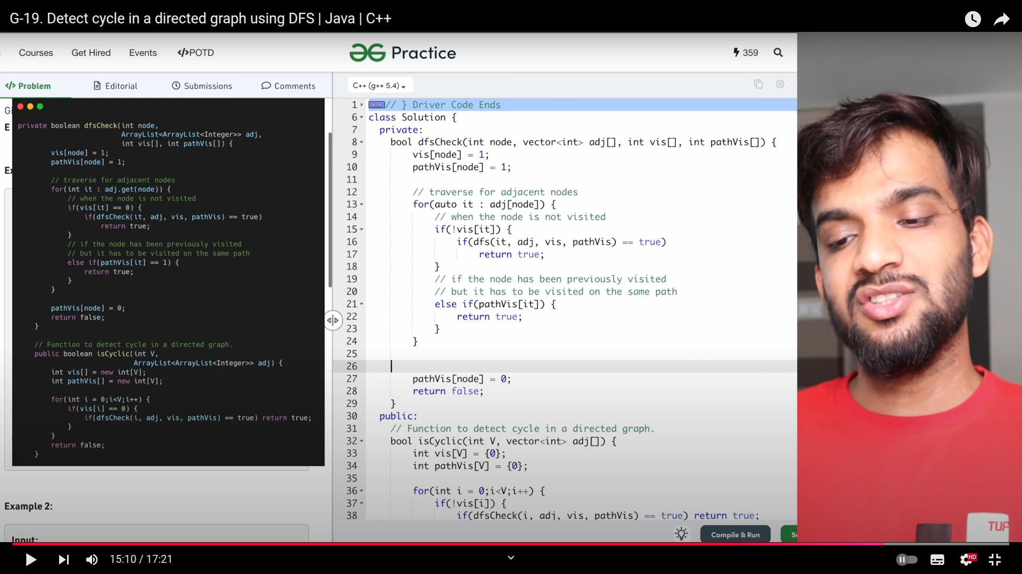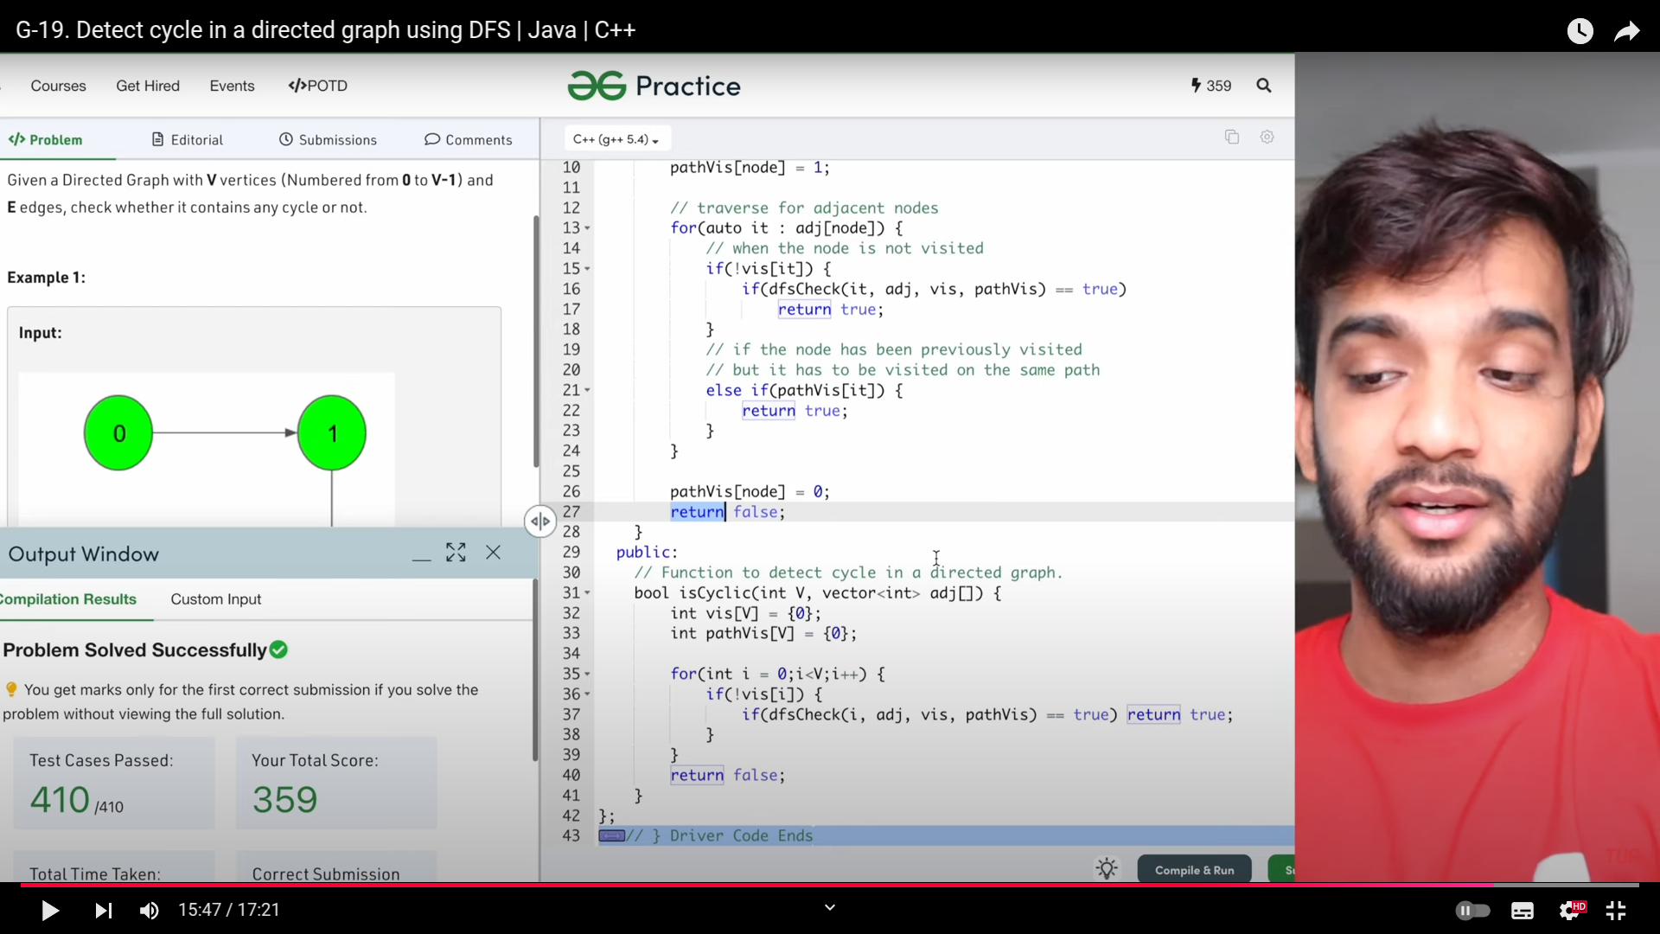

1. Even this can be donw using single array. Hint: same path then 2, else vsited then consider for 1, so while returning from the dfs, make it as 1, but when visted make it as 2(same path).

**Bipartite Graph**

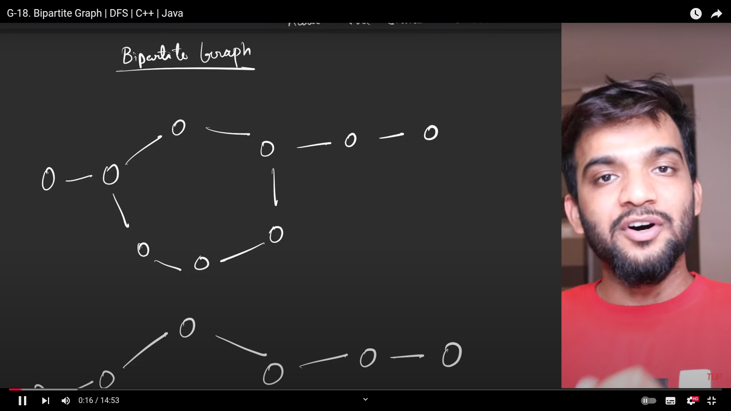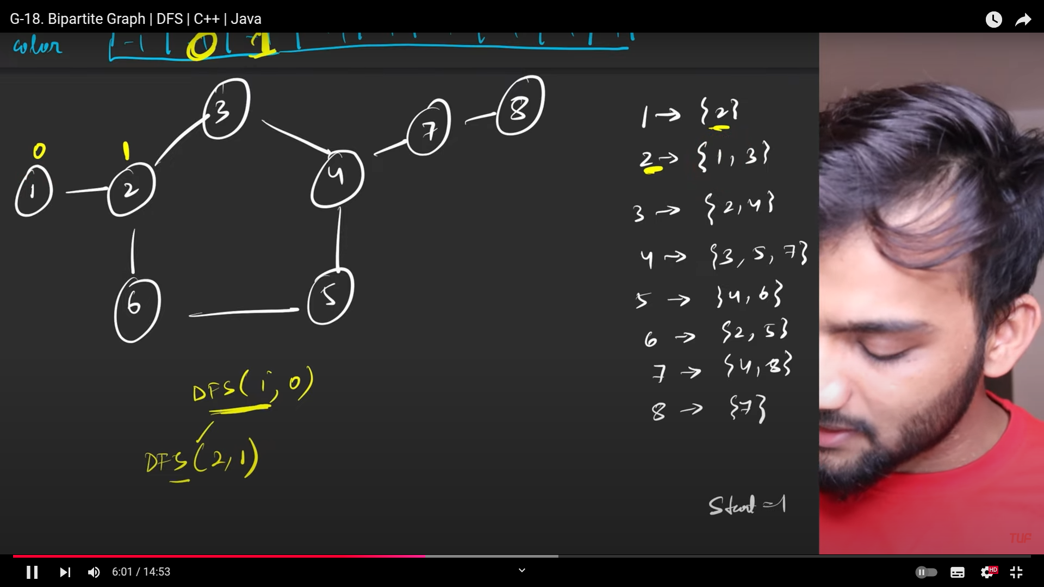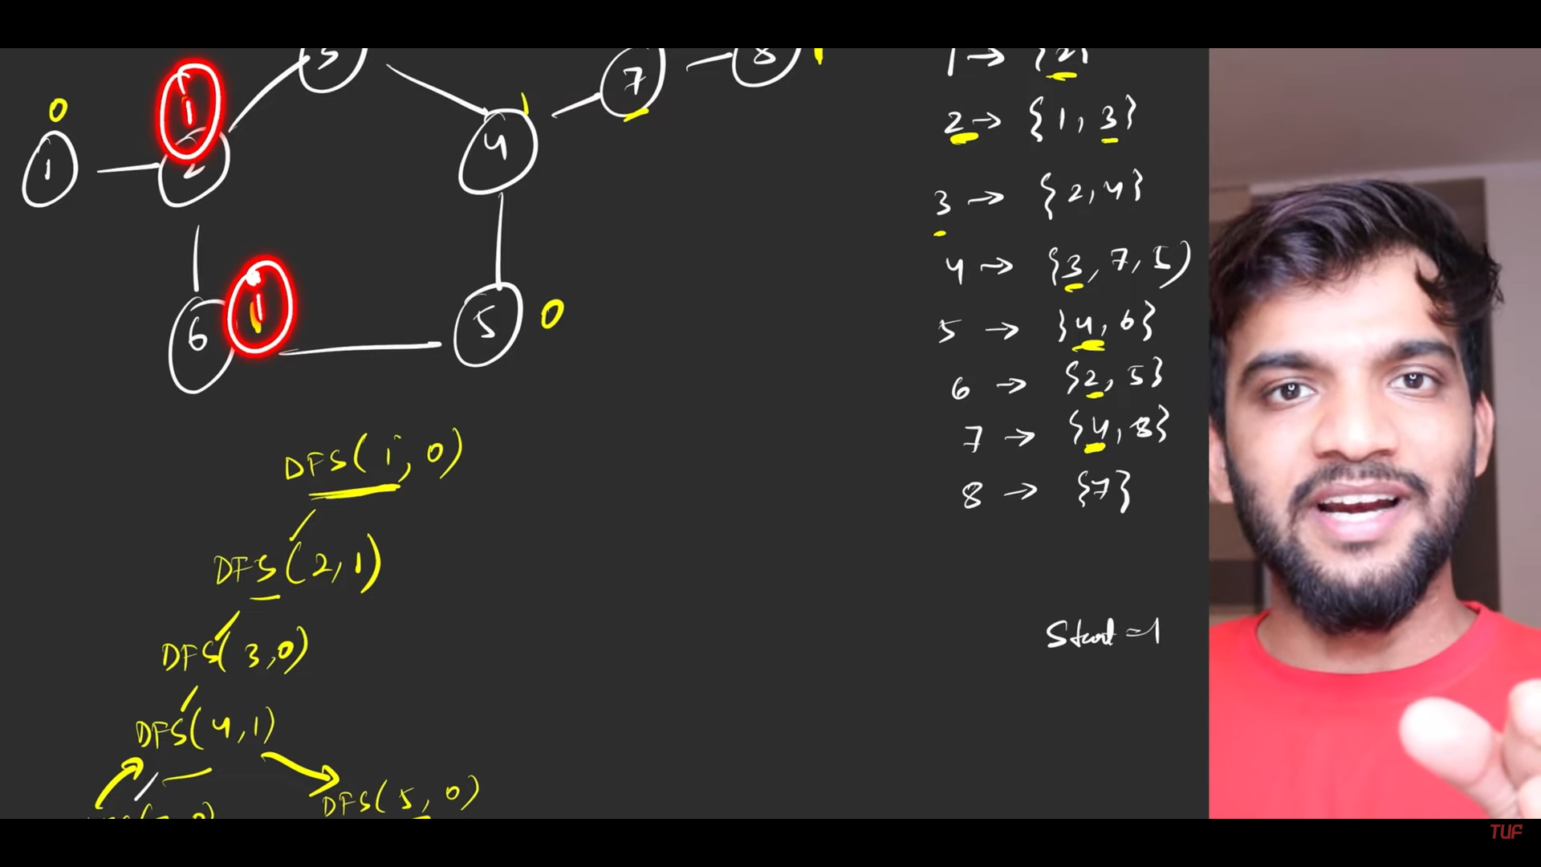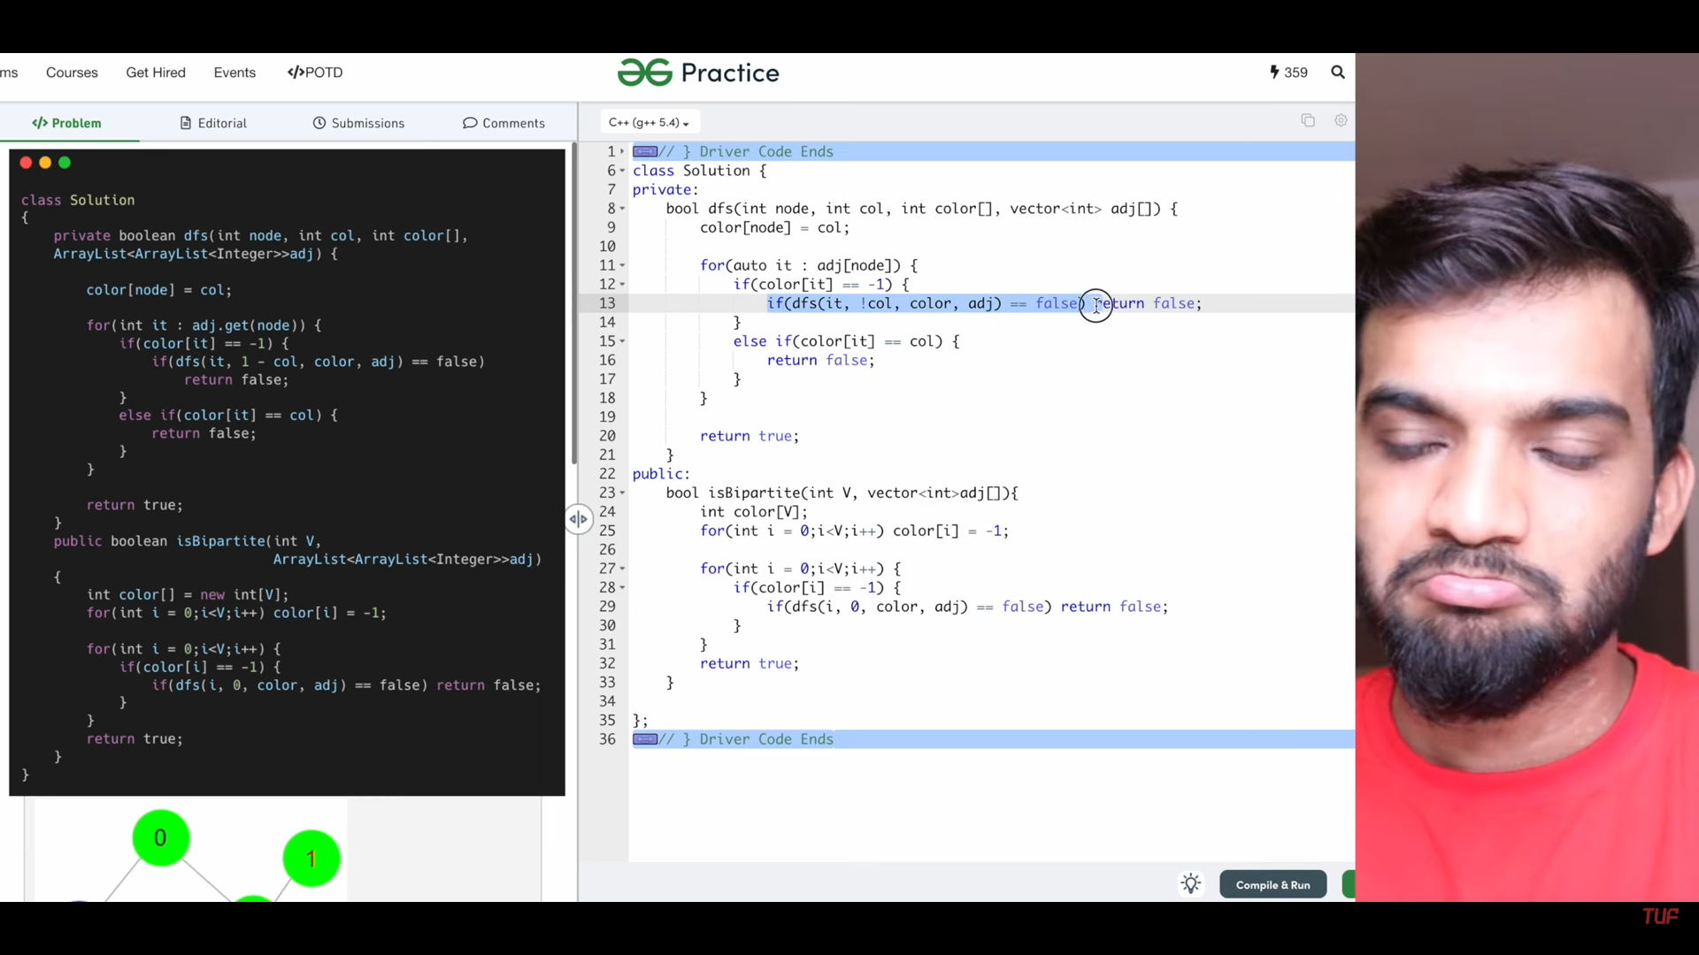

1. In bipartite graphs, we traverse the graphs with the dfs, by passing the color twhile traversing.
   1. In next sequence If I’m unable to allot the differnt color to the unvisited node then we are done, so we check for this and send false to the rest of the code .
   2. If we are able to traerse the whole nodes , then we are able to make teh color, then need to rreturn true.

**Word Ladder**

Transition to the letters in the sequence**.**

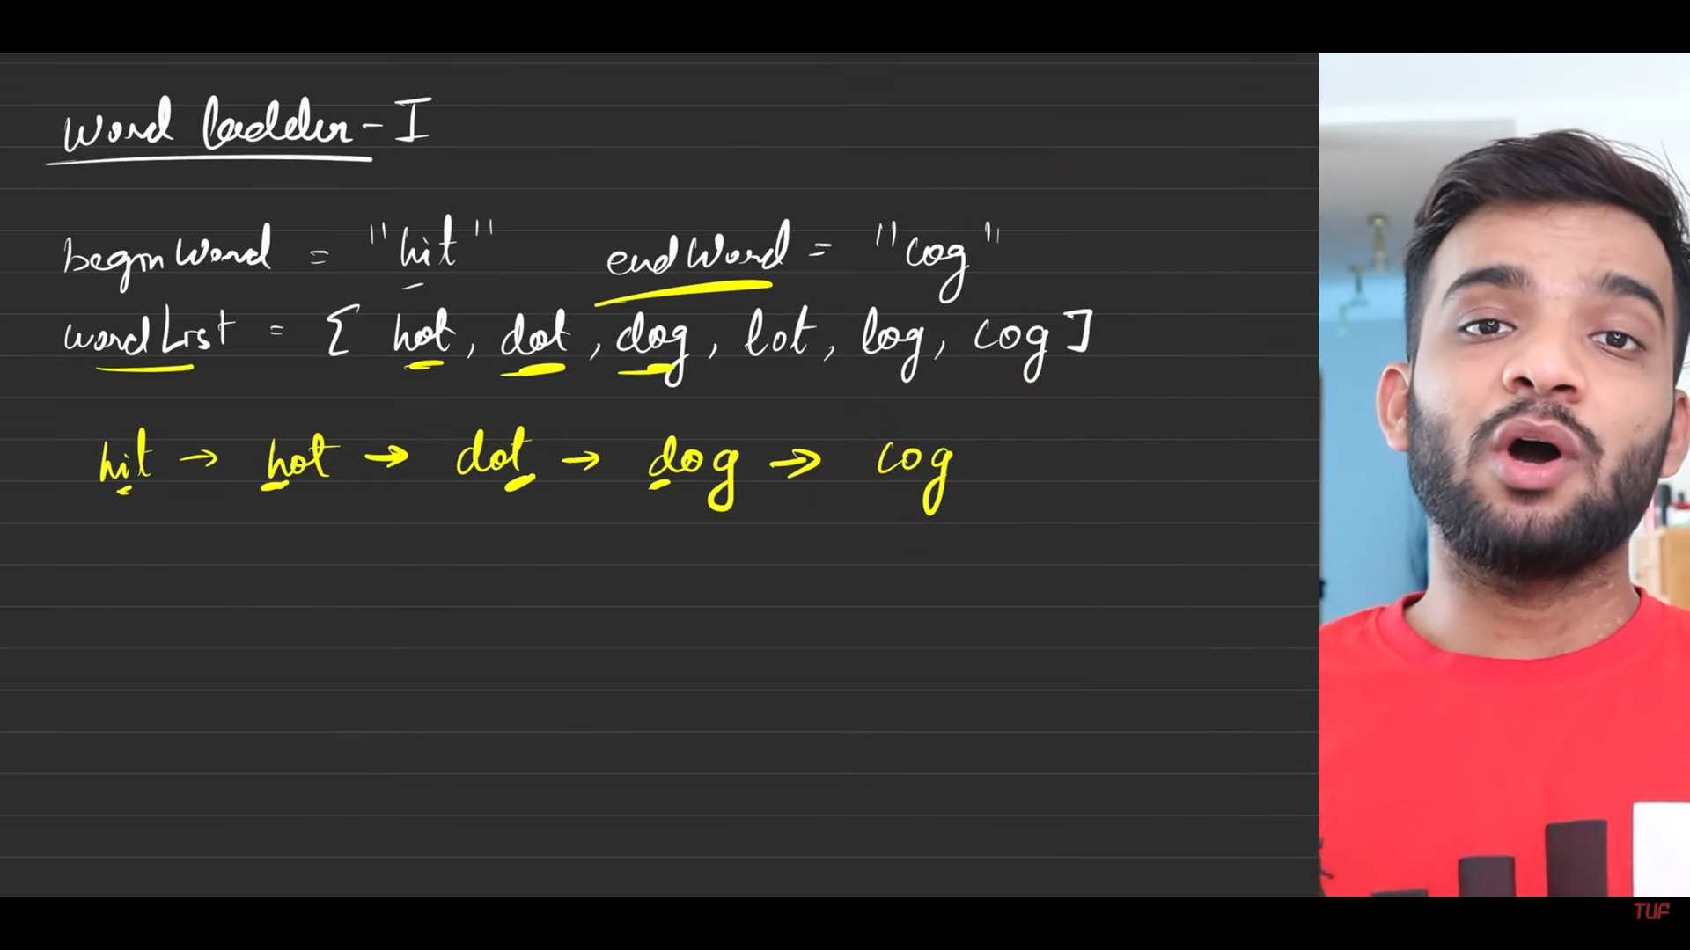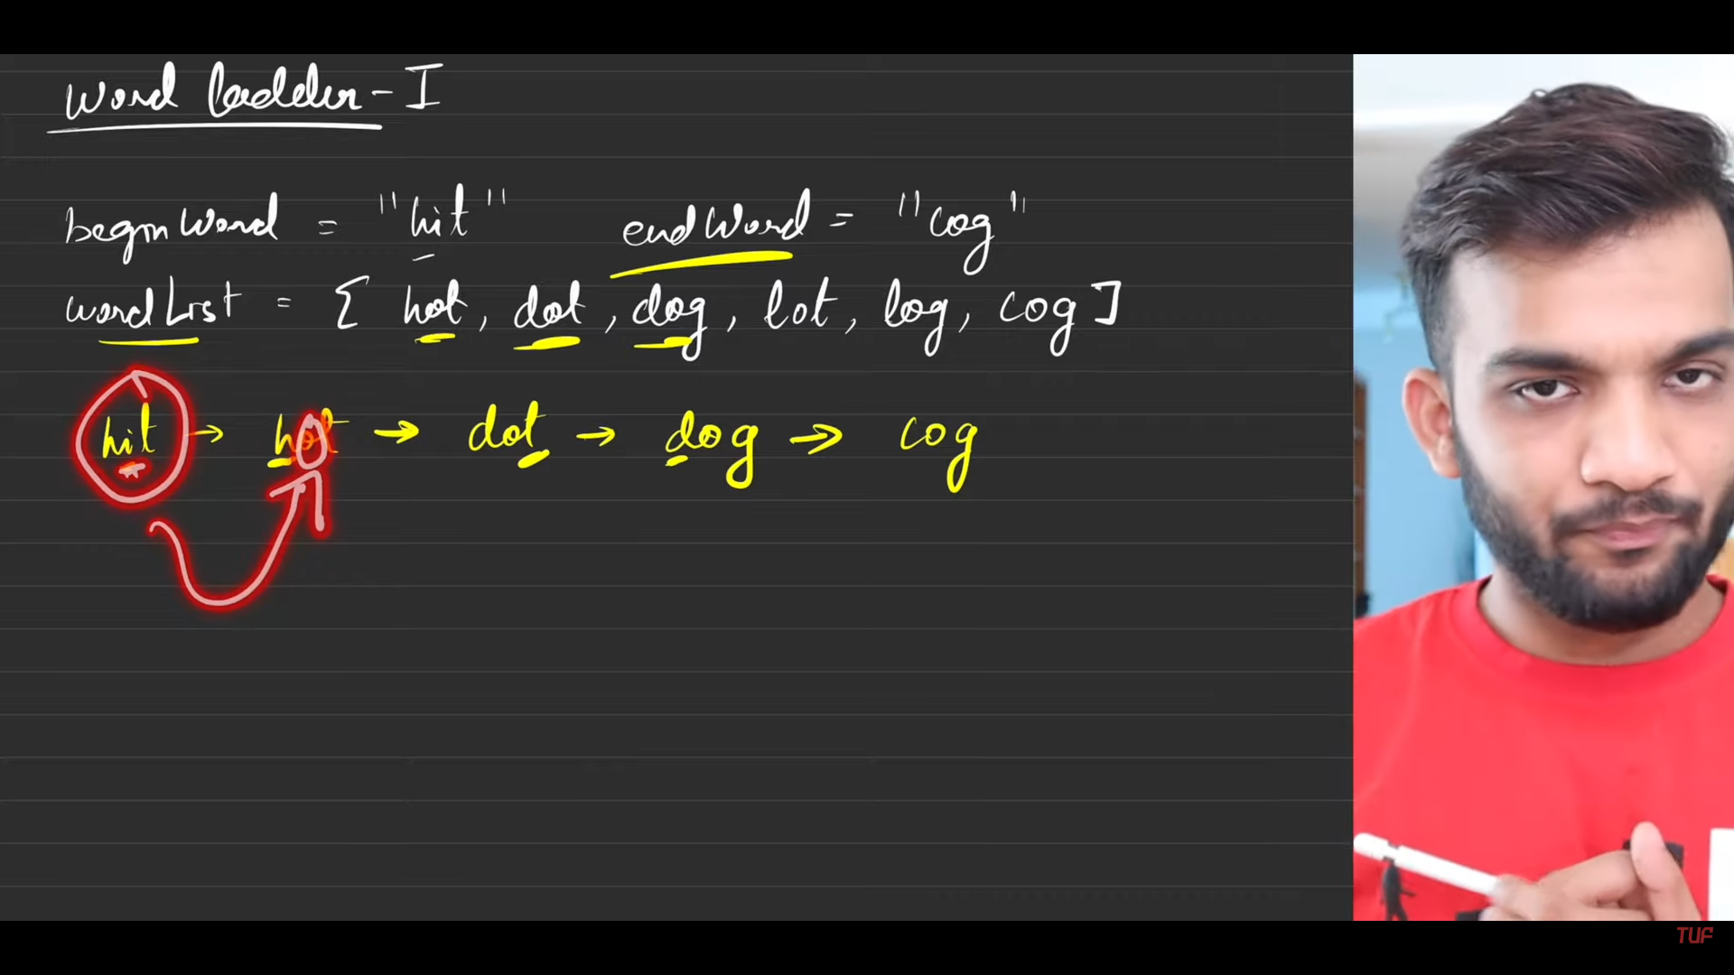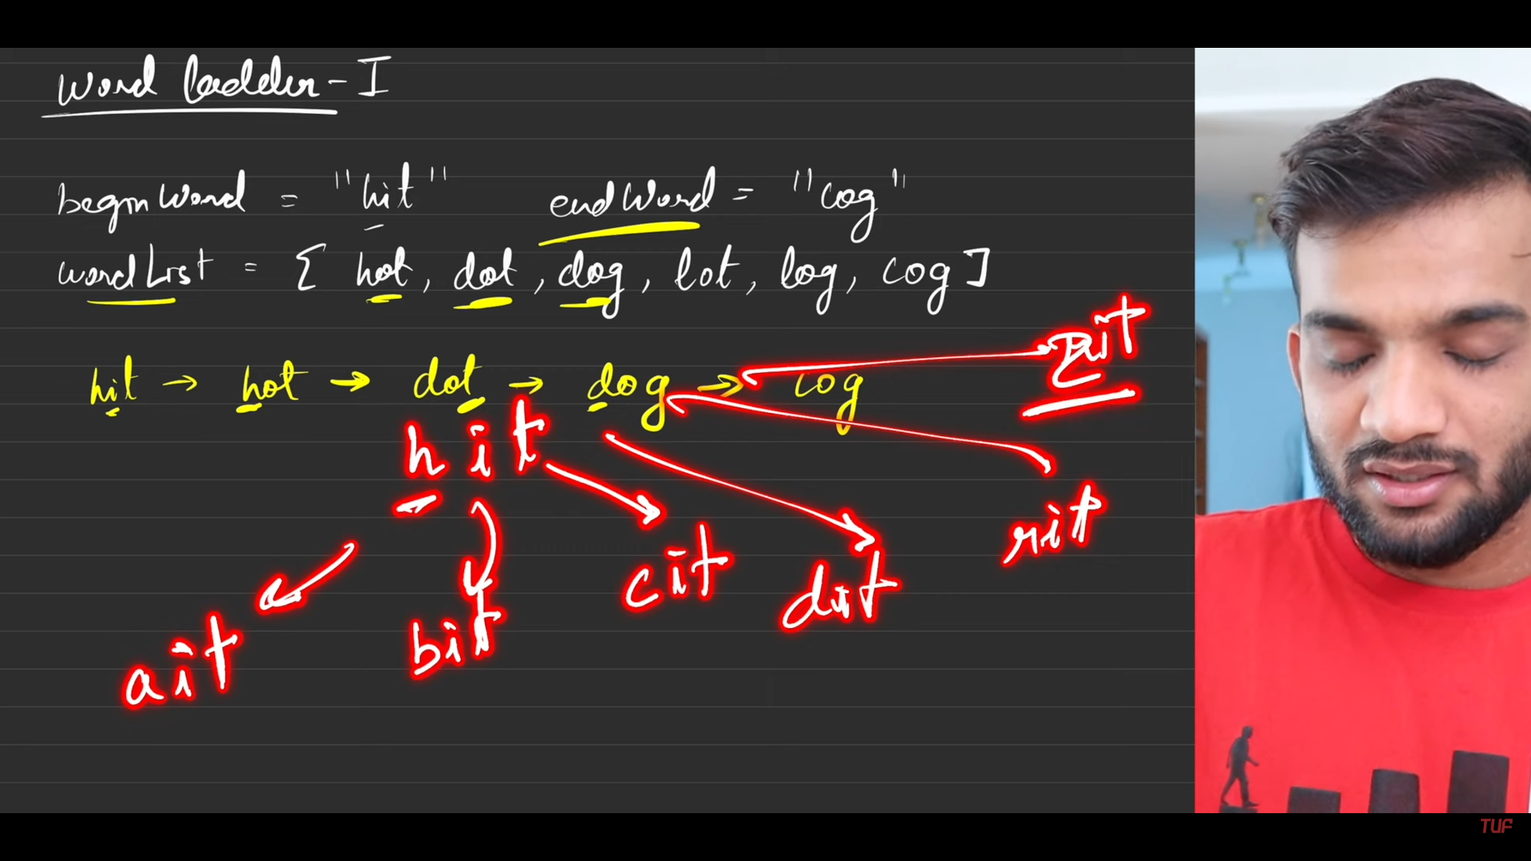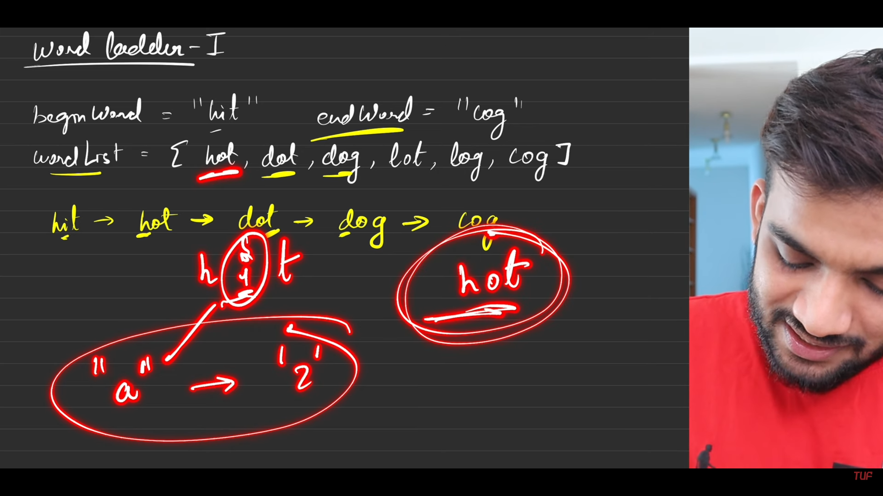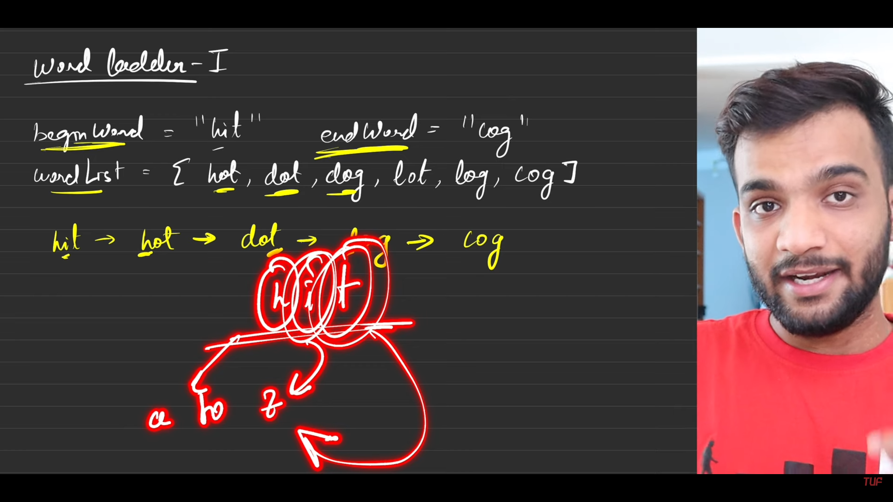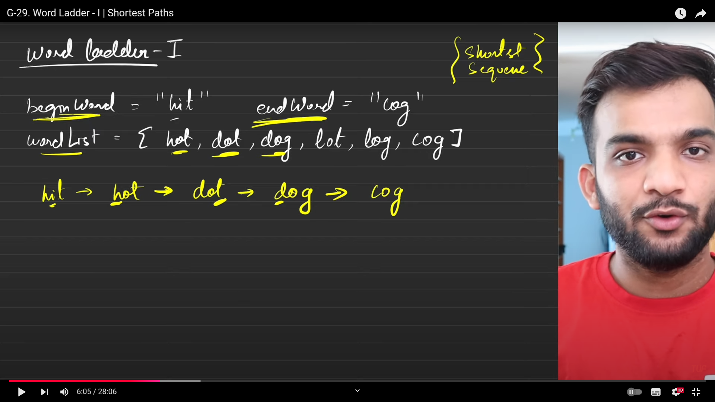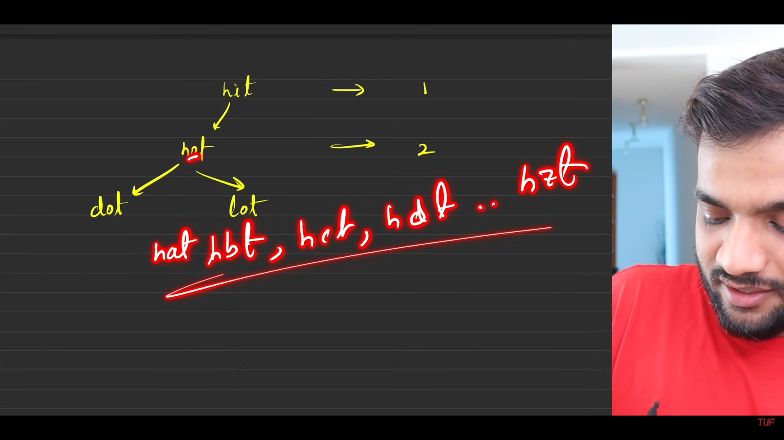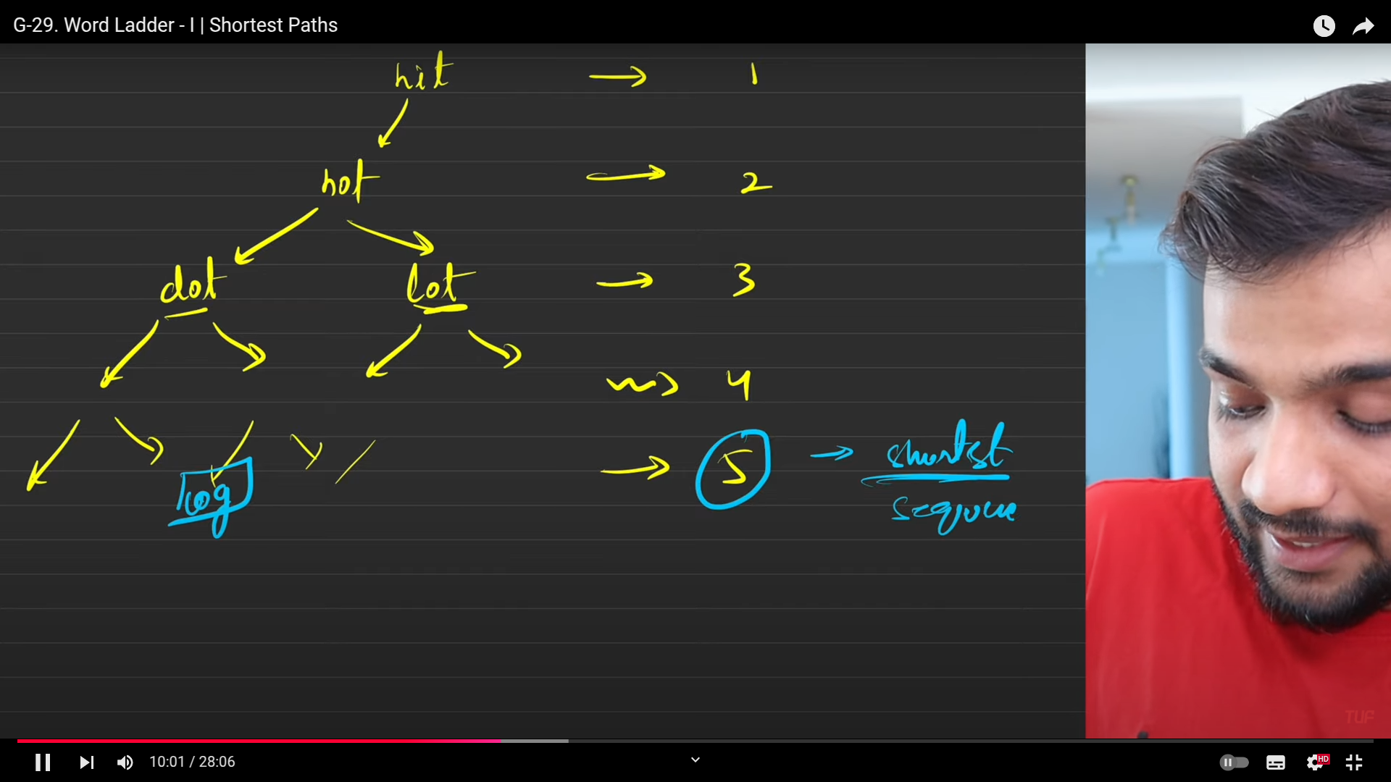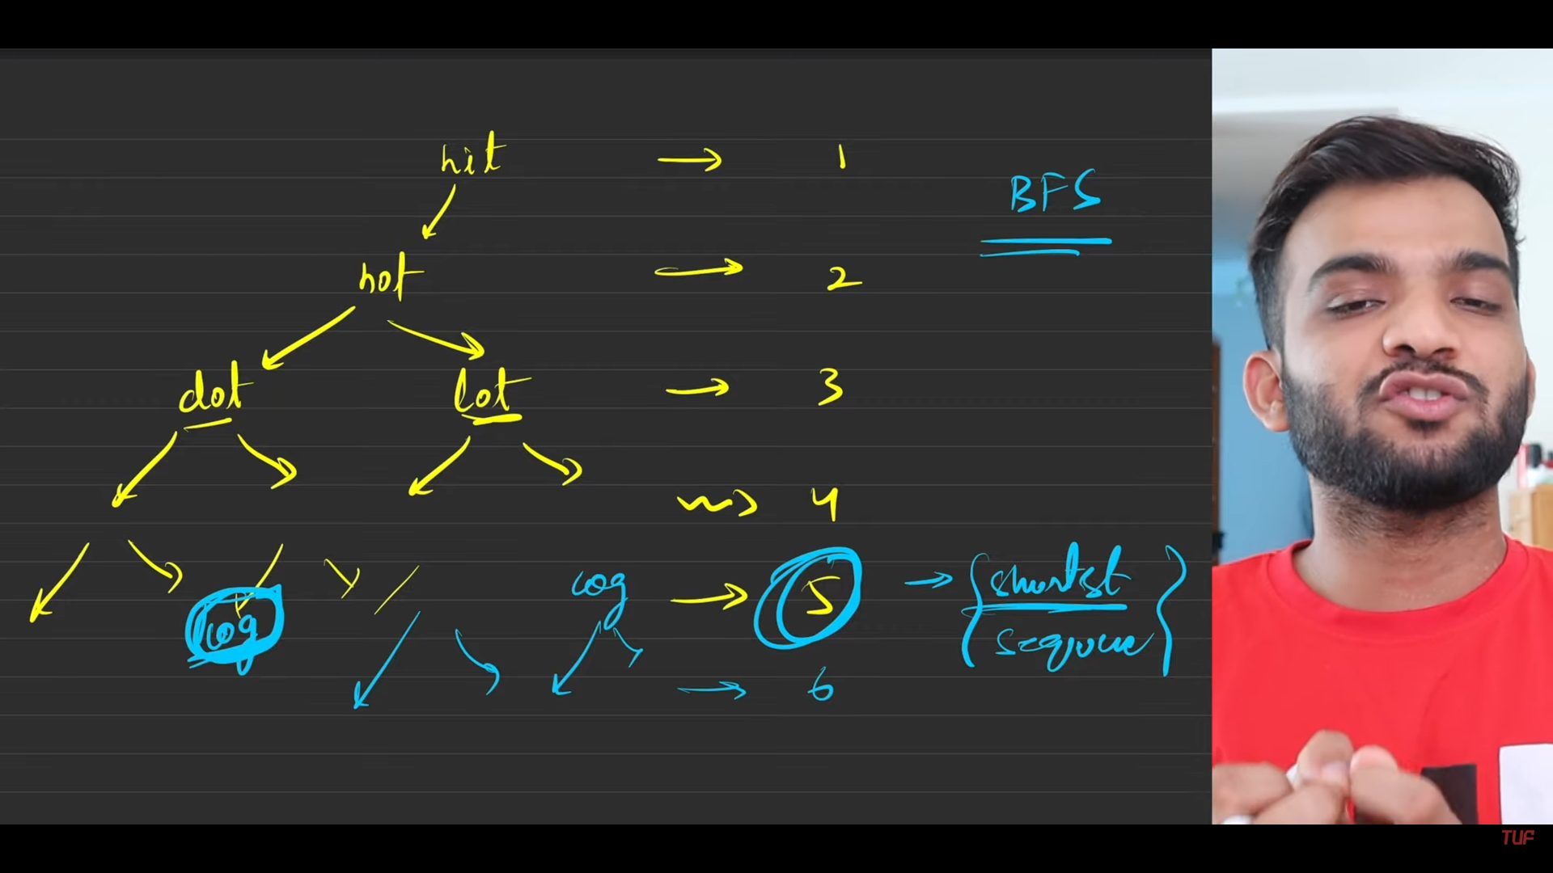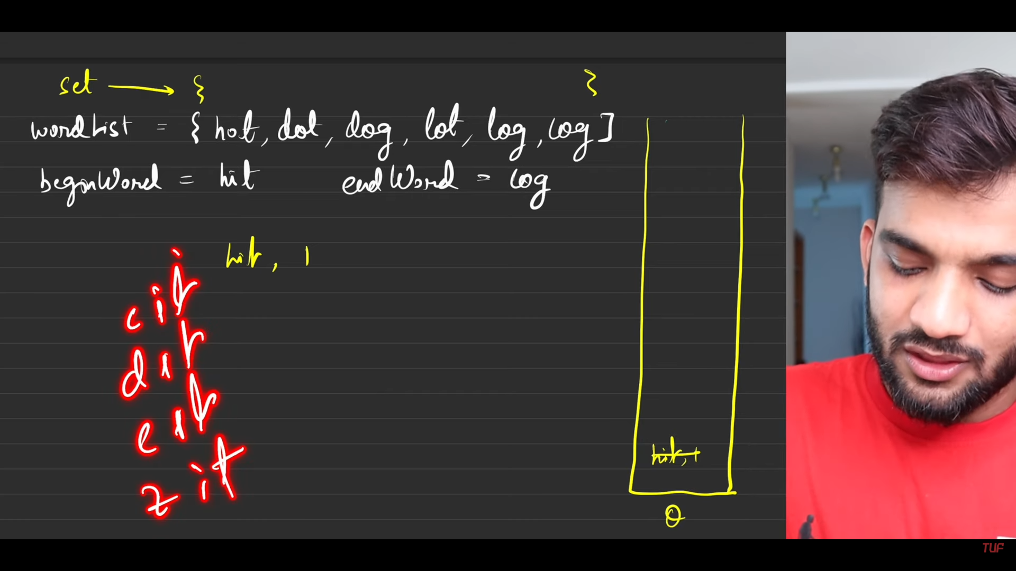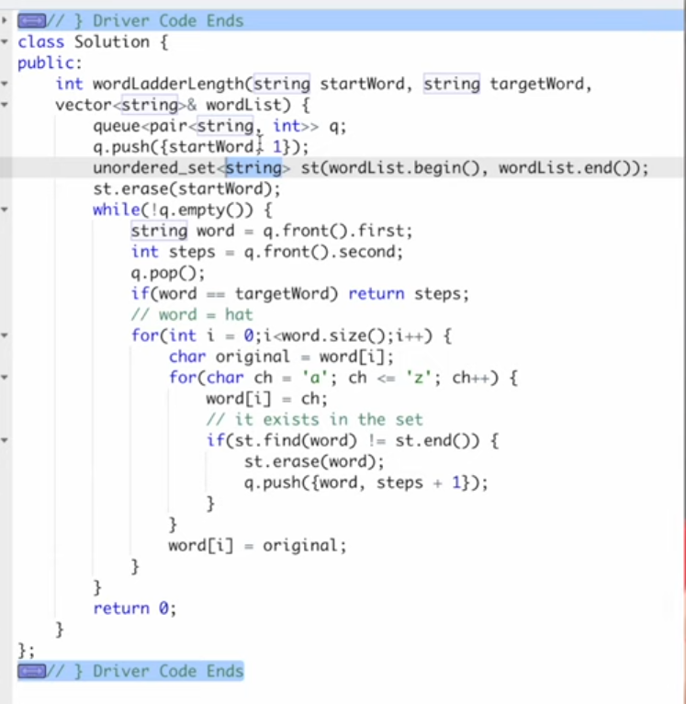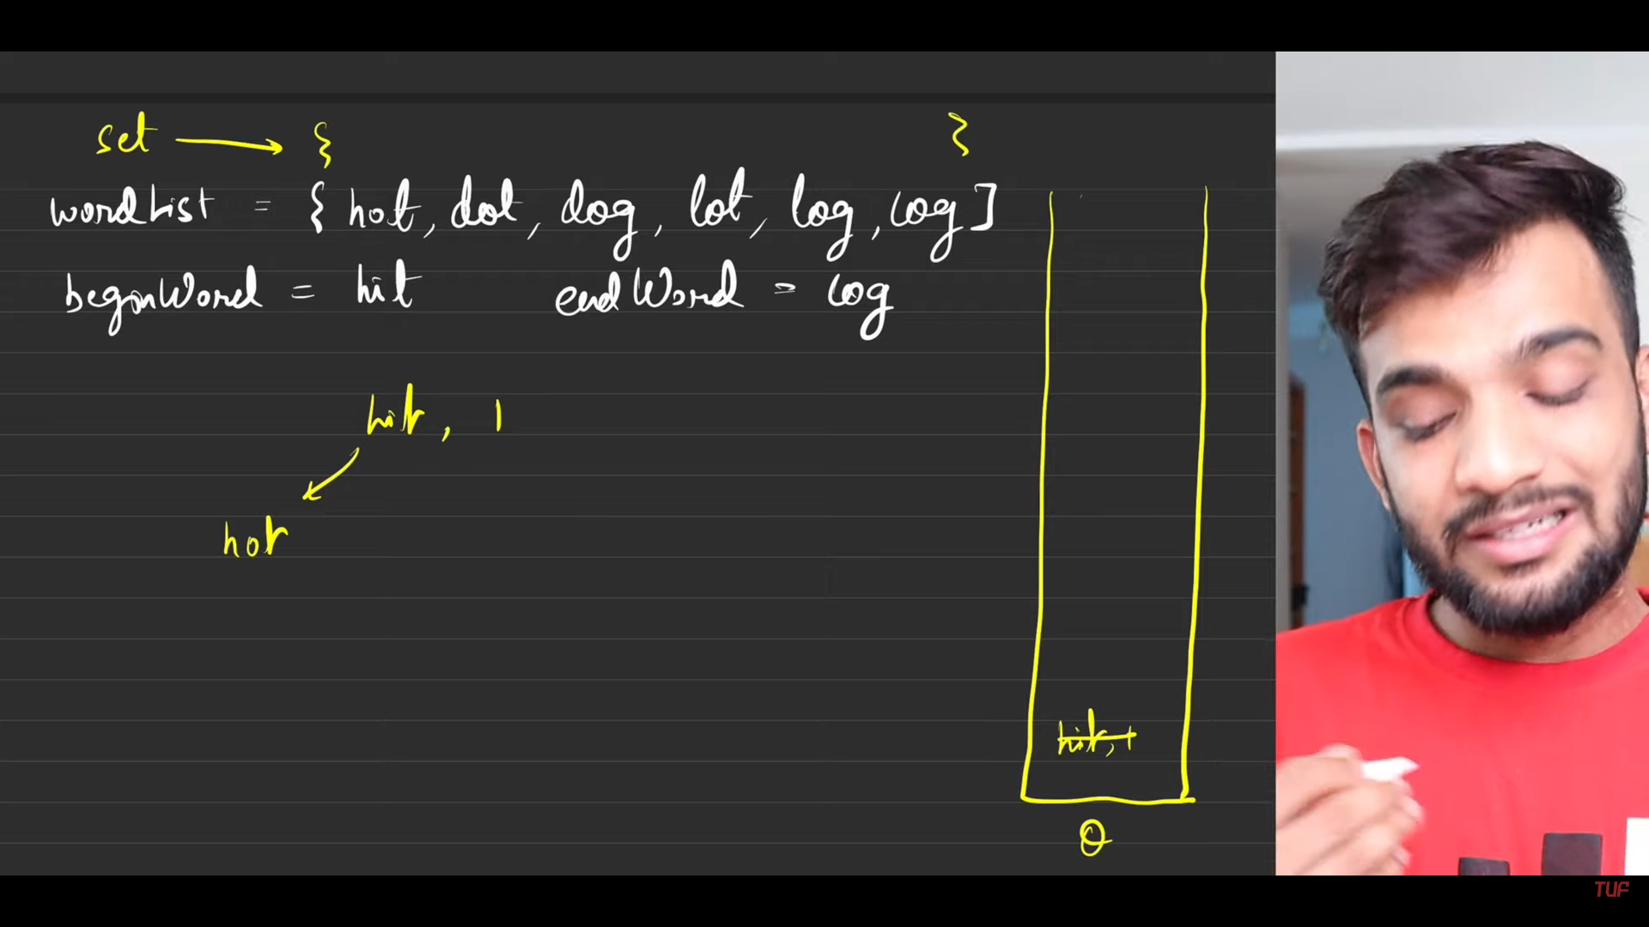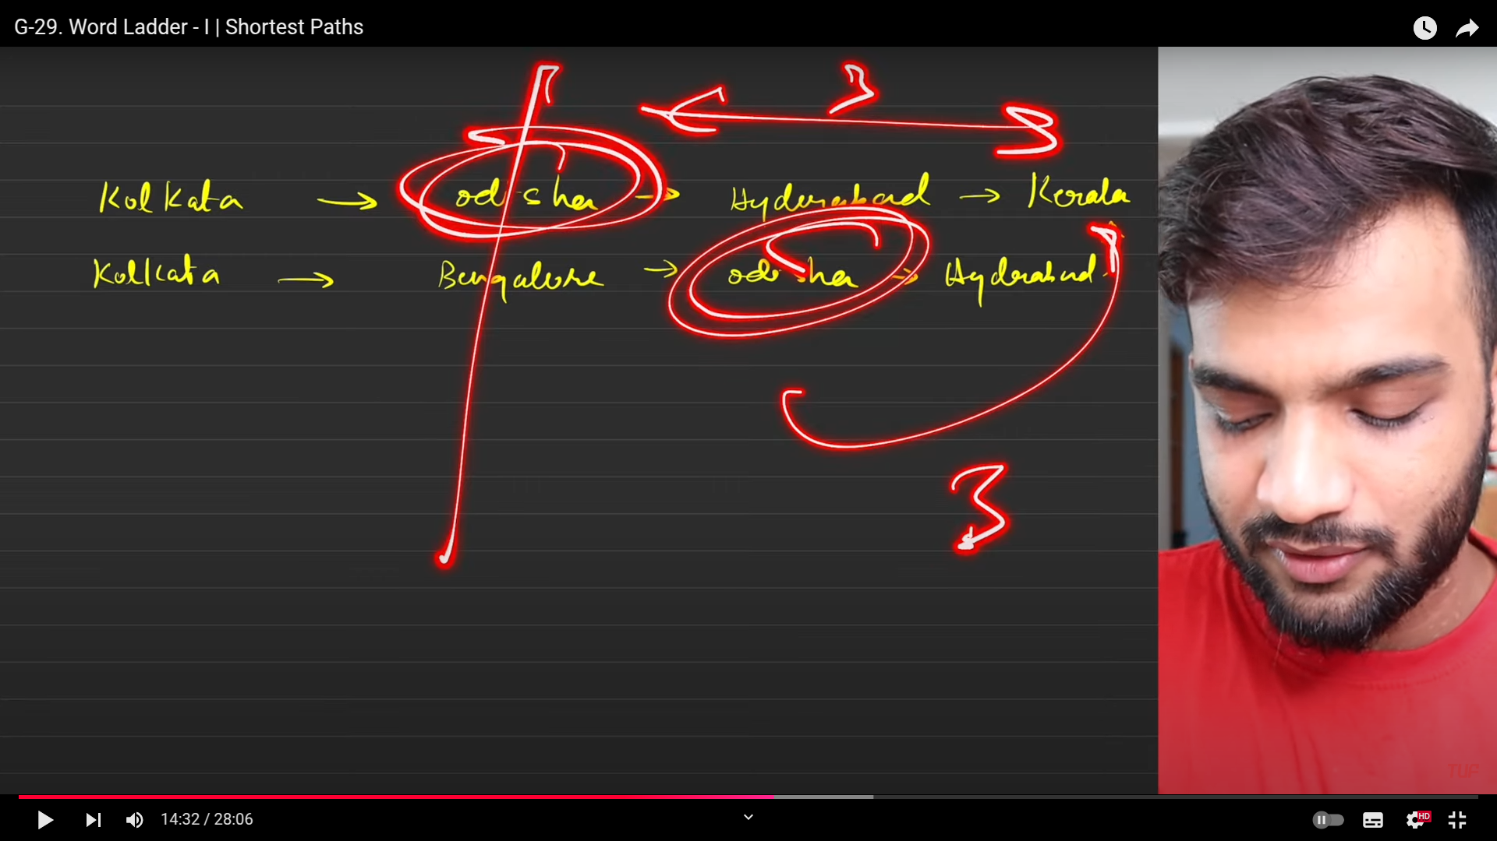

1. Triick usedd here, if once the shortest path is seen at ny point, why do I used it in the future.
2. Everytime when we were traversing in previous methods, we used to track by using the visited vertex array. But in this:
   1. Use set inorder to reduce the search time(linear if used).
   2. delete the word found from the set and keep on doing it till ending word is seen.

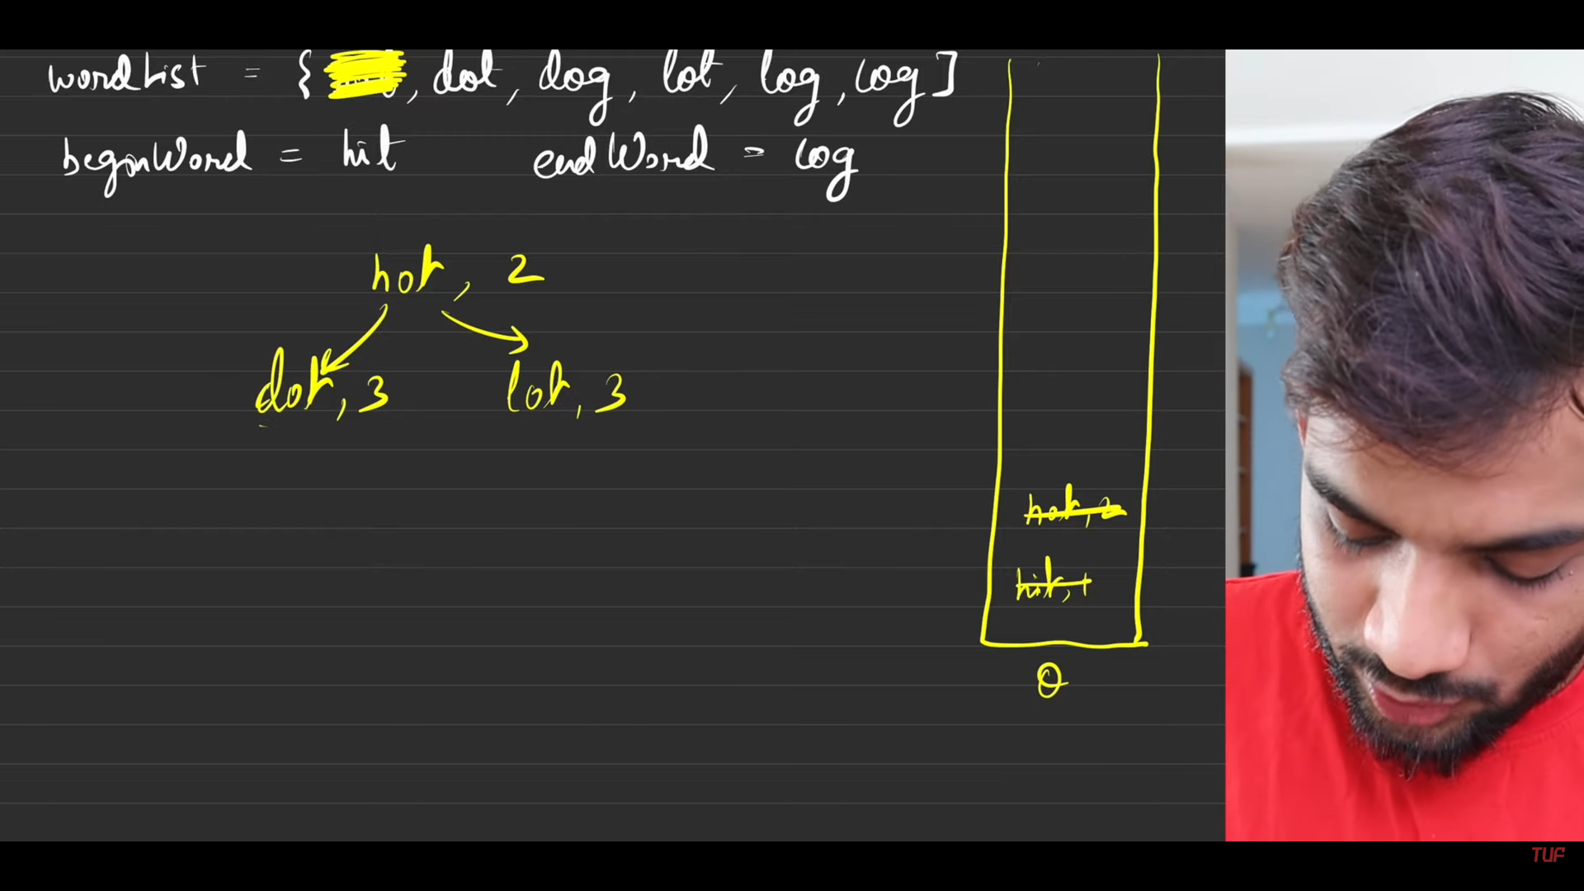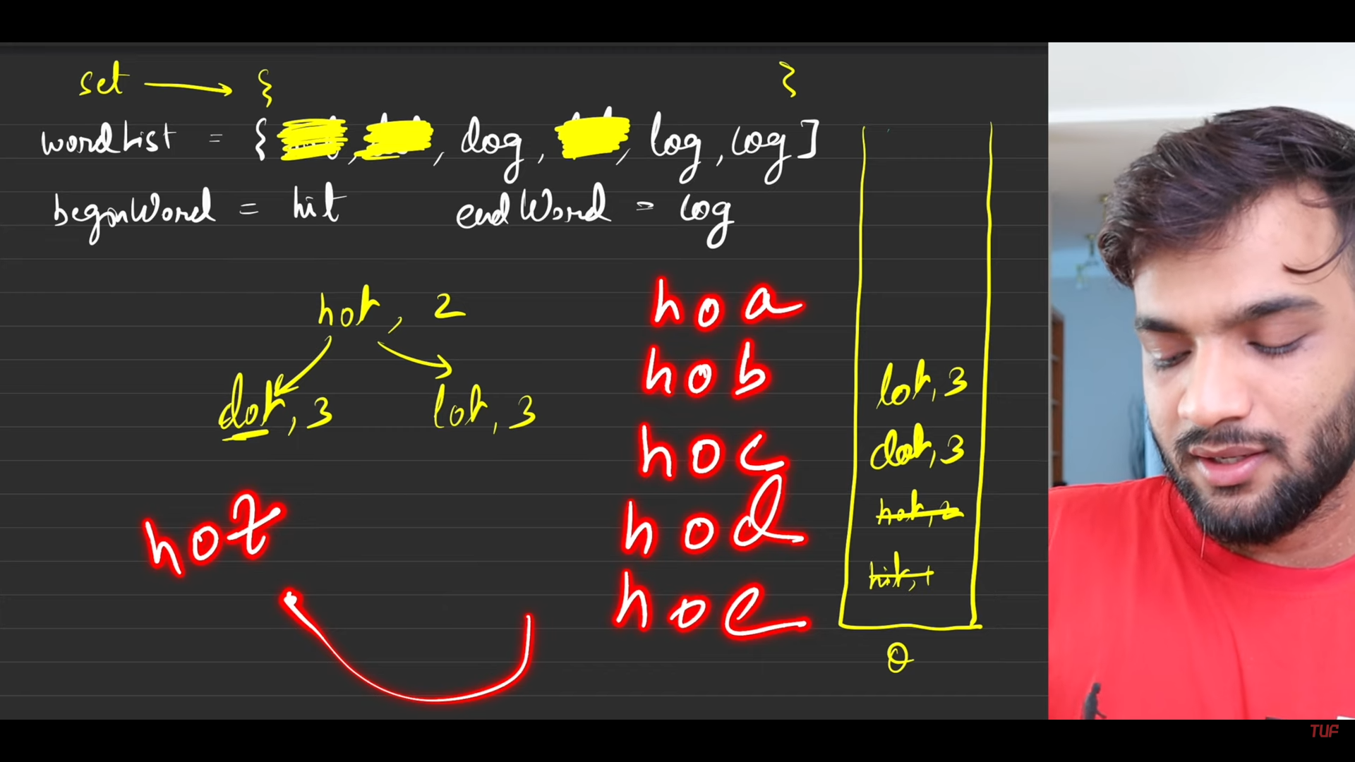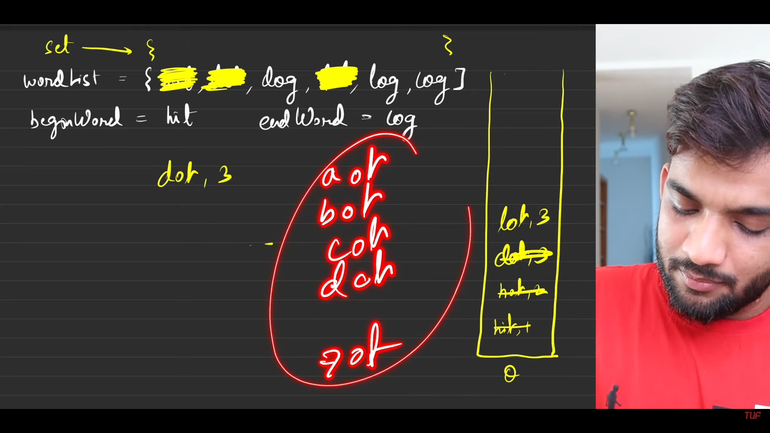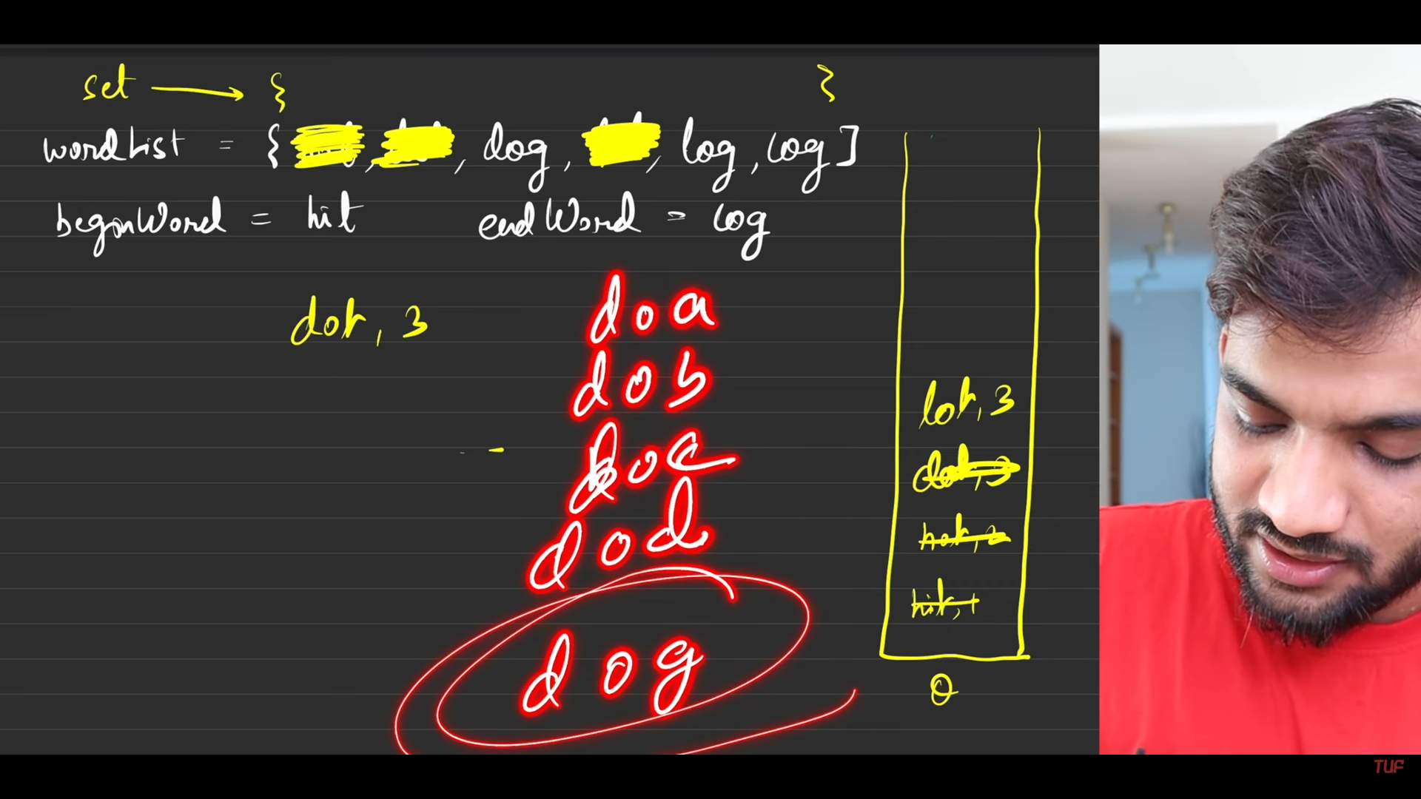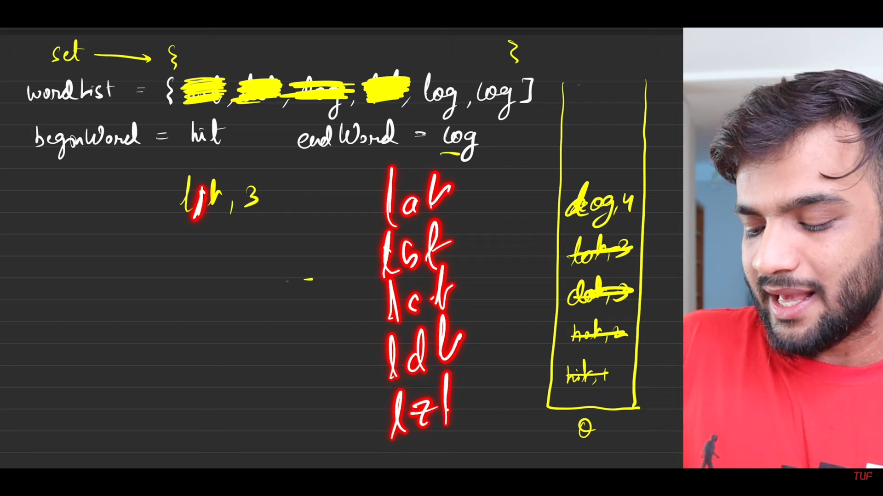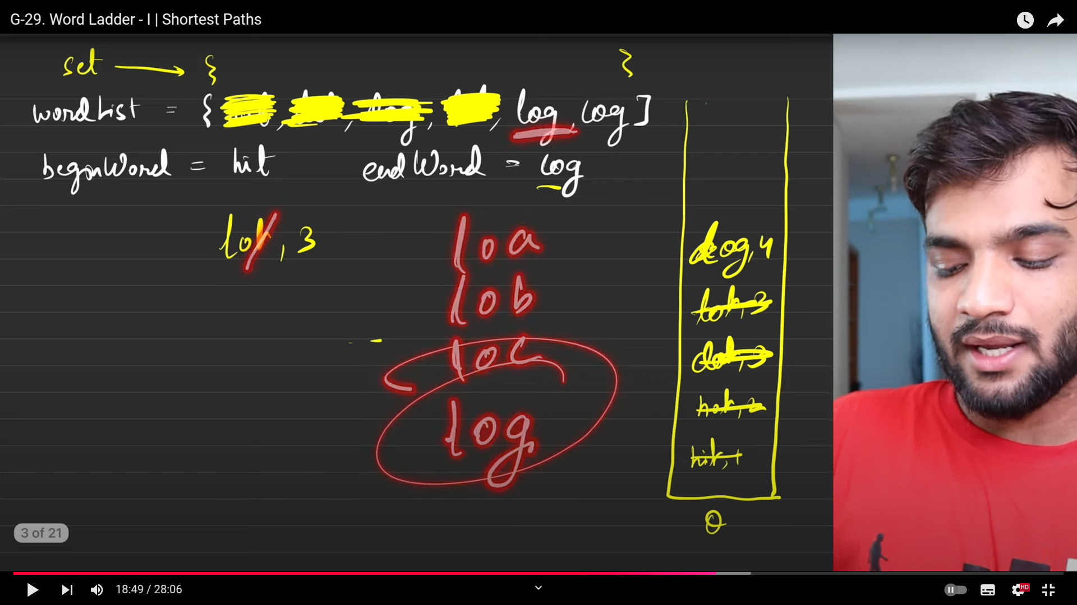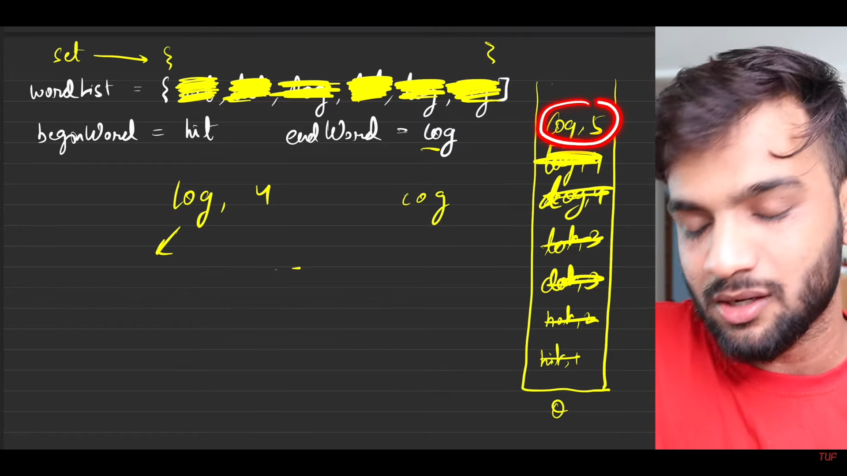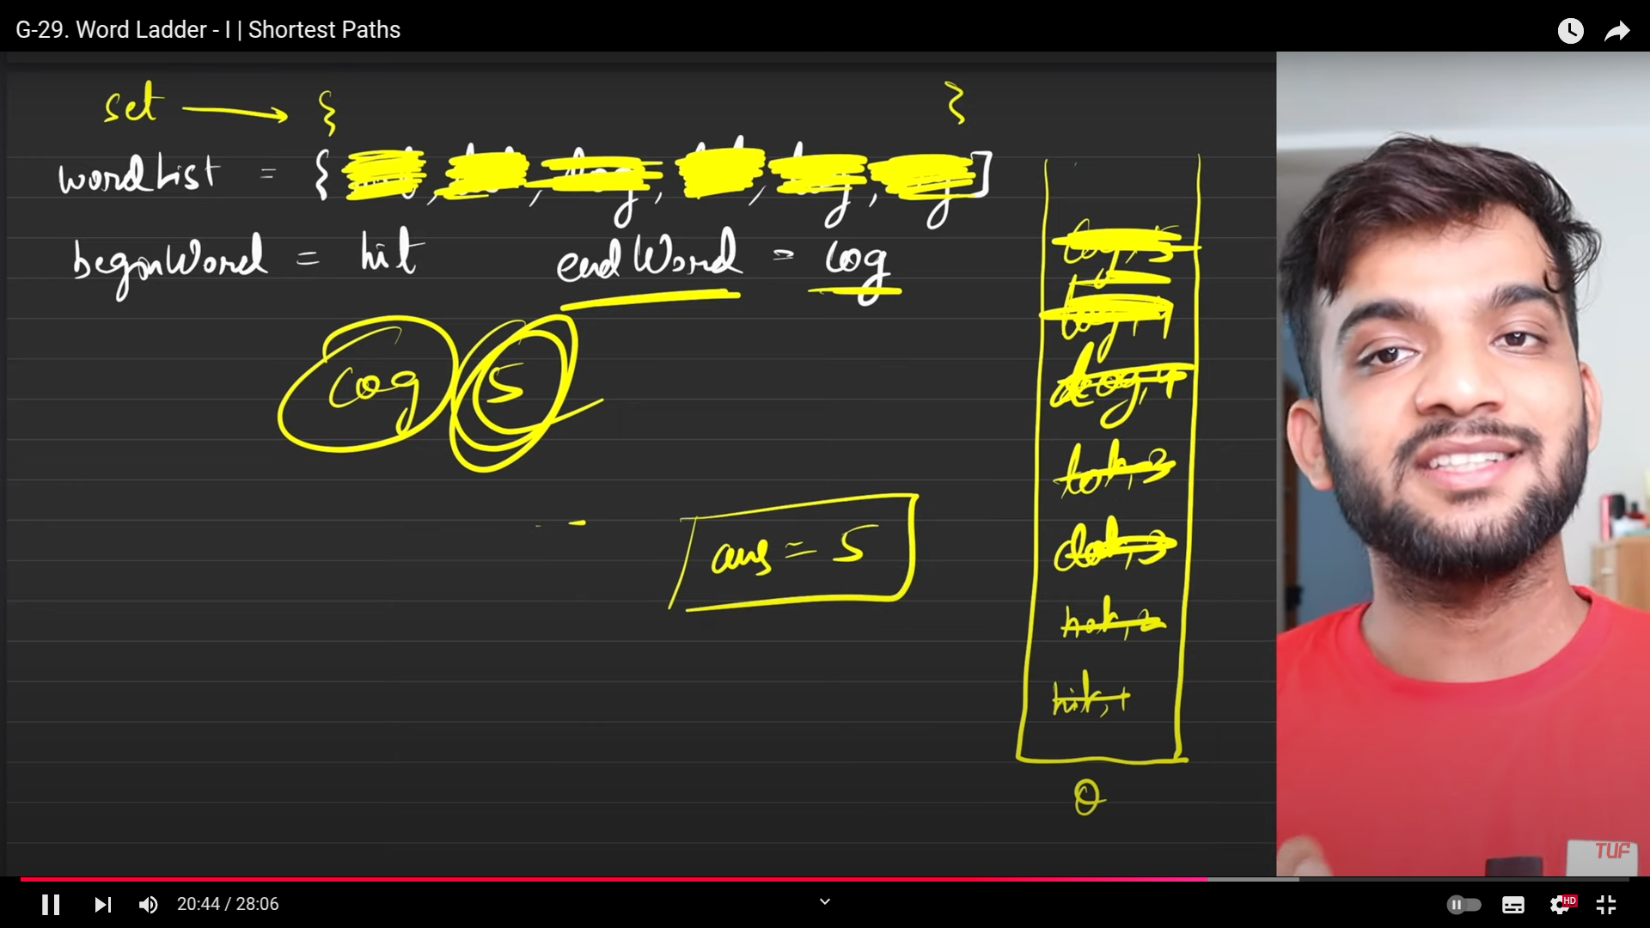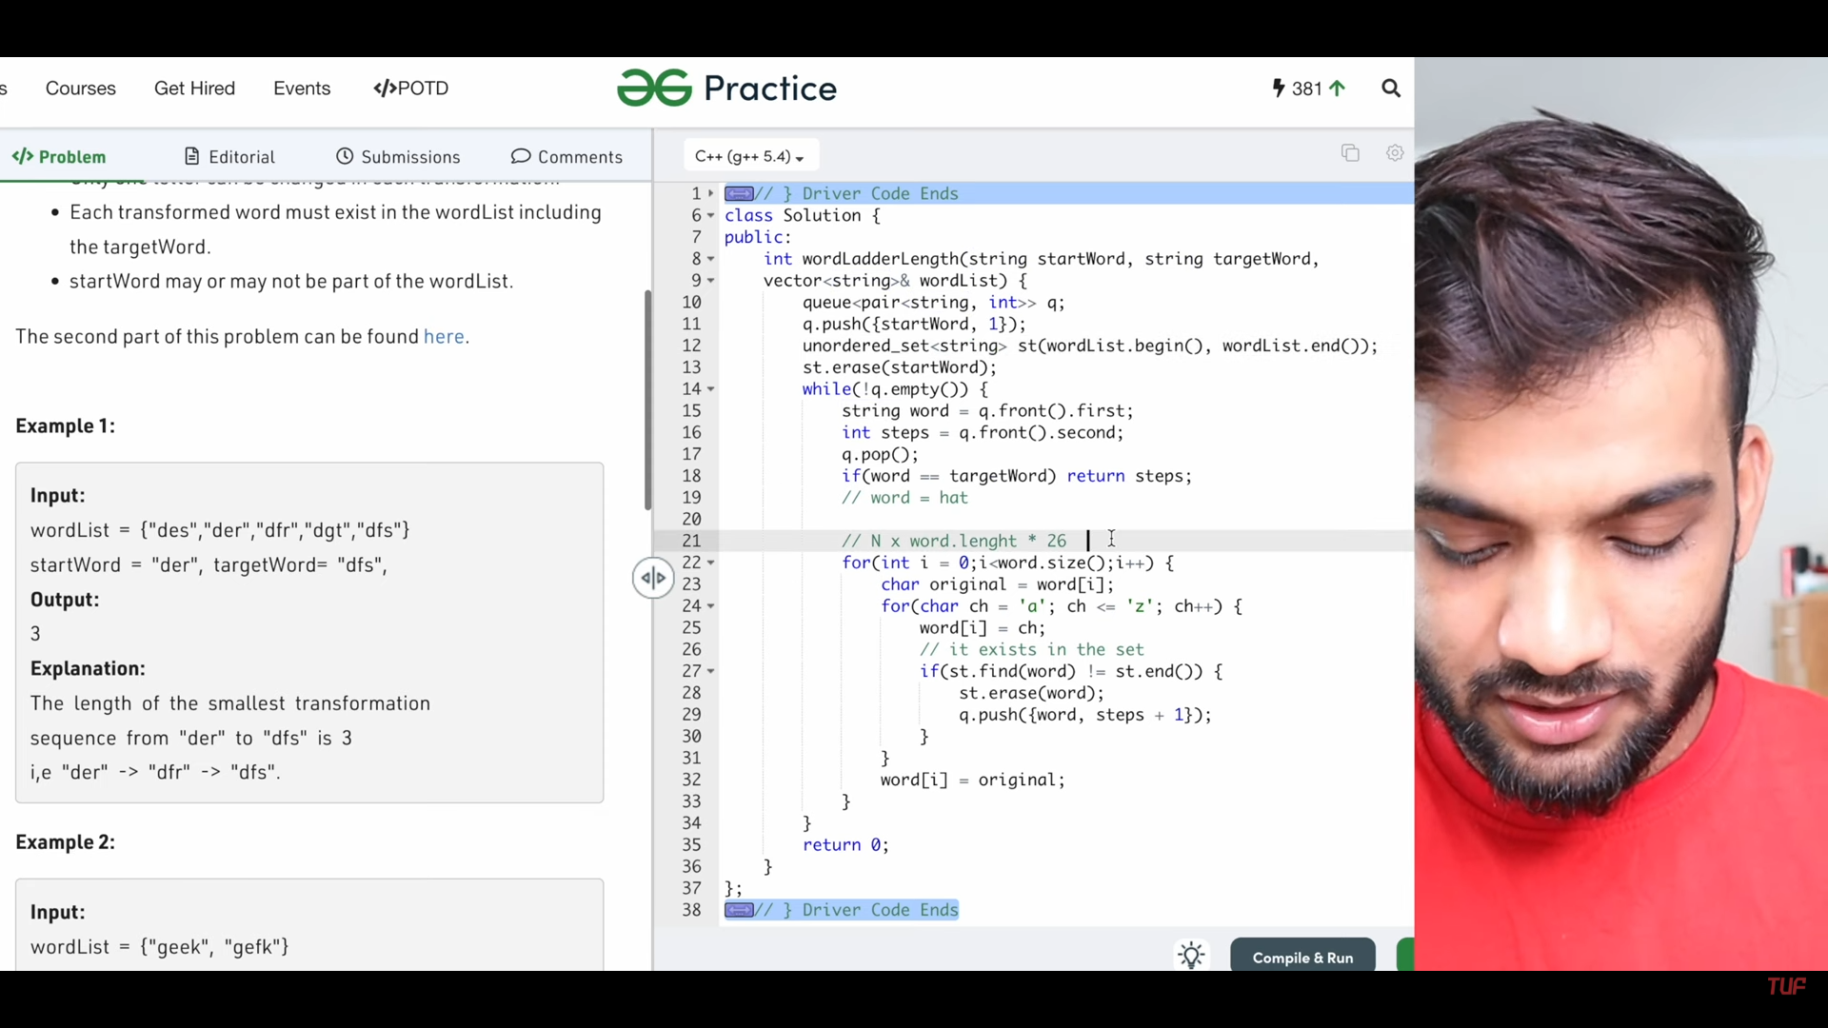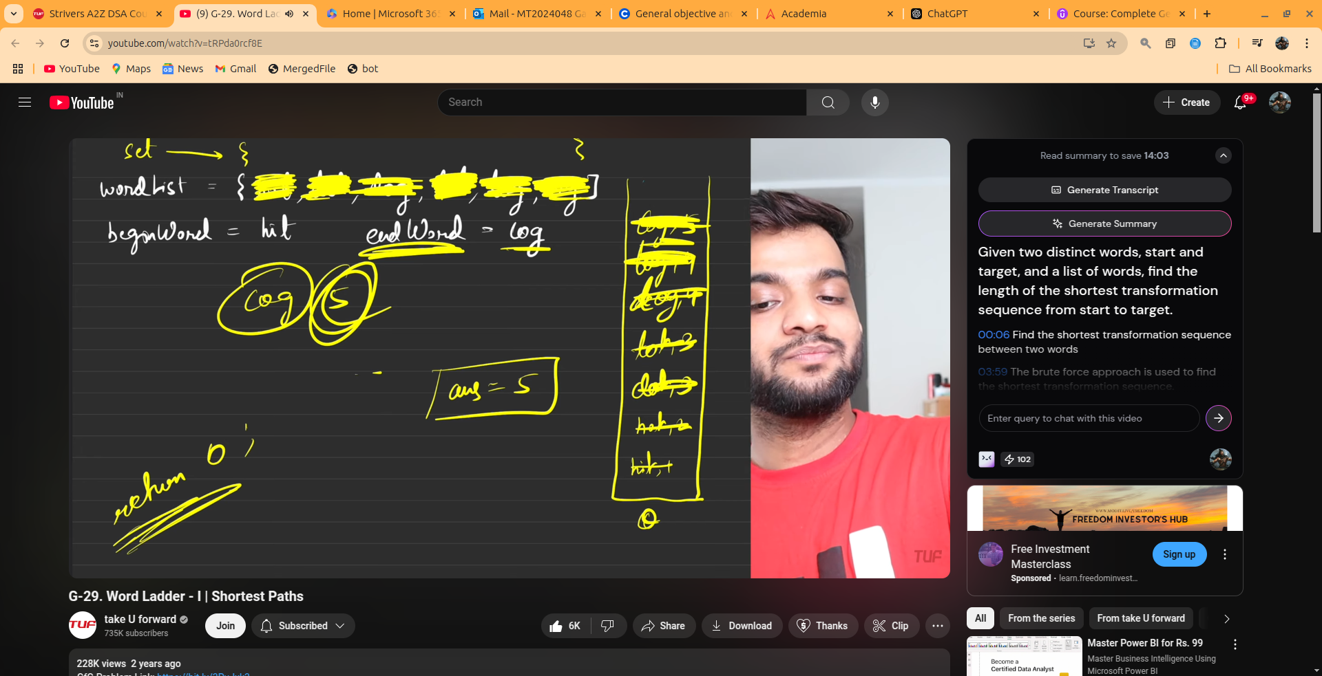

1. **WORD LADDER 2**

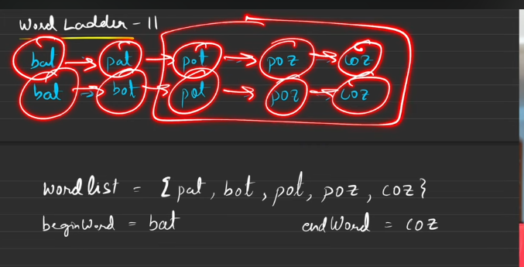

1. We need to return the above 2 by all chance.
2. We need to return tehsequnce .
3. Hence to the previous prolem we are going to change the way the queue is going to handle everything .

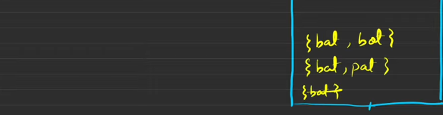



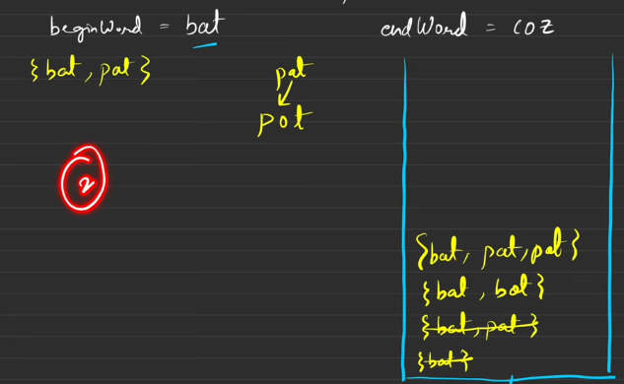



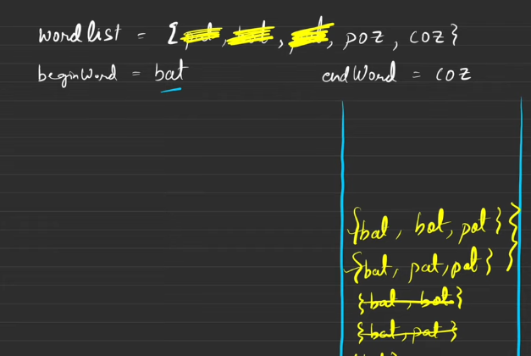



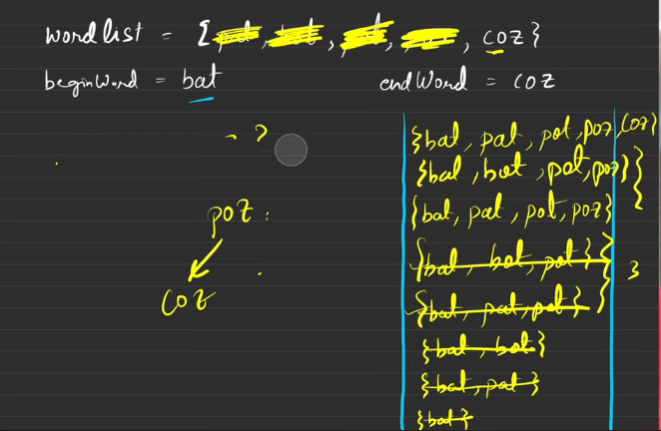



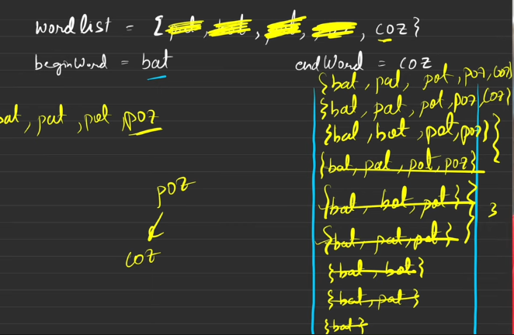



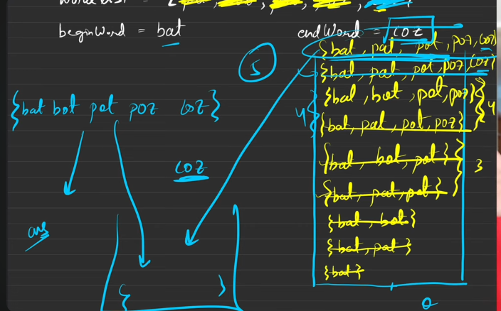





**Topological sorting**

1. DFS: Why dfs
   1. When you are gling to make the call from the node which do not have the outgoing edge, then it is not possible to go to any node from current node.
   2. But is there is outgoing edge I can travel to any node from there to the node that has the path.
   3. So, understand I have to travel the path from there till we have the path.
   4. Before making my way to my parent, I need to insert myself into the stack. Hence when we get time to get into the vector, the things will be done. In topo sort.
2. If there is a path from u to v, then u must be present at the first then comes v while making the sortings.
3. Here Undirected graphs are not possible, because of the if the edge is moving fom u to v then we say that, it can be resented for both u to v and v to u.
4. So then sorting definition will be destroyed.
5. Cyclic dependency should not be there, as shown in the below image.

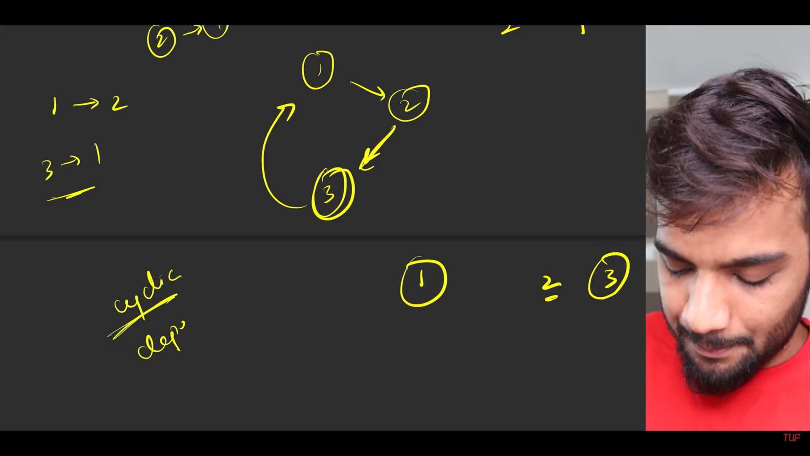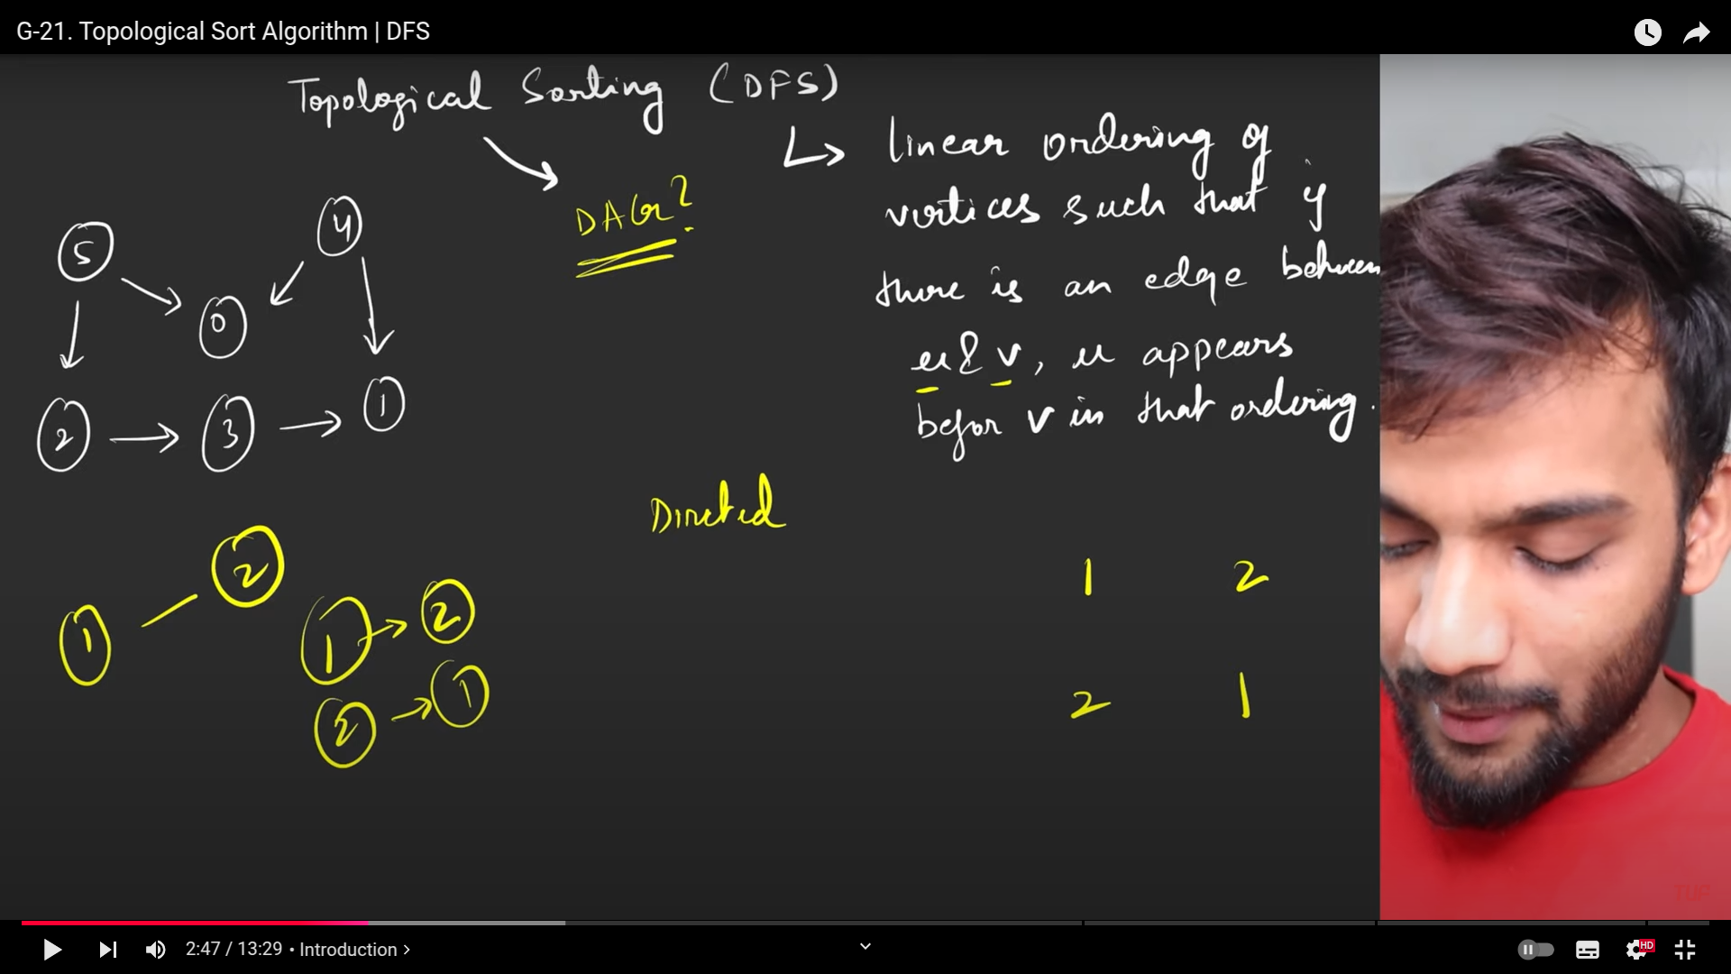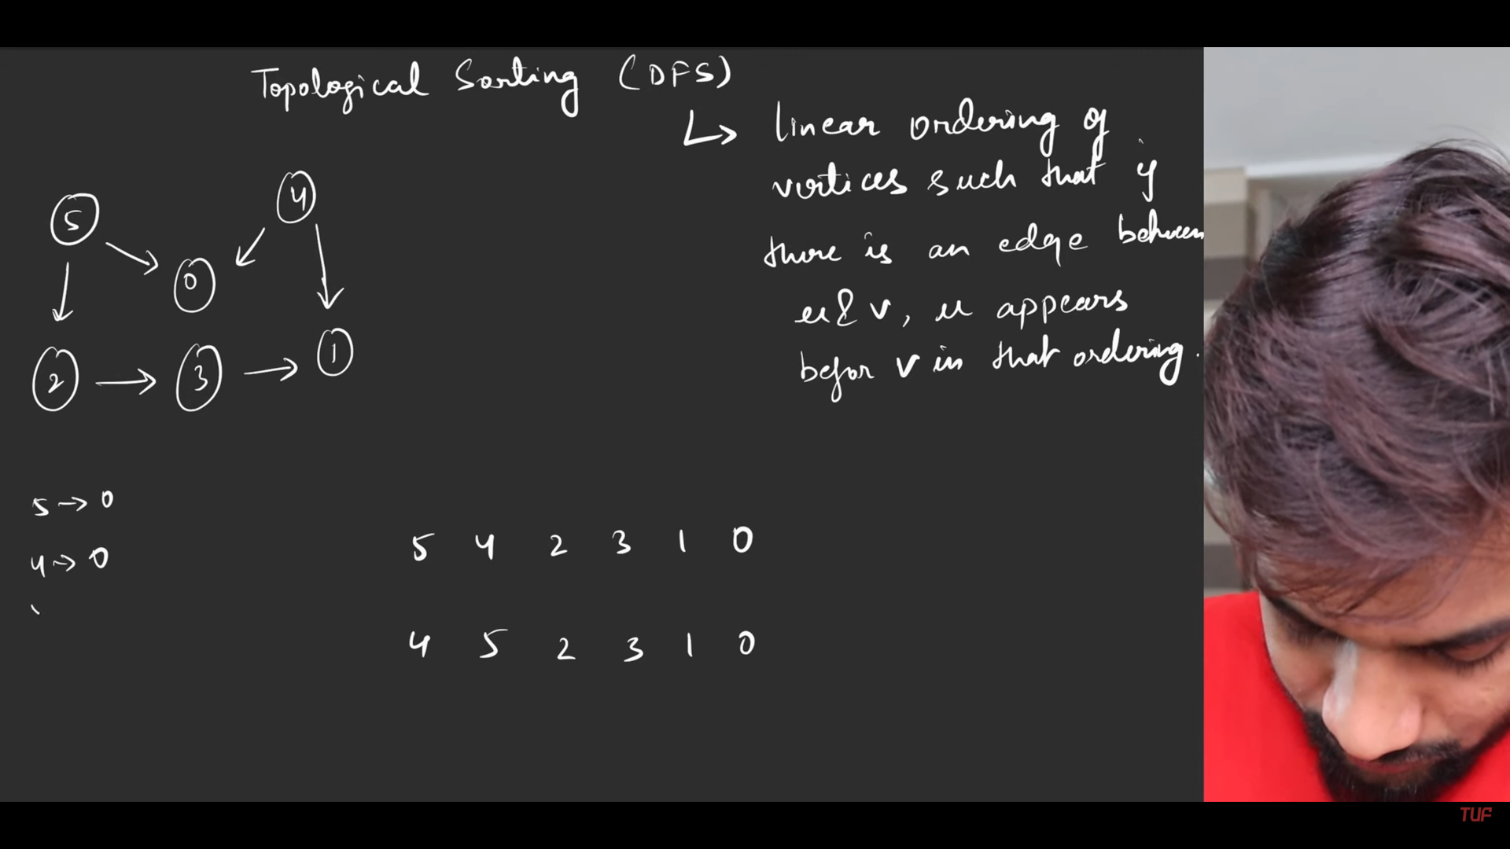

1. Why only directed graphs are possible,

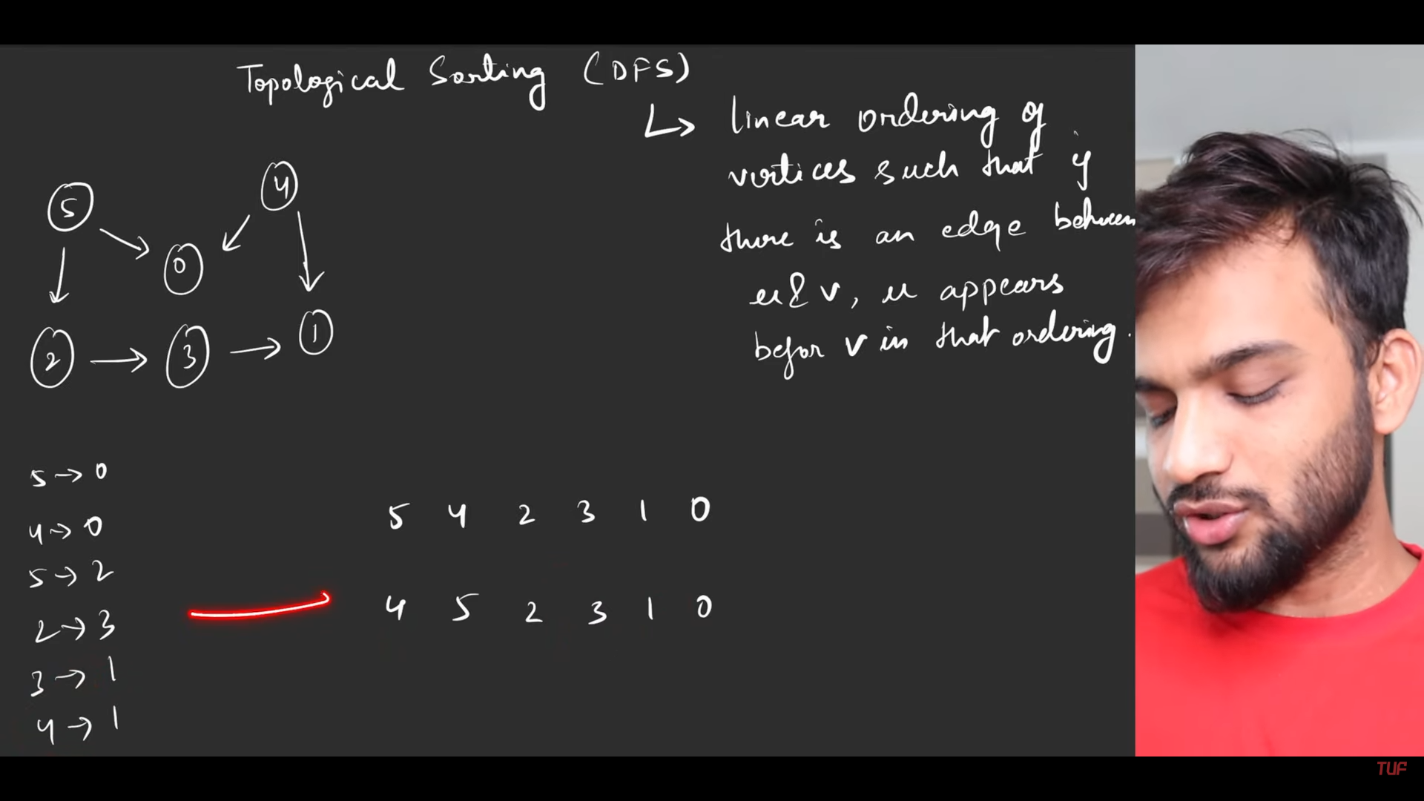

1. There can be multiple linear orderign possibe

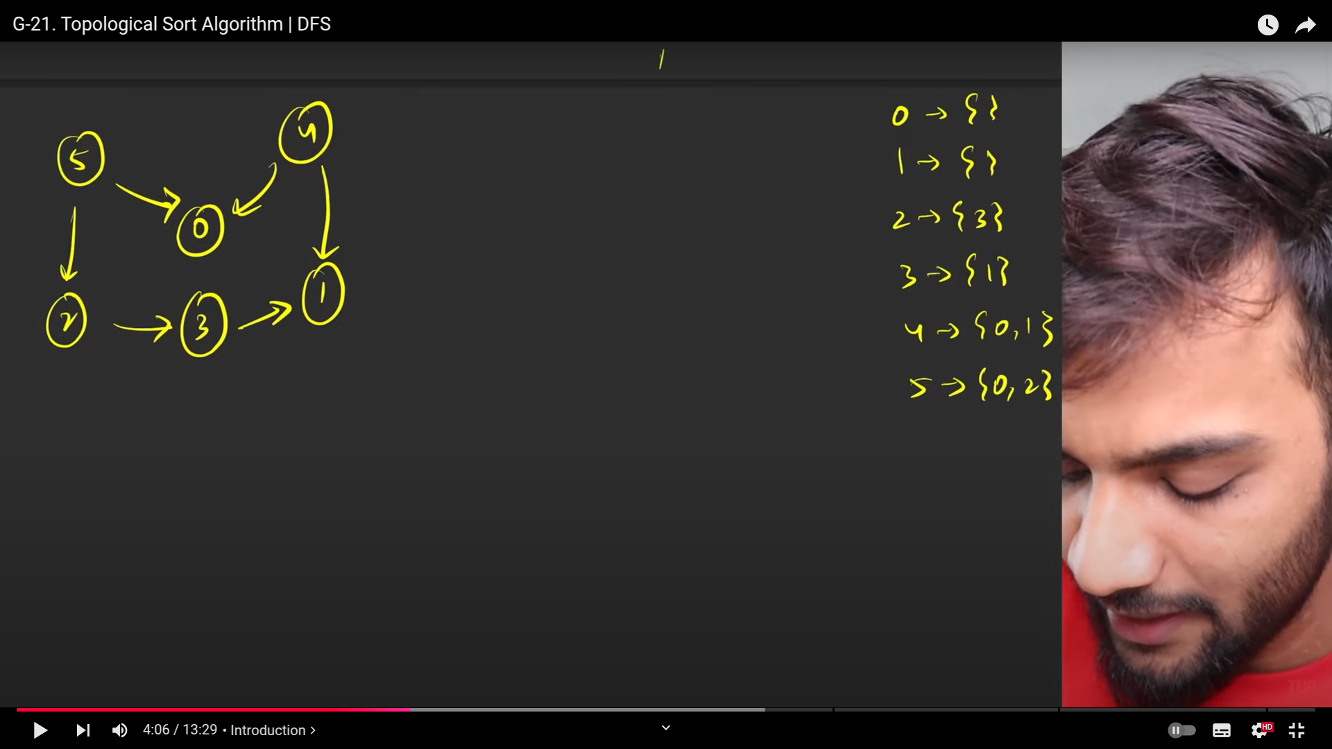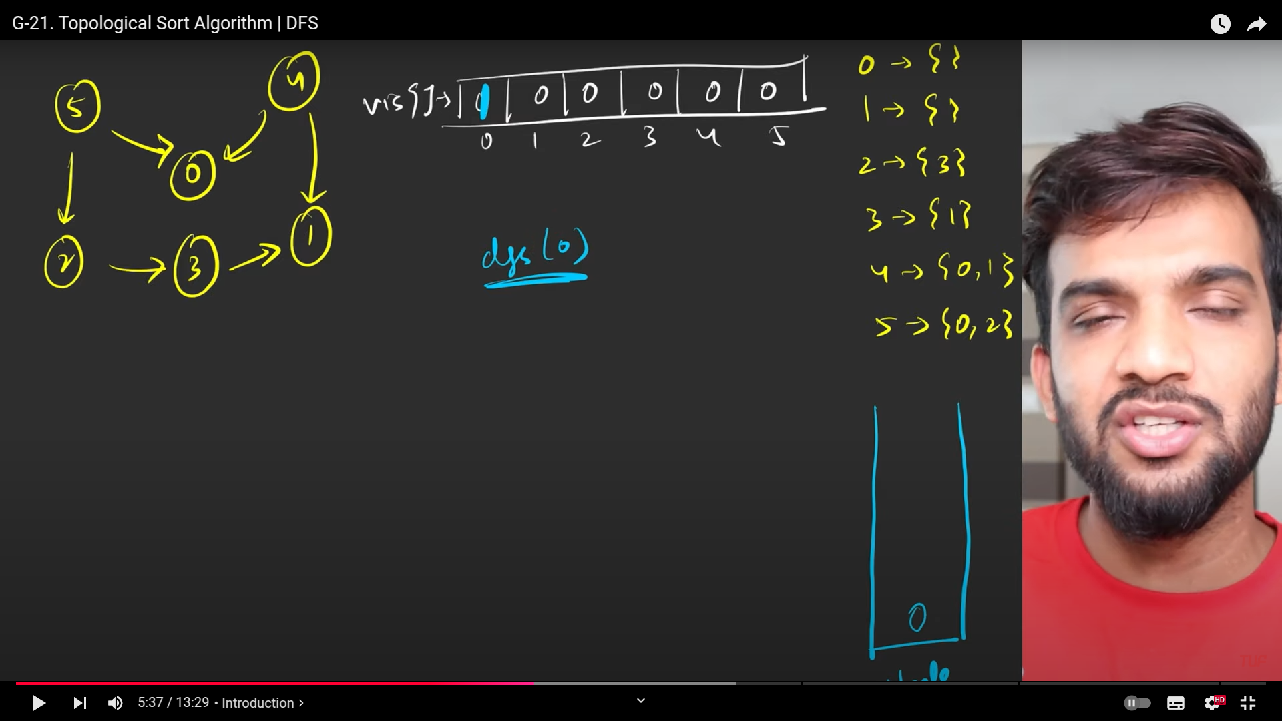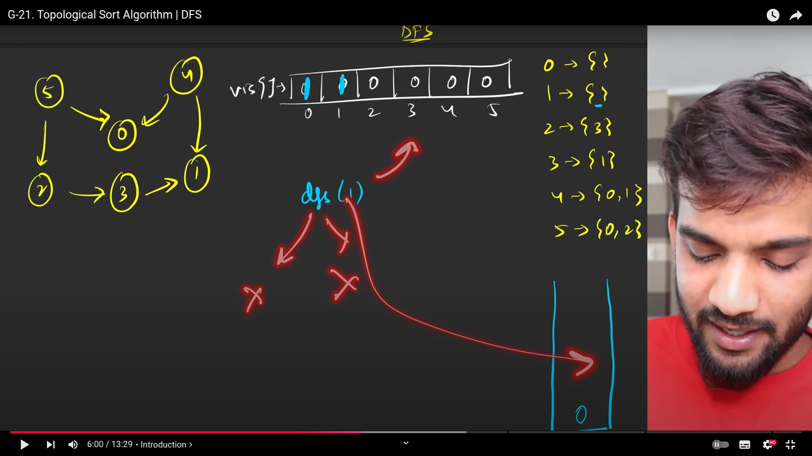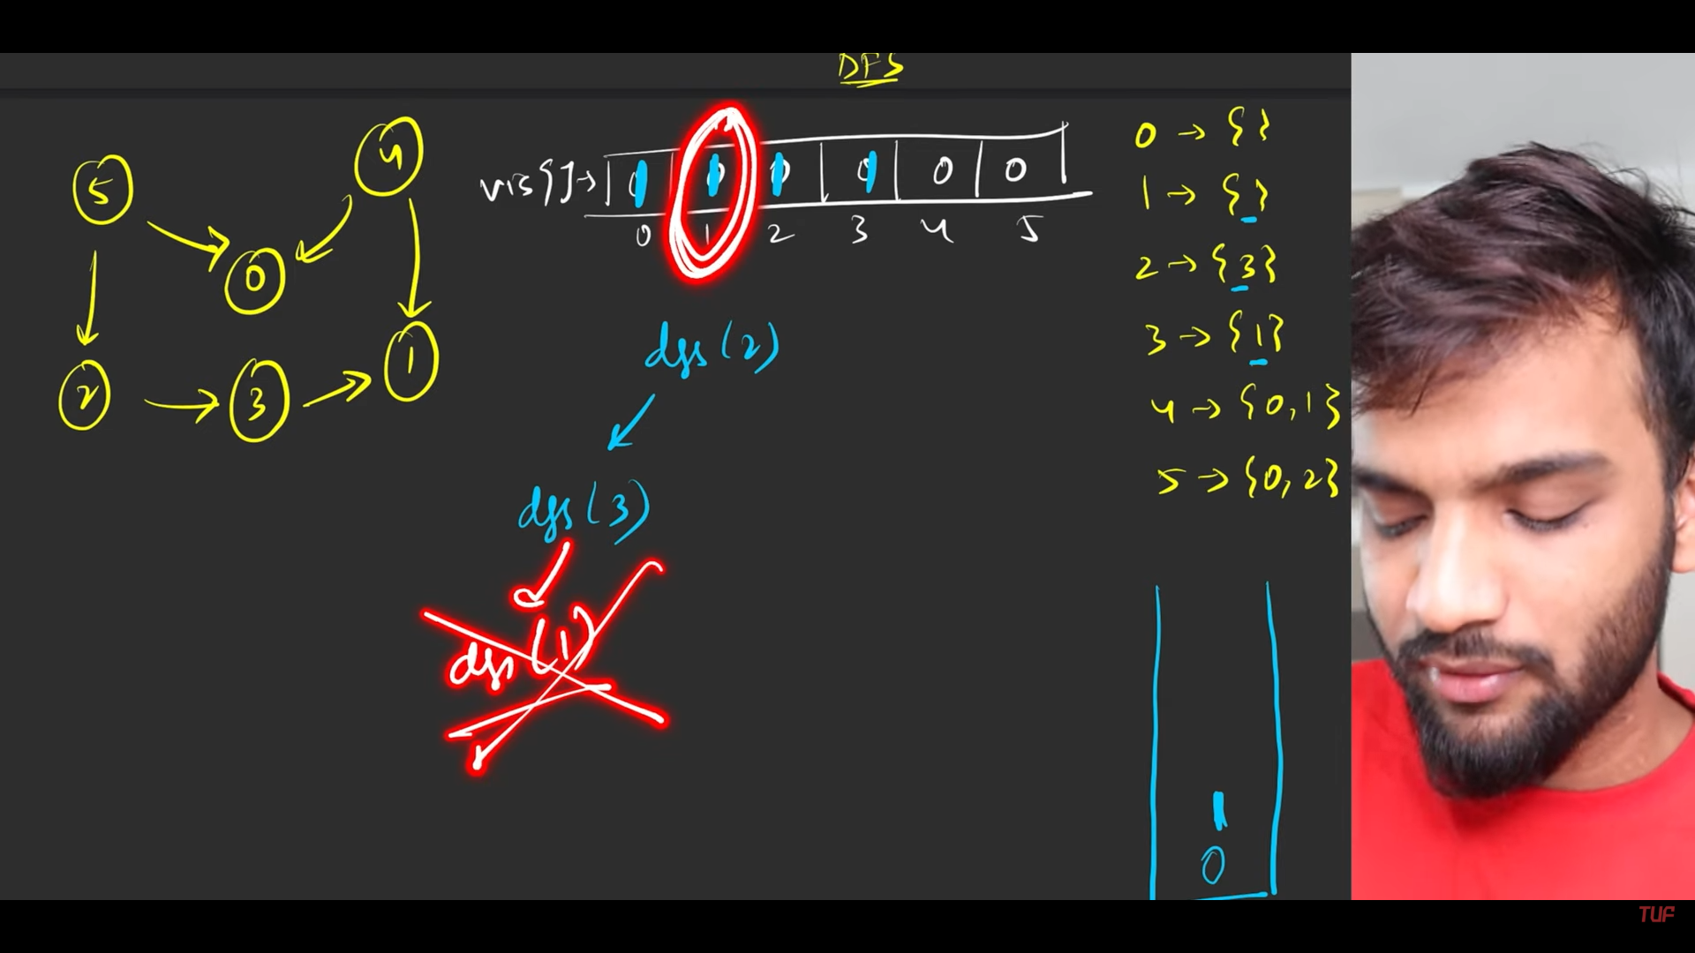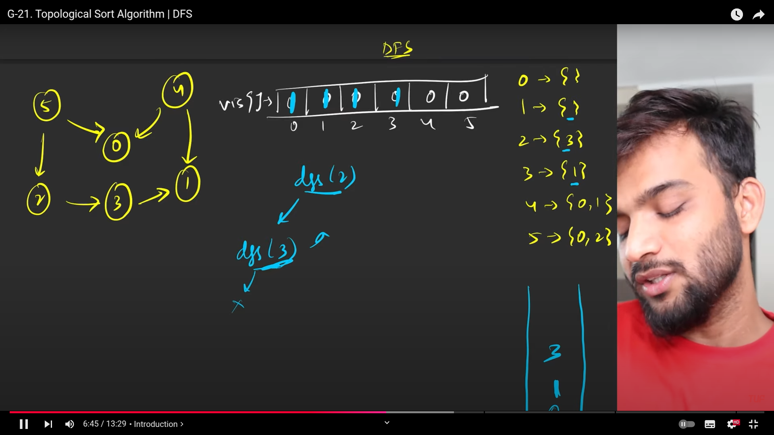

1. Push into the stack before returning from the stack .

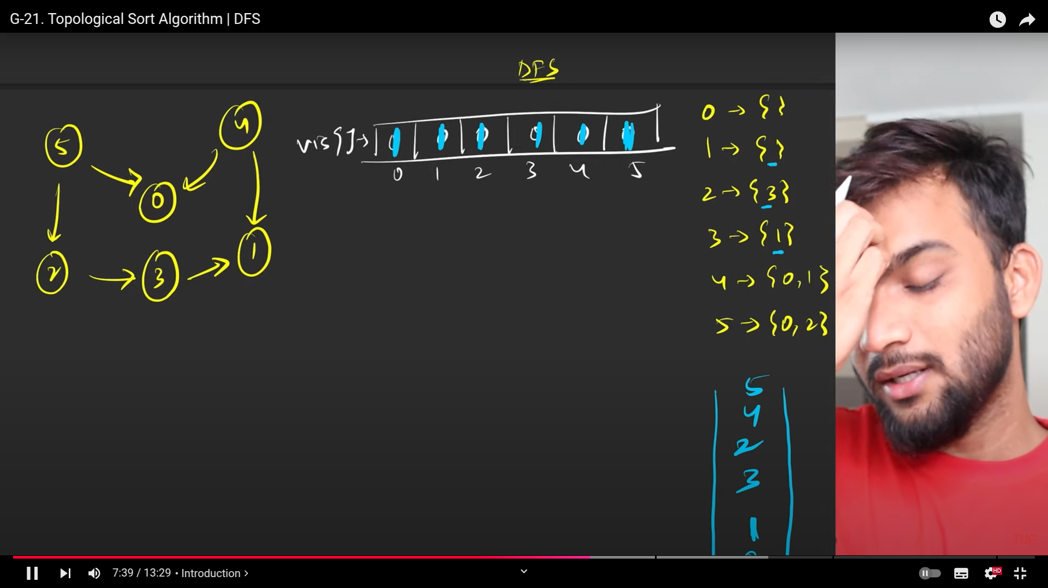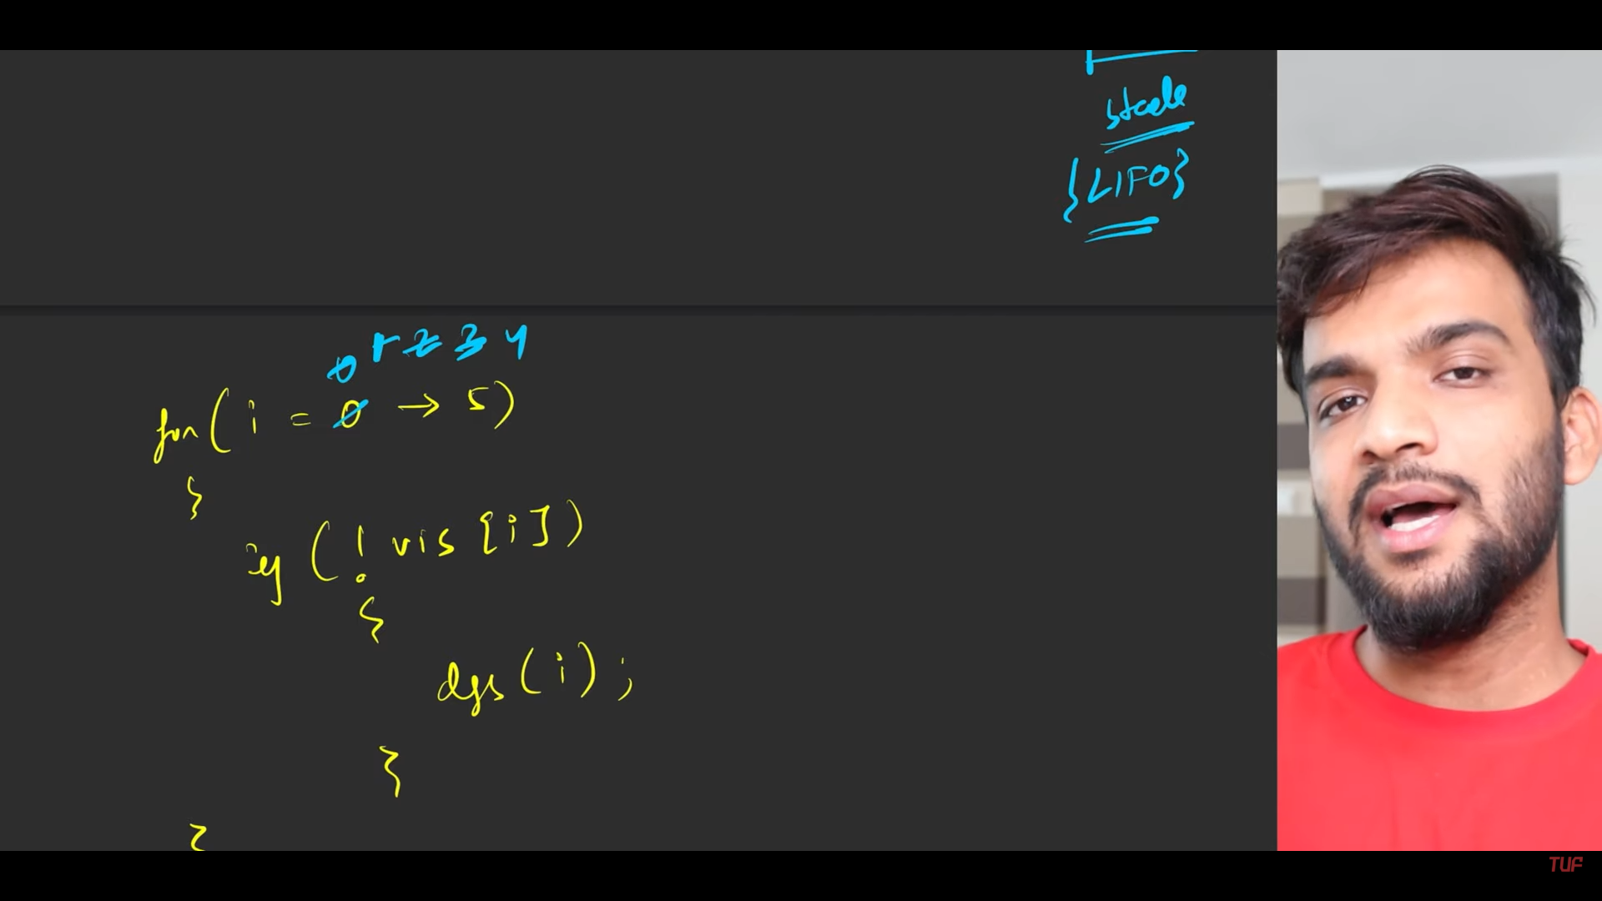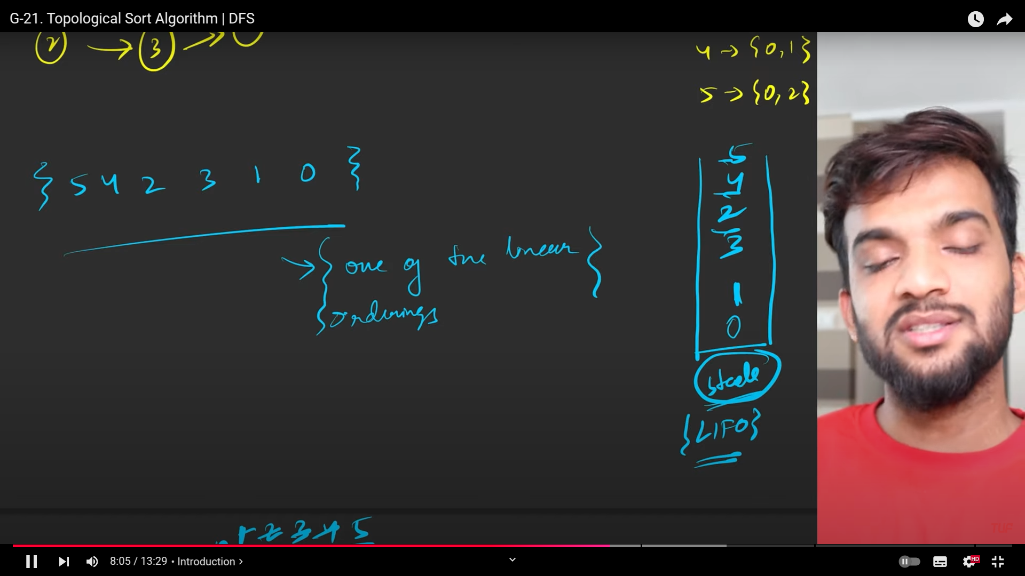

1. Whatever we pushed into the stack , start taking it out and print one by one.

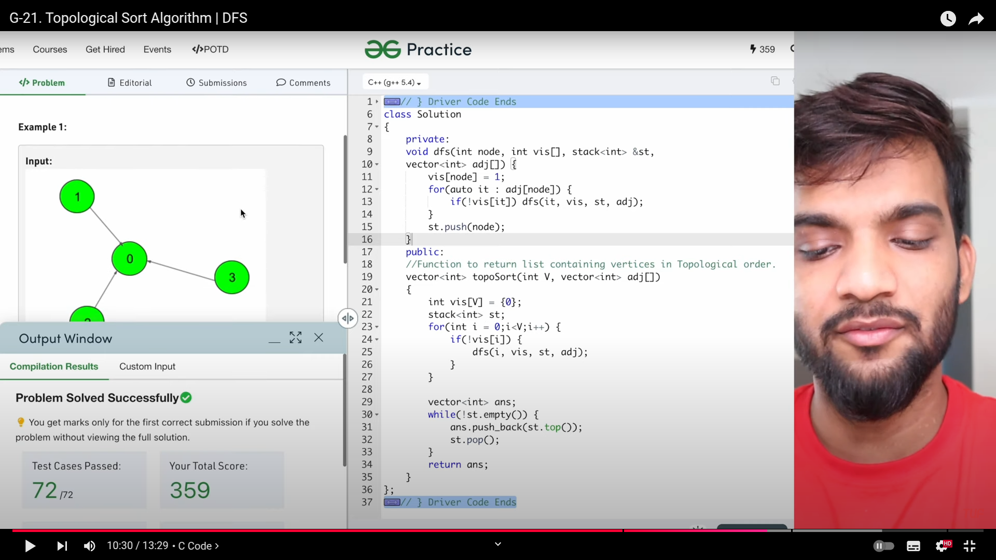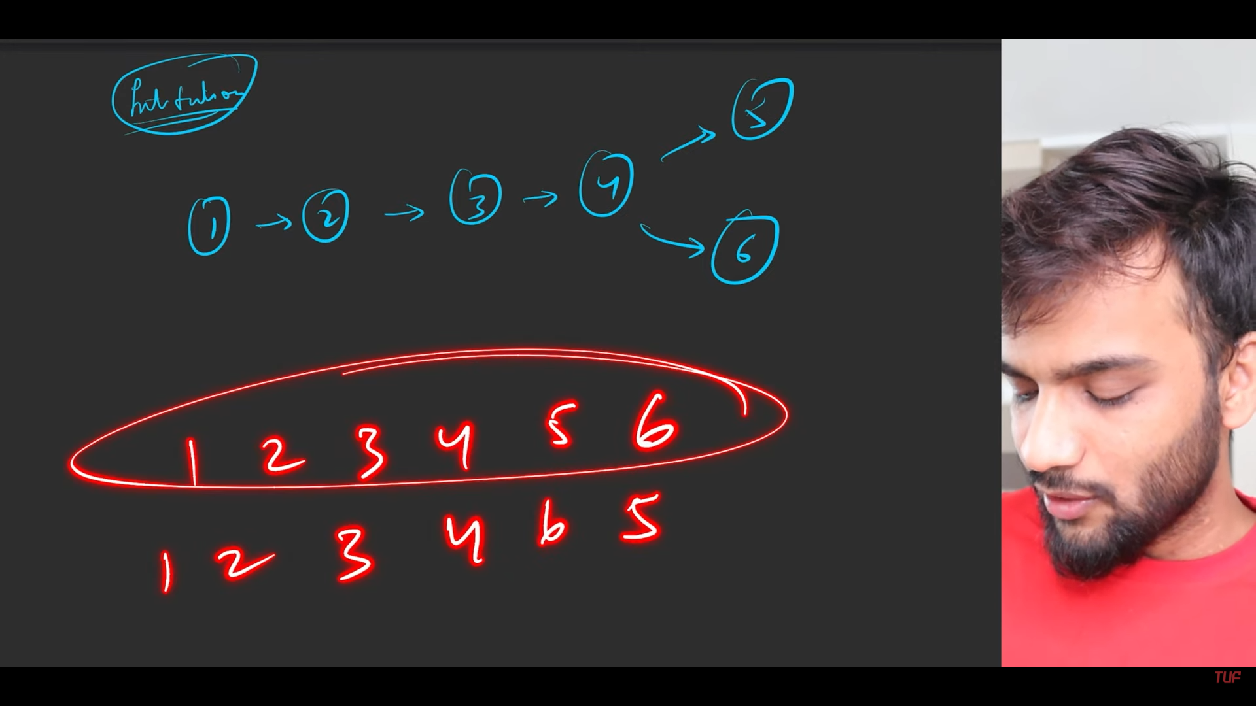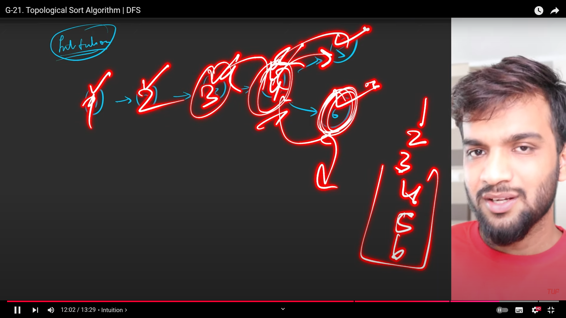

1. Intuition is that, whenever we complete teh DFS, then we add that into the stack, till then we do not add .
2. s